Carbapenem Resistance:
A Retrospective Review of the Literature and Clinical Data

by
Andrew Taylor Whaley
BS, East Carolina University, 2018

Submitted to the Graduate Faculty of the
Department of Infectious Diseases and Microbiology
Graduate School of Public Health in partial fulfilment
of the requirements for the degree of
Master of Public Health

University of Pittsburgh
2019
UNIVERSITY OF PITTSBURGH
GRADUATE SCHOOL OF PUBLIC HEALTH

This essay is submitted
by
Andrew Taylor Whaley
on
December 4, 2019
and approved by

Catherine L. Haggerty, PhD, MPH, Associate Professor, Epidemiology, Graduate School of Public Health, University of Pittsburgh

Essay Advisor: Jeremy J. Martinson, DPhil, Assistant Professor, Infectious Diseases
and Microbiology Graduate School of Public Health, University of Pittsburgh

Copyright © by Andrew Taylor Whaley
2019

Jeremy J. Martinson, DPhil
Carbapenem Resistance:
A Retrospective Review of the Literature and Clinical Data
Andrew Taylor Whaley, MPH
University of Pittsburgh, 2019

Abstract
Carbapenem resistance has emerged as one of the most urgent threats of the 21st century. Over the last 50 years there has been an increase in the resistance towards carbapenems, a last resort antibiotic known for its broad-spectrum ability to treat bacterial infections. Factors contributing to this increase include various biological and behavioral factors such as mutations among bacteria, presence of efflux pumps, and carbapenemases as well as the over prescription and misuse of antibiotics. Due to these increases we investigated carbapenem resistance at a tertiary care facility in Pittsburgh, PA as well as conducted a literature review on the epidemiology, public health impact, and mechanisms of resistance in the hopes of presenting various directions of future research on both the local and national level.
A retrospective chart review was conducted using TheraDoc® and Cerner PowerChart® to evaluate carbapenem resistant among patients at UPMC Mercy Hospital. We reviewed data between 2013 and 2019 for cases of carbapenem resistance. The five most common carbapenem resistant organisms (CROs) according to the literature were included in the study; Enterobacter sp., Klebsiella sp., E. coli, Acinetobacter sp., and Pseudomonas sp. The index culture of each patient was included; patients were reincluded as separate records if an infection appeared after 90 days of the index case and if the isolate was tested for resistance to multiple carbapenems. Microbiology results were determined by using MIC breakpoints set by the CLSI. Patient location, source of infection, and case reoccurrences were also investigated.
Results showed that 95.9% of intermediate or resistant cases were resistant to at least one carbapenem over the time period of the study. Furthermore, an upward trend between 2013-2015 followed by a downward trend between 2016-2019 was noticed. Acinetobacter sp. accounted for 50.9% of infections followed by Klebsiella sp. at 32.5%, and Enterobacter sp. at 9.9%. The most common location where infections occurred were inpatient units followed by the ICU; 37.6% and 34.3 respectively. Urinary tract infections accounted for the 35.1% of cases while respiratory accounted for 23.2%. Recurrent infections were caused commonly caused by Acinetobacter sp. This study revealed vital information regarding carbapenem resistance at UPMC Mercy Hospital. These data show the number of CRO cases, yearly trends, common sites of acquisition and patient locations, as well as the breakdown for case reoccurrences. Overall, this literature review and these data suggest that further research should be pursued in order to understand potential risk factors for CRO infections and improve antimicrobial stewardship.

Table of Contents

Preface ix
1.0 Introduction 1
1.1 Antibiotic Resistance 1
1.2 Carbapenems 3
1.3 Carbapenem Resistance 5
1.4 CRO 13
1.5 Risk Factors of Infection 16
1.6 Methods of Detection 17
1.7 Treatment Options and Adverse Effects 19
1.8 Prevention and Control Measures 23
1.9 Public Health Significance 25
2.0 Objectives 28
3.0 Methods 29
3.1 Ethics Statement 32
4.0 Results 33
5.0 Conclusion 43
Bibliography 47

List of Tables

Table 1. ß-lactam subclasses 4
Table 2. Carbapenemases 7
Table 3. Carbapenem defined breakpoints-Enterobacteriaceae; CLSI 2019 18
Table 4. Carbapenem defined breakpoints-Pseudomonas sp.; CLSI 2019 18
Table 5. Carbapenem defined breakpoints-Acinetobacter sp.; CLSI 2019 18
Table 6. Combination treatment options for Carbapenem-resistant Enterobacteriaceae 21
Table 7. Combination treatment options for Carbapenem-resistant Pseudomonas sp. 22
Table 8. Combination treatment options for Carbapenem-resistant Acinetobacter sp. 22
Table 9. Hospital Locations at UPMC Mercy Hospital 30
Table 10. Specimen locations and specimen grouping 30

List of Figures

Figure 1. Timeline of selected antibiotic introduction and resistance 1
Figure 2. Reported cases with KPC in the United States; 2017 8
Figure 3. Reported cases with NDM in the United States; 2017 9
Figure 4. Reported cases with IMP in the United States; 2017 10
Figure 5. Reported cases with VIM in the United States; 2017 10
Figure 6. Reported cases with OXA-48 in the United States; 2017 12
Figure 7. Inclusion/exclusion criteria 31
Figure 8. CRO infections by sex; 2013-2019 33
Figure 9. CRO infections by age; 2013-2019 34
Figure 10. CRO infections by race; 2013-2019 34
Figure 11. Microbiological results of CRO infections; 2013-2019 35
Figure 12. CRO isolate trends; 2013-2019 36
Figure 13. CRO infections; 2013-2019 37
Figure 14. CRO infections by hospital location; 2013-2019 38
Figure 15. Annual CRO infections by Hospital Location; 2013-2019 38
Figure 16. CRO species by hospital location; 2013-2019 39
Figure 17. CRO infections by body location; 2013-2019 40
Figure 18. Annual CRO infections by body location; 2013-2019 40
Figure 19. CRO infection by species and body location; 2013-2019 41
Figure 20.Recurrent CRO infections, 2013-2019 42

Preface

I would like to thank the members of my committee which included Dr. Jeremy J. Martinson and Dr. Catherine L. Haggerty for their mentorship through this process. I would also like to acknowledge my project mentor Dr. Ricardo Arbulu for his mentorship as well as his efforts in aiding in data collection and interpretation of results. Lastly, I would like to thank all of my essay readers as well as the quality improvement committee at UPMC Mercy Hospital for allowing me to use these data.

- Introduction

  - Antibiotic Resistance

Antimicrobial resistance (AMR) has recently become one of the most prominent and urgent public health concerns of our time [1]. Over the last 70 years there have been upwards of 100 novel antibiotics in seven distinguished drug classes that have been manufactured, approved, and released for use. While these antibiotics are beneficial in the treatment of bacterial infections, their effectiveness in treating an infection has decreased significantly over time (Figure 1). Many of the bacterial strains associated with these antibiotics are now resistant, thus becoming more difficult to treat [2]. The World Health Organization (WHO) defines AMR as microorganisms undergoing a change due to an exposure to an antimicrobial drug. This change not only causes the antibiotic drug to be ineffective, but it also increases the risk of subsequent health complications, outbreaks of disease, disability, and death [3]. 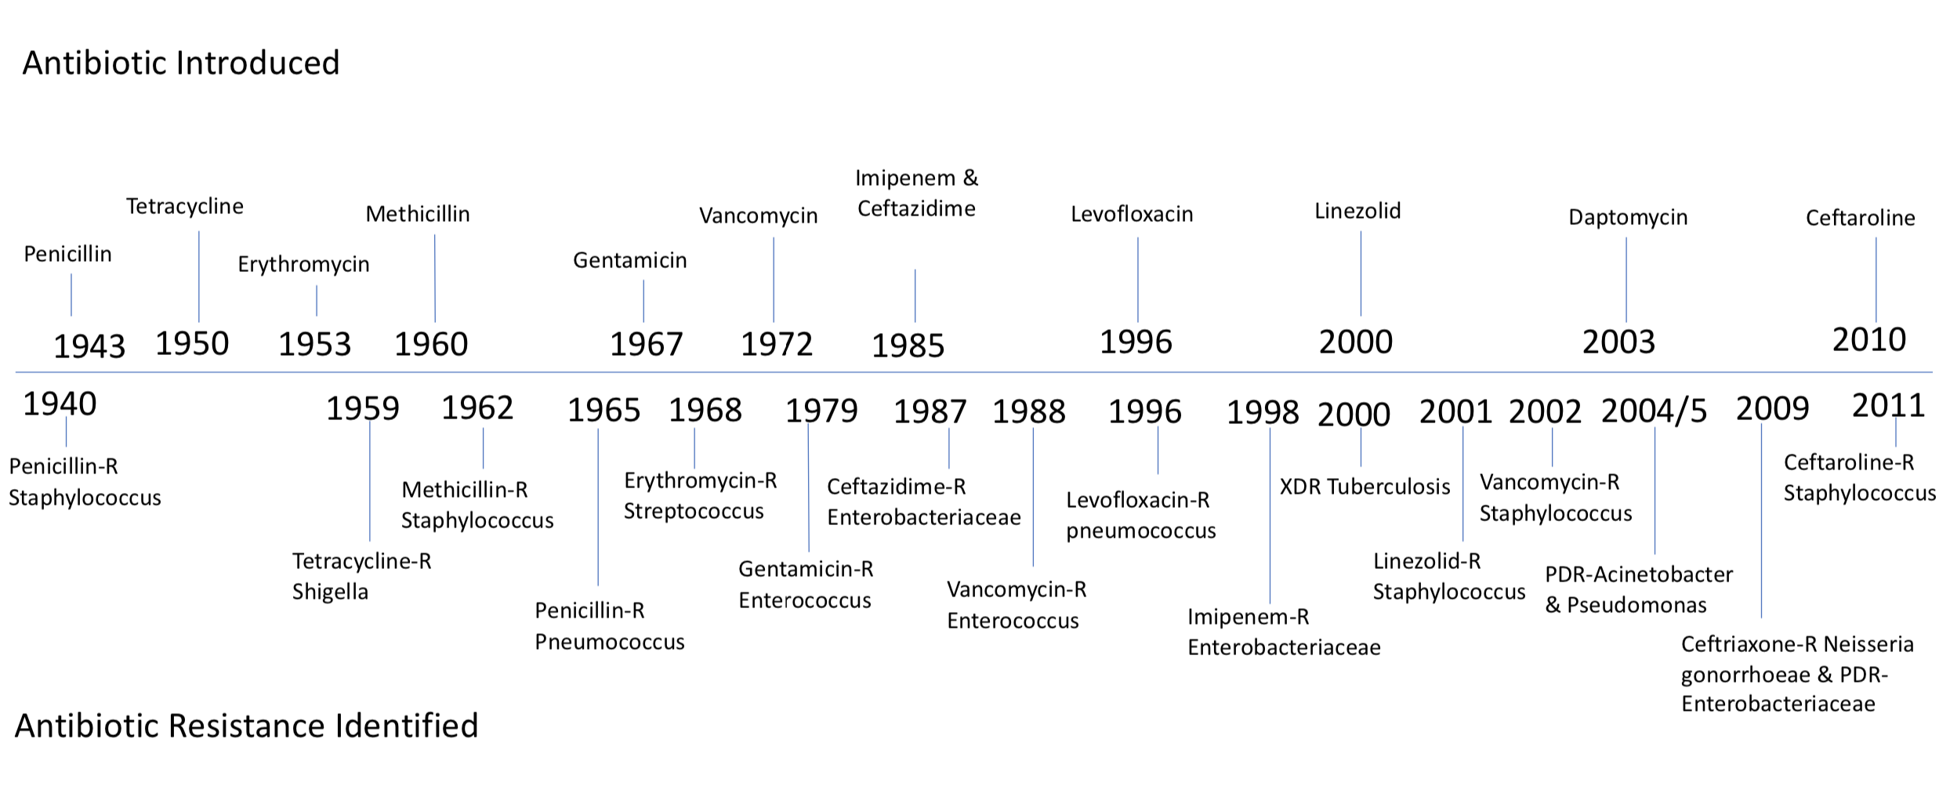
Figure 1. Timeline of selected antibiotic introduction and resistance.
Increasing rates of AMR are a result of biological changes, inappropriate prescription and use, agricultural overuse, and societal pressures [4]. In terms of over-prescription, approximately 50% of all prescriptions are unnecessary and therefore cost the United States approximately $1.1 billion annually. Agricultural use has also played a pivotal role in the AMR through the use of animal feed. According to Fair and Tor in 2014, 24.6 million pounds of antibiotics were given to animals on a non-therapeutic basis. Thus, the FDA has now banned the use of antibiotics in this context. Societal pressures and a lack of public knowledge are another factor of AMR. Due to common misconceptions much of the public believes that antibiotics treat viral and fungal infections. Furthermore, many individuals will stop taking their medication for a bacterial infection once they feel better rather than finishing the prescribed dose [5]. Overall, this has caused widespread panic, increased healthcare costs, decreased efficacy of interventions, and a need for the development of new antibiotics [2].
From a global perspective, high levels of antibiotic resistance (AR) are seen in every country, however, the highest rates are typically seen in developed or industrialized countries [3]. According to the Centers for Disease Control and Prevention (CDC) approximately two million people in the United States acquire an antibiotic-resistant bacterial strain every year. Of those individuals 23,000 die due to various complications such as sepsis [2]. This translates to approximately eight million hospital days among individuals living in the US [6]. In terms of economic impact, carbapenem resistance is estimated to cost approximately $30 billion per year in the US with a projection of $2895 billion by 2050 [7]. This urgent threat is also seen locally in the commonwealth of Pennsylvania [8]. Within the University of Pittsburgh Medical Center (UPMC) health system approximately 11,000 carbapenem resistant organisms (CRO) cases have been seen over the last 10 years. The Pennsylvania Department of Health has since created programs such as the “Get Smart Program” for antimicrobial stewardship as well as programs that focus on the monitoring of resistance across the state [8]. Hospitals within the UPMC health system are creating new positions for infection prevention and control, adopting new standards of care for the treatment of bacterial infections, and implementing antimicrobial stewardship programs in order to combat this issue [9].

  - Carbapenems

ß-lactams are among the most commonly prescribed antibiotics to treat bacterial infections. This family of pharmaceutical drugs include penicillins, cephalosporins and monobactams. Among this diverse group of antimicrobial agents are antibiotics known to treat Streptococcus species, Methicillin-sensitive Staphylococcus aureus, and Pneumococcus species [10]. Carbapenems are a subclass of highly effective antimicrobial agents in the ß-lactam family as well (Table 1). Known for their broad spectrum of activity against bacteria, potency against Gram-negative rods (GNRs) and Gram-positive rods (GPRs), and their structural stability, carbapenems are utilized as a ‘last resort’ medication for patients experiencing severe bacterial infections [7].
In the late 1960’s a disrupting enzyme, ß-lactamase, that hydrolyzes and destroys the ß-lactam ring of the antibiotic was discovered. This alarming discovery along with the enzymes subsequent threat to the effectiveness of penicillin caused scientists to begin searching for novel antimicrobial agents. In 1976, the first ß-lactamase inhibitors were discovered; however, they were chemically unstable and therefore not effective against this type of bacterial infection. Upon this discovery, scientists began to use the chemical structure from the ß-lactam inhibitor as a model for carbapenems. Eventually, various carbapenems were synthesized, many of which are utilized in healthcare settings today [11].

Table 1. ß-lactam subclasses.
ß-lactam Subclasses
Subclass | Common Antibiotics
Cephalosporins | Cefazolin, cephalexin, cefadroxil, ceftriaxone, ceftazidime
Monobactams | Aztreonam
Penicillins | Penicillin, ampicillin, amoxicillin, nafcillin, oxacillin, dicloxacillin, methicillin
Carbapenems | Meropenem, ertapenem, imipenem, doripenem, panipenem, biapenem

Antibiotics are known to have a bacteriostatic, stopping bacterial growth, or bactericidal, killing bacterial, mechanism. Carbapenems, like many ß-lactams, have a unique mechanism of action (MOA) that allows for both of these mechanisms to occur. Carbapenems allow for the penetration of the bacterial cell wall through a porin. Once penetration is complete carbapenems bind to multiple penicillin-binding proteins (PBPs) which inactivate autolytic inhibitor enzymes within the cell wall. This interaction causes a bacteriostatic effect and subsequent disruption in cell wall synthesis therefore allowing a bactericidal effect to occur via cell lysis [10, 11]. Additionally, carbapenems are used due to their concentration-independent killing effect on various forms of bacteria. This mechanism allows prolonged use of the antibiotic and give the antibiotic a wider spectrum of detrimental effects against harmful bacteria [7]. Carbapenems are chemically one of the most stable antibiotics utilized in clinical settings worldwide. The chemical structure of certain carbapenem involves a cyclic amine group that aids in the resistance to cleavage by multiple beta-lactamases and extended spectrum beta-lactamases (ESBLs). Due to theses characteristic carbapenems have fewer side effects and adverse outcomes than any other ß-lactam on the market [7, 10].
An array of antimicrobial agents within the class of carbapenems allows for the targeting of multiple bacterial species and thus makes these agents highly effective against bacterial infections. Among this subclass antibiotics, carbapenems such as imipenem, panipenem, and doripenem are the most effective against GPRs while meropenem, biapenem, ertapenem, and doripenem are consistently more effective against GNRs [11]. Carbapenems associated with a cyclic amine group such as meropenem, doripenem, panipenem, and ertapenem are notably broader in their spectrum of activity against bacterial infections [7]. Overall, ertapenem is limited in its spectrum of activity, meropenem is the least potent, and doripenem is highly stable against hydrolysis [7, 11].

  - Carbapenem Resistance

Resistance to carbapenems is quickly becoming an urgent public health threat. Since the debut of carbapenems in the 20th century, their effectiveness has been decreasing due to a variety of reasons. Human-related factors that have caused resistance to carbapenems include inappropriate prescription of antibiotics, uncontrolled access to antimicrobial agents, and a lack of infection prevention and control measures within healthcare settings [12]. Infection prevention and control or antimicrobial stewardship has proven to be effective against the acquisition of a bacterial infection. However, in 2014 only 48% of hospitals in the U.S. had adopted preventative measures. [5]. Furthermore, factors related to overall antibiotic resistance apply to carbapenems as well. According to the National Institute of Allergy and Infectious Diseases (NIAID) factors such as societal pressures, inadequate diagnostics, and agricultural use all contribute to resistance [4, 12].
In addition to human-related mechanisms of resistance, biological and genetic factors are of upmost importance when discussing carbapenem resistance as well. These factors are seen in GNRs in the forms of ß-lactamases, alterations to efflux pumps, and mutations in genetic coding that allow for a change in function or expression of porins and PBPs [11]. ß-lactamases are enzymes that bacteria utilize in order to hydrolyze the antibiotic thus preventing it from reaching the PBP target [7]. In the case of carbapenems these ß-lactamases are known as carbapenemases. Furthermore, carbapenemases are classified into four groups (Class A, B, C, D) based on their hydrolytic properties and structural similarities [11]. Carbapenems breakdown into two categories; chromosomal and plasmid (Table 2.)

Table 2. Carbapenemases.
Enzyme | Type | Year of Isolation | Origin
SME | Chromosome | 1982 | London, UK
IMI | Chromosome | 1984 | California, USA
NMC-A | Chromosome | 1990 | Paris, France
IMP | Plasmid | 1994 | Japan
KPC | Plasmid | 1996 | North Carolina, USA
VIM | Plasmid | 1997 | Verona, Italy
OXA | Plasmid | 1985 | Scotland, UK
NDM | Plasmid | 2010 | India

Class A carbapenemases use a serine residue in order to hydrolyze the ß-lactam bond on the antibiotic, thus protecting the bacteria from destruction [13]. Chromosomal encoded enzymes within this class include non-mellatoenzyme carbapenemase A (NMC-A), Serratia marcescens carbapenemase-1 (SME), imipenem-hydrolyzing ß-lactamase (IMI-1) and Serratia fonticola carbapenemase-1 (SFC-1). Comparatively, plasmid encoded enzymes include Klebsiella pneumoniae carbapenemase (KPC), specifically KPC-2 to KPC-13, as well as IMI-1 to IMI-3, and Guiana extended spectrum (GES) which includes GES-1 to GES-20 [7, 10]. Moreover, the most prevalent carbapenemase among Class A across the globe are KPCs. This type of carbapenemase has caused outbreaks in much of Asia, Europe, Africa, and in North America as well [7]. According to the CDC, in 2017 patients with any variant of KPC-producing Carbapenem resistant Enterobacteriaceae (CRE) were reported in every state in the U.S. (Figure 2).
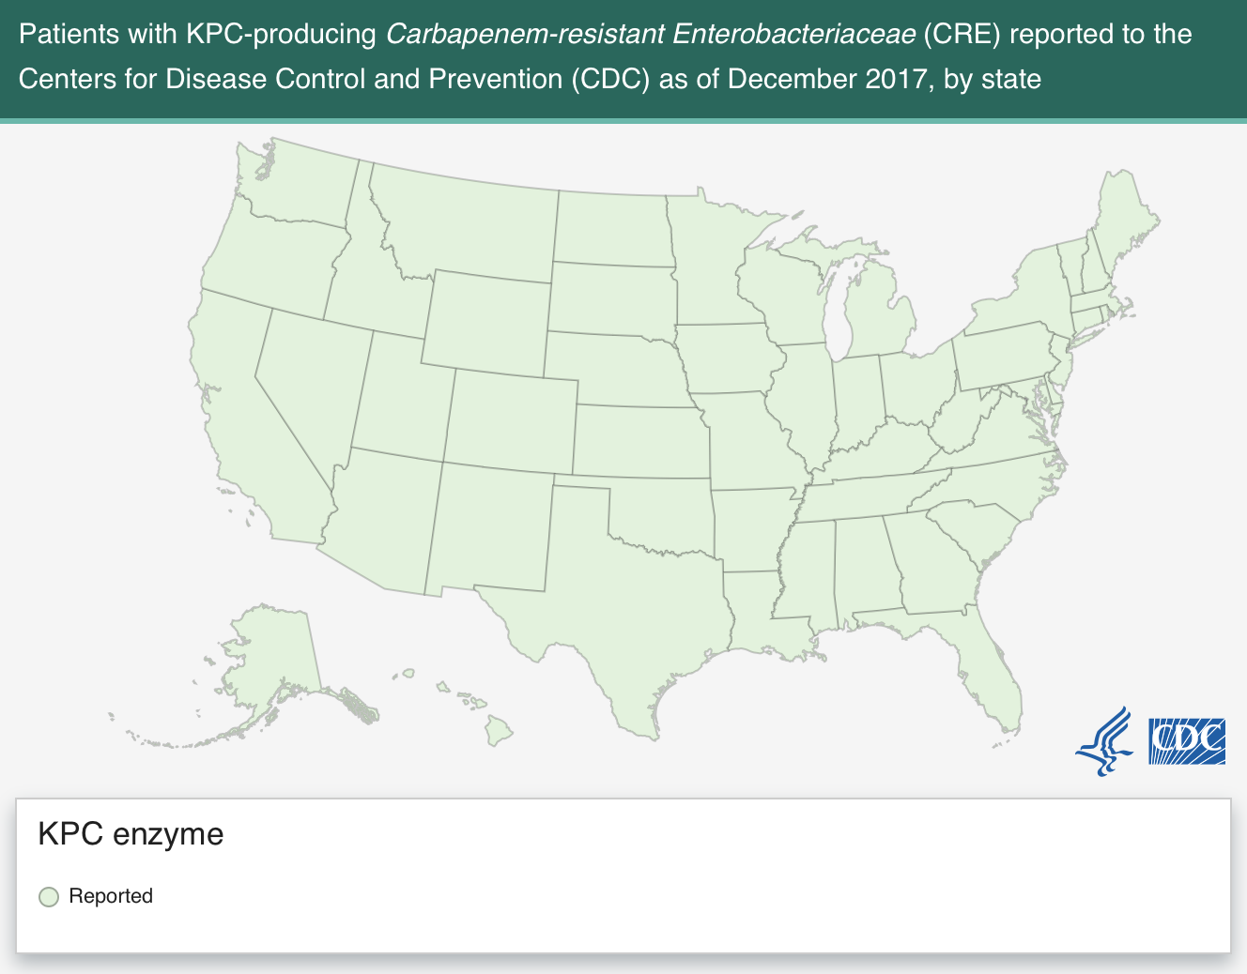
Figure 2. Reported cases with KPC in the United States; 2017.

Class B carbapenemases are another group of enzymes; however, this class utilizes zinc (Zn) in order to inactivate ß-lactams. While this mechanism allows for the inactivation of the ß-lactam, it also makes overall stability more susceptible to destruction via ethylenediamine-tetraacetic acid, EDTA [7]. Within the context of this class there are a variety of enzymes including the New Delhi metallo-ß-lactamase 1 (NDM-1), imipenem-resistant Pseudomonas (IMP), Verona integro-encoded metallo-ß-lactamase (VIM), German imipenemase (GIM), and Seoul imipenemase (SIM) [7, 14]. According to the CDC in 2017, patients with NDM-producing CRE were reported in 34 states with the most Illinois (n=109) and California (n=75) while 5 cases were reported in Pennsylvania. In terms of prevalence regarding IMP-producing CRE a total of 36 cases were reported. Overall, the highest rates were seen in Iowa (n=8) and California (n=7). Pennsylvania reported no cases. Lastly, in 2017 VIM-producing CRE cases were reported 57 times with no cases in Pennsylvania (Figures 3-5) [15].

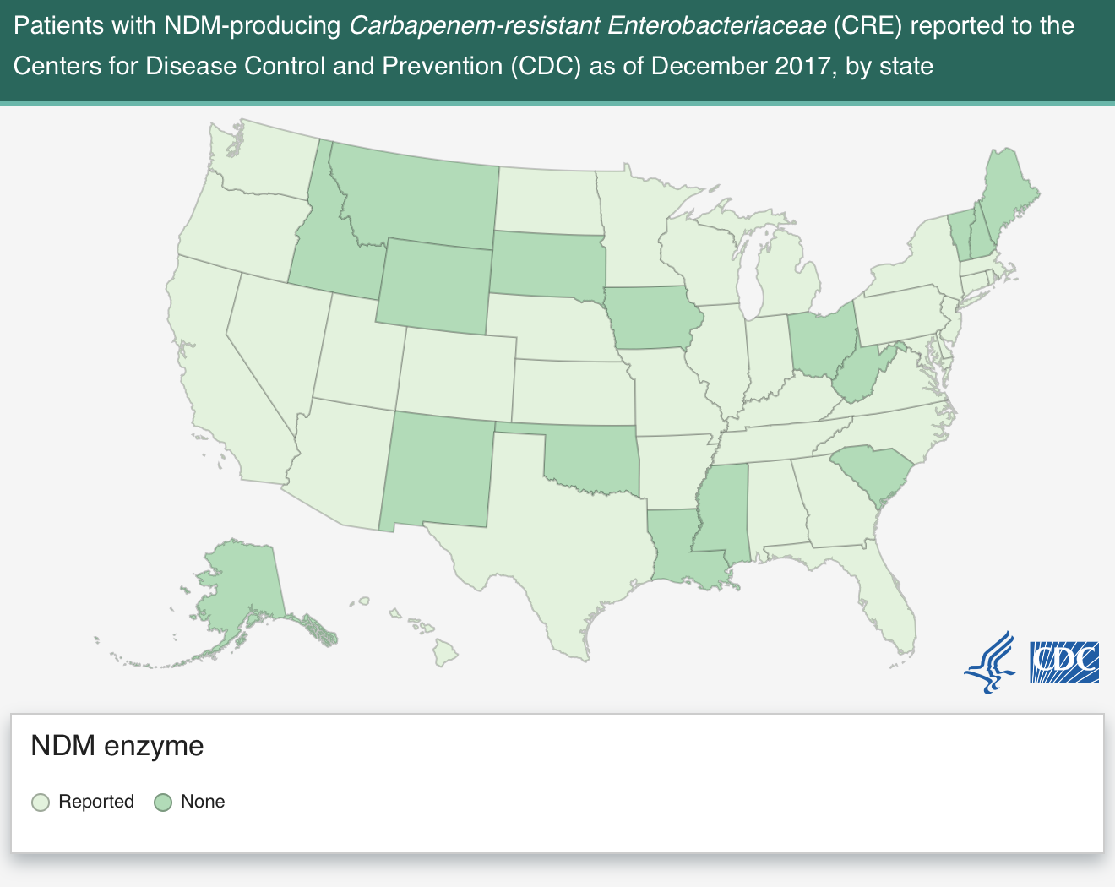
Figure 3. Reported cases with NDM in the United States; 2017.
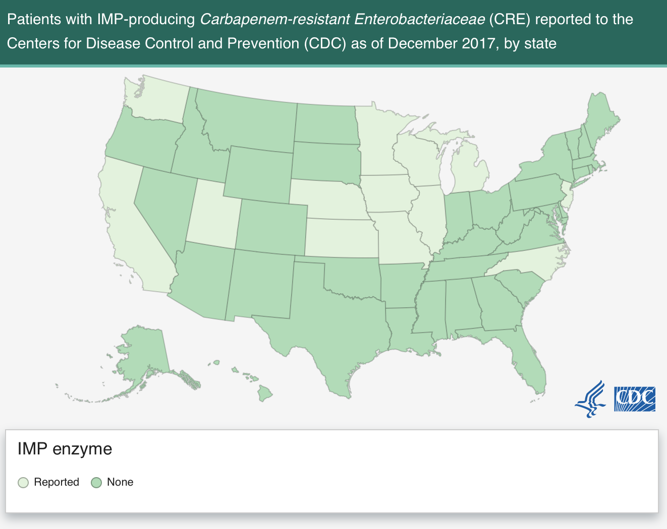
Figure 4. Reported cases with IMP in the United States; 2017.

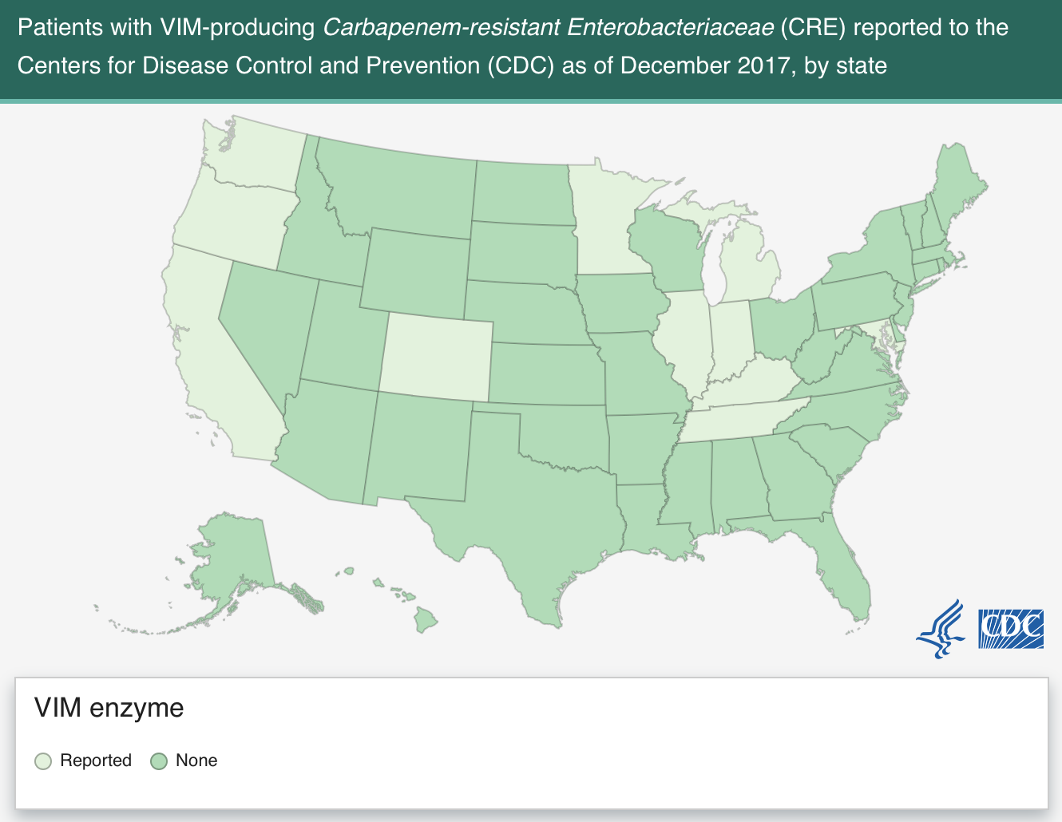
Figure 5. Reported cases with VIM in the United States; 2017.
Class C carbapenemase enzymes, much like Class A, use a serine residue to hydrolyze the ß-lactam bond. While much of the clinical role regarding Class C is still unknown, the effect on carbapenems is relatively weak. Instead, Class C has a pronounced effect on penicillins and cephalosporins [7, 16]. Class D carbapenemases also use a serine residue in order to hydrolyze the ß-lactam bond; however, this class is poorly inhibited by EDTA, but have minute activity against carbapenems The most common enzyme seen among this class is oxacillin (OXA) due to its ability to degrade multiple forms of cephalosporins and carbapenems [16].
Furthermore, the OXA enzyme is typically seen in various forms including OXA-23, 24, 48, and 58. According to a review by Codjoe and Donker in 2018, OXA-23 is seen globally, but is most prevalent in the U.S. and Europe while OXA-24 and 58 are most commonly seen in the environment, cause community acquired infections, and major outbreaks. OXA-48 is the most common type overall and is seen in the Middle East, North Africa, and Europe [7]. OXA-48 producing CRE cases were reported to the CDC approximately 146 times in 2017. Among those cases, California (n=25), Washington (n=14), and Illinois (n=13) were the most common states seen while Pennsylvania reported three cases (Figure 6.) [15].

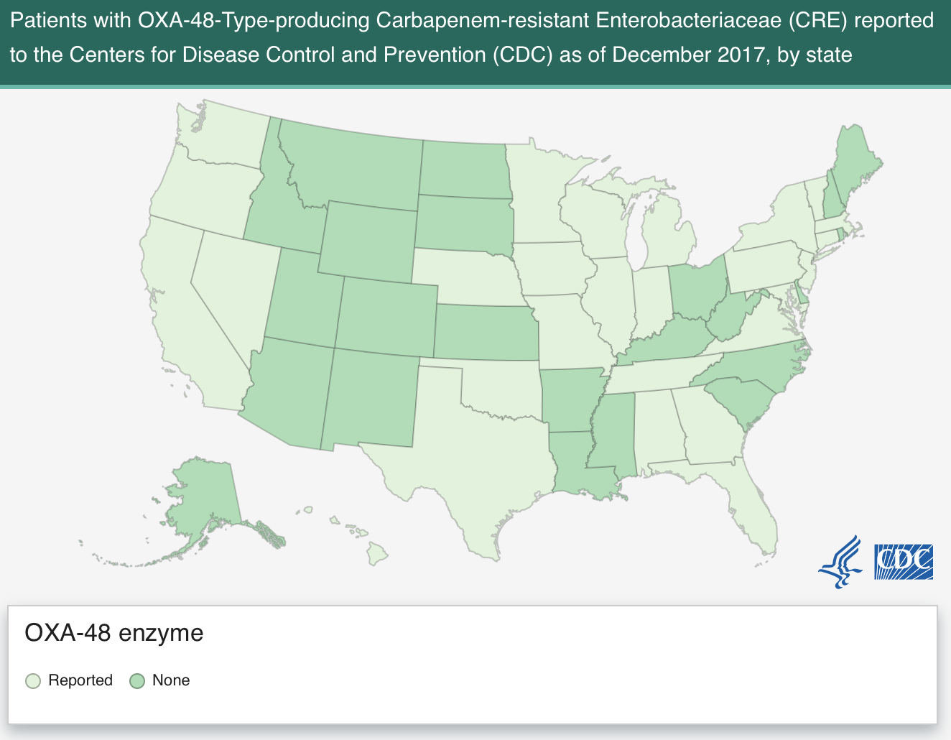
Figure 6. Reported cases with OXA-48 in the United States; 2017.

Outer membrane proteins (OMPs) and decreased antibiotic penetration are other mechanisms of carbapenem resistance that are typically seen in the clinical and research setting [10]. Gram-negative organisms have developed resistance to carbapenems in order to prevent the uptake of the lethal molecules contained in the antibiotic. This mechanism is seen in the outer membrane of the cell wall and thus limits the amount of substance uptake the bacteria performs via OMPs. Porins, a type of OMP, can undergo alterations in the form of three processes; type shift, fluctuation in expression, and function impairment. Furthermore, OMPs are classified into four families; general, substrate specific, gated, and efflux porins. Among the four families of OMPs only general, substrate-specific, and efflux pumps directly causes resistance to carbapenems [11, 16].
Efflux pumps are the key mechanisms of non-carbapenemase resistance that Gram-negative bacteria use. Due to the overexpression of these pumps carbapenems get eliminated and thus are ineffective in treating a bacterial infection. Efflux pumps are divided into five families, which have different functions based on their structure, amino acid sequence, and energy source; small multidrug resistance (SMR), resistance-nodulation-division (RND), major facilitator superfamily (MFS), ATP-binding cassette (ABC), and the multidrug and toxic compound extrusion (MATE). Among these efflux pumps, RND is the most common and complex [11]. Another mechanism of resistance stems from changes in the target site of the antibiotic via genetic mutations and coding [10]. Changes in the target site include target protection and modification, both of which increase resistance. Target protection involves the bacteria coding for specific proteins through genetic sequences while target modification includes mechanisms such as point mutations, enzymatic alterations at the binding site, and the replacement of the original target [16]. Overall, these human-related and biological mechanisms have contributed and continue to contribute to carbapenem resistance. Among Gram-negative bacteria there are five common bacterial species that are consistently seen to be carbapenem resistant in the U.S. among hospital settings.

  - CRO

Carbapenem resistant organisms (CROs) such as Enterobacter sp., Klebsiella sp., E. coli, Pseudomonas sp., and Acinetobacter sp. are of importance when discussing the rising incidence and overall prevalence of antibiotic resistance [17]. These bacterial species have emerged as the five most common CROs seen in both community and clinical settings [18]. Collectively the species of Enterobacter, Klebsiella, and E. coli are known as carbapenem resistant Enterobacteriaceae (CRE) while Pseudomonas and Acinetobacter are classified separately. Moreover, these five organisms have been in existence for well over a century and have mutated, evolved, and now contain various mechanisms that allow for their resistance to carbapenems. Therefore, these organisms are a cause of great concern for susceptible patients as well as healthcare professionals [16, 19-22].
In regard to CRE related organisms such as Enterobacter, Klebsiella, and E. coli, each one is relatively similar to the others in their MOA and history. CRE was first deemed a public health issue in the 20th century due to the evolving resistant nature of bacteria to antibiotics such as penicillin [23]. Since that time various mechanisms of resistance have been established for this group of bacteria and include carbapenemases, altered cell walls, and the use of hydrolysis (Section 1.3) [7, 23]. In a study conducted on CRE in an acute care hospital, researchers found that demographic elements such as age, race and gender were huge factors in CRE incidence. The average age of participants in this study was 69 years old. The most common race was African American (83%), and the most common gender was female (63%). In addition, this study assessed the distribution of infections and colonization at different body sites that included blood, urine, sputum, wounds, and genital discharge. Results showed that 80% of infections occurred in the blood [24].
Another study on CRE showed that infection rates seem to come in waves of emergence. This study took place at 21 hospitals in Orange County, California and showed that CRE is widely common yet the surveillance surrounding it is quite novel. Furthermore, demographic data showed that Whites were most likely to acquire an infection and that the average age was between 66-85. [25]. In a separate study on CRE among various hospital locations the ICU was the most common area where CRE was seen, of which 69% of infections were due to Klebsiella-type infections. Overall, CRE is prevalent through the country among various hospitals, hospital locations, and body sites [26].
Carbapenem resistant Pseudomonas and Acinetobacter infections are other types of CROs with widespread prevalence and various MOAs. With respect to these two types of CRO the most common places they are seen in hospitals are ICU and inpatient floors. Of those that fall under this patient population those who are on ventilators, have a placed catheter, open wound, are immune-compromised are most likely to acquire an infection [20, 22]. Recent studies on carbapenem resistant Pseudomonas infections show that chromosomal mutations and modifications in efflux pumps as well as carbapenemases are common in this bacteria MOA to avoid destruction by a carbapenem [10, 16, 27]. In a study conducted by the CDC the mean age of individuals with a carbapenem resistant Pseudomonas infection was 66 years old. In terms of race and gender the majority was white (66%) and only 41.6% were female. This study assessed where in the hospital patients were located at the time of infection as well as the location on the body at which the infection was. 25.6% of infections were seen in the ICU while the most common body location was in the respiratory tract (44.0%) followed by the urine (40.7%).
Acinetobacter related infections are common among all body locations for individuals who are hospitalized. The CDC states that common sites of infections are in the bloodstream, urinary tract, and lungs; however, wound infections are quite common as well [22]. In a recent study conducted on the prevalence of Acinetobacter-related infections, researchers found that the average age of infection was 65.6 years. Additionally, the most common area of infections was concluded to be in the respiratory tract (62%) and 62.2% of cases were in ICU settings. While this type of bacteria is relatively common in the United States, the literature suggests that more research needs to be completed in order to understand the full impact of CRO globally [28].
  - Risk Factors for Infection

Mechanisms that increase the likelihood for acquiring a CRO infection include a variety of modifiable and non-modifiable risk factors. The most common risk factors include exposure to healthcare environments in both short- and long-term settings, previous use of carbapenems, and intensive care unit (ICU) admission. According to the CDC, individuals receiving care for medical conditions in acute and long term healthcare facilities are at an increased risk for CRO infections [29]. Furthermore, due to the opportunistic nature of CROs, individuals who are immune-compromised are at a significantly increased risk for a severe infection [7, 29]. With respect to individuals who were positive for a prior infection approximately 50% will have a subsequent infection in their lifetime [30]. Among patients in the ICU, typically all experience a severe illness in addition to a stressed immune system. These factors cause a synergistic effect and thus place these patients at the highest risk for an infection [7].
In addition, risk factors such as us of non-sterile medical equipment as well as increased age, and pre-existing medical conditions play a pivotal role in CRO infections [7, 29, 30]. The use of mechanical ventilation as well as undergoing complex surgical procedures such as organ transplantation substantially increase the risk of infection. Richter et al. found that approximately 55.3% of individuals who were ventilated during their stay in an acute care setting were determined to be positive for GNR carbapenem resistance. Among patients who received an organ transplant, approximately 16.9% were determined to have some form of carbapenem resistance. In addition, this study found that the average age of individuals with resistance was 63.8 years and is consistent with findings by Nicolas-Chanoine et al. (64 years) [31, 32]. In terms of race, one study found that Whites accounted for 53.0% of resistant cases, while Latinos, Blacks, and Asians accounted for 20.9%, 16.1%, and 5.9% respectively. Lastly, CRO infections are typically seen in patients who have vascular disease, diabetes, malignancies, have a urinary catheter, or are in a state of multi-system organ failure [7, 29]. Among those who have a urinary catheter, approximately 63.2% have a carbapenem resistant infection while 47.5% of individuals with vascular disease are resistant. In conclusion, there are an array of potential risk factors that may not only contribute to CRO infections, but also increase their likelihood and severity.

  - Methods of Detection

Over the last decade a wide variety of detection methods in regard to carbapenem resistance have become available for clinicians and researchers [33]. These methods include disc diffusion, minimum inhibitory concentrations (MICs), selective agar, modified Hodge test, whole genome sequencing and molecular methods. Overall, disc diffusions, MICs, and the modified Hodge test are widely used in a clinical setting while molecular and whole genome sequencing are readily available in research laboratories [7]. Disc diffusion protocols typically include an impregnated disc containing a set amount of antibiotic to be deposited on agar and cultured overnight. This method then utilizes instruments to calculate the zone of inhibition produced by the antibiotic. Comparatively, MIC reference levels (Table 3-5) are produced annually by the Clinical and Laboratory Standards Institute (CLSI). This method of detection is more accurate in determining resistance due to using broth microdilution and agar dilution and labels organism as susceptible (S), intermediate (I), and resistant (R). Lastly, the modified Hodge test is typically used in pathology laboratories; however, this method does not detect all carbapenemases and therefore is limited in its specificity [7, 30, 34].

Table 3. Carbapenem defined breakpoints-Enterobacteriaceae; CLSI 2019.
Antimicrobial Agent | Zone Diameter Interpretive Criteria (nearest whole mm) |  |  | MIC interpretive criteria (µg/mL)
 | S | I | R | S | I | R
Doripenem | ≥23 | 20-22 | ≤19 | ≤1 | 2 | ≥4
Ertapenem | ≥22 | 19-21 | ≤18 | ≤0.5 | 1 | ≥2
Imipenem | ≥23 | 20-22 | ≤19 | ≤1 | 2 | ≥4
Meropenem | ≥23 | 20-22 | ≤19 | ≤1 | 2 | ≥4

Table 4. Carbapenem defined breakpoints-Pseudomonas sp.; CLSI 2019.
Antimicrobial Agent | Zone Diameter Interpretive Criteria (nearest whole mm) |  |  | MIC interpretive criteria (µg/mL)
 | S | I | R | S | I | R
Doripenem | ≥19 | 16-18 | ≤15 | ≤2 | 4 | ≥8
Imipenem | ≥19 | 16-18 | ≤15 | ≤2 | 4 | ≥8
Meropenem | ≥19 | 16-18 | ≤15 | ≤2 | 4 | ≥8

Table 5. Carbapenem defined breakpoints-Acinetobacter sp.; CLSI 2019.
Antimicrobial Agent | Zone Diameter Interpretive Criteria (nearest whole mm) |  |  | MIC interpretive criteria (µg/mL)
 | S | I | R | S | I | R
Doripenem | ≥18 | 15-17 | ≤14 | ≤2 | 4 | ≥8
Imipenem | ≥22 | 19-21 | ≤18 | ≤2 | 4 | ≥8
Meropenem | ≥18 | 15-17 | ≤14 | ≤2 | 4 | ≥8

Genotype techniques such as whole genome sequencing (WGS) in addition to molecular methods including polymerase chain reaction (PCR) and pulsed gel electrophoresis are among the most common techniques used in laboratory settings. PCR is high in sensitivity and specificity and results are typically seen within 6 hours of testing [7]. Moreover, WGS has been used for characterization of bacterial isolates; however, this method is immensely laborious and causes epidemiological issues regarding characterization. Lastly, matrix-assisted laser desorption ionization time-of-flight mass spectrometry (MALDI-TOF MS) is a method that tracks resistance patterns. MALDI-TOF MS detects mass changes in biomolecule mass/charge ratios and is available in most laboratories. High sensitivity and specificity make this method desirable in addition to affordability and relatively short response time [7, 35].

1.7 Treatment Options and Adverse Effects

Treatment options for GNR infections, specifically CRO, have become increasingly complex over the last 15 years due to the vast amount of resistance seen in clinical settings. Currently, there is no optimal treatment for CRO infections, thus management of the patient through infectious disease prevention and control protocols by physicians and nurses is of upmost importance when treating a CRO positive patient [30]. In the presence of outbreaks of CRO, empiric therapy is the used until a culture can be obtained and a treatment plan has been established. Due to limited treatment availability, there are suggestions available through clinical testing and laboratory research based on the type of bacteria, carbapenemase, and patient history; however, there is no singular standard of care [30].
According to Meletis, there are three types of treatments for a CRO infection. These treatments include monotherapy, combination therapy without a carbapenem, and combination therapy with two or more drugs and a carbapenem [12]. Monotherapy is relatively common in the treatment of CRO infections. Antibiotics such as Colistin, aminoglycosides, Tigecycline, and Fosfomycin are typically used due to their bactericidal nature. There are limitations to these methods whereas Colistin resistance is relatively unknown due the complexity of testing methods, aminoglycosides are used for urinary tract infections but have limited tissue penetration, and Tigecycline has increased tissue penetration but is less efficient in serum. Fosfomycin tends to have drastic emergence of resistance and severe side effects [36].
Combination therapy without a carbapenem is another option a clinician may utilize in order to treat CRO infections [12]. This type of therapy relies on synergistic effects that the pharmaceutical drugs create and those with tigecycline and polymyxin [36]. In a study on the efficacy of tigecycline combination treatments researchers found that high dose treatment in a combinatorial fashion not only decreases mortality rates but also decreases the length of stay (LOS) of the patient as well. In addition, combination therapies with polymyxin are effective in treatment of CROs as well. In 2017 researchers discovered that a combination with polymyxin is superior to any monotherapy in the treatment of CRO infections. Combination treatments that include a carbapenem are used in the presence of CRO infections. This type of treatment relies on stressing the bacteria in order to allow the carbapenem to take effect [30]. A retrospective study conducted on the efficacy of carbapenem combination therapies found that a protective effect is seen when a carbapenem is utilized [37]. Contradictorily, another study found that no benefit is seen from a carbapenem combination therapy [38]. Due to a lack of conclusiveness various combination therapies have been studied and are suggested based on a carbapenemase characteristics (Table 6-8.) [39, 40].

Table 6. Combination treatment options for Carbapenem-resistant Enterobacteriaceae
Carbapenemase | Susceptibility/Resistance |  | Treatment Options
Carbapenem-resistant Enterobacteriaceae
Metallo-beta-lactamase (MBL) | Aminoglycoside susceptible |  | Aminoglycoside + meropenem
 | Quinolone susceptible |  | Quinolone + meropenem
 | Aminoglycoside resistant | Colistin susceptible | Colistin + meropenem
 |  | Tigecycline susceptible | Tigecycline + meropenem
 |  | Ceftazidime/avibactam susceptible | Ceftazidime/avibactam + aztreonam
Klebsiella pneumoniae carbapenemase (KPC) | Aminoglycoside susceptible |  | Aminoglycoside + meropenem
 | Quinolone susceptible |  | Quinolone + meropenem
 | Aminoglycoside resistant | Colistin susceptible | Colistin + meropenem
 |  | Tigecycline susceptible | Tigecycline + meropenem
 |  | Ceftazidime/avibactam susceptible | Ceftazidime/avibactam
Oxacillinase (OXA-48) |  | Ceftazidime/avibactam susceptible | Ceftazidime/avibactam
No Type |  | Colistin susceptible | Colistin + meropenem
 |  | Ceftazidime/avibactam susceptible | Ceftazidime/avibactam
KPC/GES |  | Fosfomycin susceptible | Fosfomycin + meropenem
Salvage Therapy | Absence of response | Colistin susceptible | Colistin + ertapenem + meropenem
 |  | Colistin resistant | Ertapenem + meropenem

Table 7. Combination treatment options for Carbapenem-resistant Pseudomonas sp.
Carbapenemases | Susceptibility/resistance | Treatment
Carbapenem-resistant Pseudomonas sp.
No typing | Ceftolozane/tazobactam susceptible | Ceftolozane/tazobactam + colistin
 | Ceftazidime/avibactam susceptible | Ceftazidime/avibactam + colistin
 | Ceftolozane/tazobactam and Ceftazidime/avibactam resistant | Colistin + meropenem
KPC/GES | Ceftazidime/avibactam susceptible | Ceftazidime/avibactam + colistin
 | Ceftazidime/avibactam resistant | Colistin + meropenem
MBL | Aztreonam susceptible | Aztreonam
 | Aztreonam resistant | Aztreonam + colistin
 | Ceftazidime/avibactam and aztreonam susceptible | Ceftazidime/avibactam + aztreonam

Table 8. Combination treatment options for Carbapenem-resistant Acinetobacter sp.

Susceptibility/Resistance | Treatment Options
Carbapenem-resistant Acinetobacter sp.
Colistin susceptible | Colistin + meropenem or imipenem
Colistin and tigecycline susceptible | Colistin + tigecycline
Salvage Therapy | Colistin + meropenem + ampicillin/subactam
 | Colistin + meropenem + tigecycline
 | Minocycline + meropenem or imipenem + colistin
 | Minocycline + colistin

Patients at UPMC Mercy Hospital who have a positive CRO result are immediately isolated and are placed on contact precautions. In terms of patient care, patients with CRE are typically treated with a combination therapy regimen of ceftazidime/avibactam or meropenem/vaborbactam. There is no consensus for use of empiric therapy against CRE in individuals who are classified as high risk patients. Overall, there is no standard of treatment when providing care to a CRO positive patient. This has caused ambiguity in the treatment process and has even led to various adverse effects. Adverse effects related to the treatment of CRO infections are common in the clinical setting. Physicians and nurses are therefore required to monitor CRO positive patients for signs of allergic reactions, decreased kidney function, nephrotoxicity, as well as nausea, vomiting, and diarrhea [36]. Among the carbapenem family, meropenem and ertapenem may impair renal function as well as allergic reactions, complete blood count (CBC) abnormalities, and elevated liver function tests (LFTs). In regard to the aminoglycosides and Polymyxin theses effects are also seen in addition ototoxicity. Moreover, glycylcyclines in addition to epoxides and many combination therapies may cause a plethora of side effects including headache, vaginitis, vomiting, nausea, hypokalemia, and rapid heart failure [36, 41, 42].

1.8 Prevention and Control Measures

Infection prevention and control measures play a pivotal role in the prevalence of CRO infections. According to the World Health Organization (WHO) recommendations on measures such as proper hand hygiene from patients and providers, surveillance, contact precautions, patient isolation and environmental cleaning should all be followed by all personnel in healthcare settings [43]. With respect to each recommendation the WHO reviewed and conducted various experiments to produce evidence-based guidelines for healthcare providers.
Ten hand hygiene and surveillance studies were reviewed with regard to CRE, carbapenem resistant Acinetobacter (CRA), and carbapenem resistant Pseudomonas (CRP) [43]. Among the hand hygiene CRE studies, 45% concluded that hand hygiene significantly reduced CRE prevalence while approximately 60% of CRA studies showed significant decreases as well. Three CRP studies were reviewed for an association between hand hygiene and a reduction in infection rates. Among these studies, none showed a significant decrease in overall cases [43]. Studies on all CRO-type infections were evaluated in order to determine the role surveillance has in preventing infections. Results showed that 80% of CRE studies reported a reduction in infection rates after implementing surveillance initiatives. Furthermore, 66.6% of CRA and CRP studies showed a significant decrease after surveillance. These results demonstrate that hand hygiene among patients and healthcare personnel in addition to patient surveillance decreases incidence, prevalence, and the overall burden of CRO infections [43].
Contact precautions, patient isolation, and environmental cleaning protocols are also topics of interest when discussing CRO infections. With respect to patient isolation 88.9% of reviewed studies by the WHO showed a significant decrease in overall prevalence among CRE infections. 100% of CRA studies showed that contact precautions decrease infection rates while 33.3% of CRP studies show decreases in infection rates. Patient isolation among a positive CRO result is technique to prevent the spread of the bacteria to other patients. With respect to CRE and CRA studies, 88.9% and 100% showed patient isolation decreases overall infections, respectively, while only 33.3% of CRP studies showed a reduction. Lastly, environmental cleaning was shown to be effective in 88.9%, 75%, and 100% of all CRE, CRA, and CRP studies reviewed by the WHO [43].
Overall, the WHO recommends that all healthcare facilities follow hand hygiene best practices for personnel, patients, and visitors by using alcohol-based products along with monitoring initiatives for all direct patient contact personnel. Surveillance should also be performed for all CRO infections and well as an epidemiological studies and risk assessments. Additionally, patient isolation protocols for CRO positive patients should be in place and followed upon diagnosis as well as compliance with environmental cleaning protocols [43]. These recommendations are consistent with the literature; however, Quale et al. states that patients with a positive result should be placed on contact isolation indefinitely each time they are admitted to a hospital [30]. In addition to these guidelines, the CDC and WHO have released lists of common best practices for health care facilities that include personnel wearing Personal Protective Equipment (PPE), following patient transportation safety protocols and discontinuing catheters as soon as no longer necessary [18, 44].

  - Public Health Significance

Antibiotic resistance, in particular carbapenem resistance, poses an urgent threat to communities and hospitals in the United States as well as the rest of the world [44]. With the increasing incidence and prevalence rates of CRO infections in addition to the lack of consensus on treatment, there is a need for in depth research, novel treatment strategies, and improved surveillance regarding the tracking of CRO infections. CROs alone are factors that not only increase morbidity and mortality but also increase the length of stay (LOS) in acute care facilities, hospital costs, and likelihood of comorbidities [29]. In recent years the CDC has deemed carbapenem resistance to be one of the top threats to health and overall society due to the vast amount of new cases every year. Moreover, the CDC and WHO has deemed CRO to be an ‘urgent’ threat due to the gaps in knowledge, research, and individuals being at extremely high risks [17, 44].
In regard to economic costs of CRO infections, the total cost of treatment varies depending on the type of CRO an individual is infected with. Bartsch et al. found that CRE costs per case can range from $22,000 to approximately $66,000 for hospitals. This goes even further and can cost third party payers up to $31,000 and even $83,000 for taxpayers and society. At a rate of 15 cases per 100,000 individuals the total costs would amount to $1.4 billion, $0.8 billion, and $2.8 billion for hospitals, third-party payers, and society respectively. Overall, CRE treatment costs are much higher than that of many chronic and acute health issues [45]. With respect to other CRO infections such as Acinetobacter and Pseudomonas, costs are relatively the same. Acinetobacter treatment ranges from $30,000 to $70,000 while Pseudomonas infections typically range from $35,000-$60,000 [46, 47].
Overall, the increase in LOS in acute care settings in addition to the economic cost, widespread increasing incidence rates across the globe, and the lack of knowledge regarding CRO infections, there is a huge push for research on various aspects of care. Currently, research on preventative strategies such as antimicrobial stewardship and novel antibiotics is being done. In addition, researchers are investigating combination therapies further than ever before as well as looking at current standards of care in order to change them in the hopes of improving outcomes. From a public health perspective, researchers and public health officials are approaching this threat from both a biological and behavioral perspective with the hopes of improving surveillance, decreasing incidence and prevalence rates, lowering health care costs, and improving outcomes.

- Objectives

The goal of this study was to establish a patient list of individuals with any resistance to carbapenems in order to understand the epidemiological importance of carbapenem resistance in a tertiary care center. In order to understand the impact of CRO in Pittsburgh, we investigated whether an increase in resistance to carbapenems has been seen among Gram-negative rods between the years of 2013-2019. The objectives of this study were therefore to determine the prevalence of CRO per year at UPMC Mercy Hospital; identify the most commonly seen CRO among patients; investigate various hospital locations in order to determine where clinical specimens were most likely to be seen; identify the most frequent source of infection among patients; and investigate the number of recurrent CRO infections within a given timeframe. Thus, a retrospective medical chart review was conducted in Pittsburgh, Pennsylvania at UPMC Mercy Hospital.

- Methods

A list of patients at UPMC Mercy Hospital, a 500-bed tertiary healthcare facility, was obtained using Theradoc®, a healthcare surveillance system used to track and notify healthcare providers of diseases and adverse health outcomes among patients. Medical alerts of patients who tested positive for Klebsiella sp., E. coli, Enterobacter sp., Pseudomonas sp., and Acinetobacter sp. cultures between January 2013 and July 2019 were retrieved and analyzed using Cerner PowerChart®. CLSI criteria for MIC breakpoints among carbapenems were applied to the microbiology results of each case. After MIC breakpoint application, isolates were determined to be intermediate (I) or resistant (R) to one or more carbapenems (Table 1).
Epidemiological investigations into potential risk factors associated with resistance to carbapenems were also included in this review. The location of the patient at the time of specimen collection was recorded in order to determine the most frequent locations of CRO infections (Table 9). Furthermore, patient charts were reviewed to determine the most frequent body location or sources CRO infections. Upon data collection these sites were compared in order to determine if any change in site of infection was noticed over time. These sites included areas such as the urinary tract, bloodstream, bone, wounds, soft tissue, and bronchioalveolar lavage (BAL). Due to a vast amount of body sites noticed in the data, four main sites of infection were established (Table 10). Lastly, data regarding subsequent infections was collected in order to determine the most frequent type of recurrent infection. These data were then analyzed to determine if a different CRO infected a patient after the index case.

Table 9. Hospital locations at UPMC Mercy Hospital.
Intensive Care Unit (ICU)
Inpatient Units (IN)
Outpatient Units (OUT)
Emergency Department (ED)
Radiology/Operating Room (RAD/OR)
No Location Specified (NL)

Table 10. Specimen locations and specimen grouping.
Specimen Sites/Sample | Specimen Group
Blood | Blood
Bronchioalveolar Lavage (BAL) | Respiratory
Nares
Sinus
Lower respiratory tract, non-cystic fibrosis
Sputum
Urine/Urinary tract | Urine
Wound | Wound
Fluids (pleural, synovial, peritoneal, body) | Other
Soft tissue/skin
Gastrointestinal tract
Bone
Abscess drainage

Index cases between 2013 and 2019 were automatically included in the study. A case with a subsequent infection more than 90 days after the index case was reincluded as a separate case. Isolates tested for resistance to more than one carbapenem were also included as separate cases in order to understand the full impact of carbapenem resistance at this facility. Cases were excluded from the study if a subsequent infection was seen within 90 days of the index case. Initially 368 isolates were retrieved for the purposes of this study of which 271 were included. Due to the exclusion criteria, 90 isolates were excluded on the basis of being recurrent infections within 90 days of an index case. Seven isolates where excluded due to being duplicates. (Figure 7). Upon inclusion, patient charts were further reviewed using Cerner PowerChart® for the collection of demographic data and were assigned a number (i.e. patient 1, patient 2). All private health information (PHI) was de-identified and coded in order to comply with the Health Insurance Portability and Accountability Act (HIPAA).
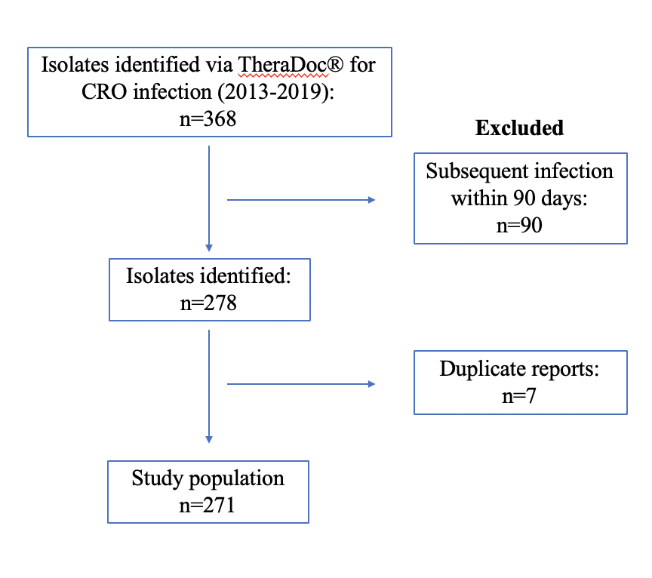
Figure 7. Inclusion/exclusion criteria.
3.1 Ethics Statement

This study was approved by the quality improvement review committee (QIRC) at UPMC Mercy Hospital and did not require IRB approval. Upon approval, this study was identified as Project #2441.

- Results

The complete data set of CRO positive patients at Mercy Hospital included 271 bacterial isolates consisting of 188 individuals between 2013-2019. From a demographic perspective, CRO infections by sex, age, and race were investigated in order to understand the differences in the study population. It was determined that men accounted for 59.0% of CRO infections at this tertiary care center while women only accounted for 41.0% (Figure 8). Upon collecting information on age at the time of infection it was concluded that the average of age of infection was 58 years old with a minimum of 17 years old and a maximum of 92 years old. Furthermore, the two age ranges of 55-64 and 65-74 were noticed to have the highest rates of infection (Figure 9). Demographic data regarding race showed that approximately 81.4% of all cases were seen in Whites while only 17.6% of cases were seen in African Americans. These data compare to 2017 Allegheny county census data in that 48.6% of population is male 41.2% is above 45 years old, while 80.1% is white and 3.4% is African American.

Figure 8. CRO infections by sex; 2013-2019.

Figure 9. CRO infections by age; 2013-2019.

Figure 10. CRO infections by race; 2013-2019.
Microbiological results provided by TheraDoc® and the antibiogram at UPMC Mercy Hospital showed approximately 95.9% of isolates were considered to be resistant to at least one carbapenem while only 4.1% were intermediate (Figure 11). Furthermore, when assessing results for CRO trends between the specified time of the study we noticed that rates have declined overall. In 2013 the most prevalent CRO seen at this center was Acinetobacter sp. (n=26) and is still the most prevalent in the current year (n=17). While a decrease among all CROs was noticed between 2013-2014, a sudden increase was seen in 2015 among each organism except Pseudomonas sp. At the conclusion of data collection only Acinetobacter sp. were noticed to be prevalent in 2019 (Figure 12).

Figure 11. Microbiological results of CRO infections; 2013-2019.

Figure 12. CRO isolate trends; 2013-2019.

Throughout the timeframe of the study Acinetobacter sp. accounted for approximately 50% of infections followed by Klebsiella sp. at 32.5%. This equated to 138 cases and 88 cases for the these two CROs. Infections due to Enterobacter sp., E. coli, and Pseudomonas sp. accounted for 27 cases, 7 cases, and 11 cases respectively as well (Figure 13). Comparatively, a study conducted at UPMC Presbyterian showed that Pseudomonas sp. was the most prevalent infection see among patients followed by Enterobacter sp. and Klebsiella sp. Moreover, this study showed a sudden increase among CRO infections in 2015 as well. In terms of percentages Pseudomonas sp. accounted for approximately 60% of infections while Klebsiella accounted for 20%.

Figure 13. CRO infections; 2013-2019.

Upon investigating hospital location as a potential risk factor for CRO infections five locations were of interest; ICU, inpatient units, outpatient units, the emergency department, and radiology/operating room. The majority of cases between 2013-2019 were seen in ICU (n=93) and inpatient units (n=102) accounting for 72.0% of all cases; however this population may have more attributable risk factors for infection. The emergency department (n=44), outpatient settings (n=19), and radiology/operating rooms (n=7) accounted for 16.2%, 7.0%, 2.6% of cases, respectively (Figure 14). Between 2013-2016 the greatest number of cases were seen in ICU settings and inpatient floors with a peak of all cases in 2015. In 2015, an 73.3% increase of CRO infections was seen in ICU settings from the previous year; however, a 26.9% decrease was notice between 2015 and 2016. Thus far in 2019, inpatient settings have accounted for 88.2% if infections (Figure 15). When assessing infection rates by comparing species and hospital location we noticed Acinetobacter sp. was the most prevalent species in all locations. Additionally, between 2013-2019 ICU settings consisted of predominantly Acinetobacter and Klebsiella infections (Figure 16). Overall, rates of CRO infections have declined among all hospital locations.

Figure 14. CRO infections by hospital location; 2013-2019.

Figure 15. Annual CRO infections by hospital location; 2013-2019.

Figure 16. CRO species by hospital location; 2013-2019.

Data pertaining to infection rates among various body locations were also collected for this review. Urinary infections accounted for approximately 35.1% while respiratory-type infections accounted for 23.2% of all infections. Contrary to hypothesized rates, bloodstream infections accounted for only 7.0% of all infections; the lowest percentage overall. Wound infections accounted for 12.9% (n=40) while the remaining infection types accounted for 21.8%, of which more than half were abscess drainage infections (Figure 17). When examined on an annual basis, urinary infections were typically the most prevalent type over the course of the study. Bloodstream infection rates increased between 2013-2016, but have recently been on a downward trend with no cases reported in 2019. In 2015, the highest proportion of infections were urinary-type, accounting for 49.2%. From 2013-2015 urinary infections increased by 60% but decreased by 93.75% between 2015-2019. Overall, all types of infections have decreased between the beginning and end of this study; potentially attributable to antimicrobial stewardship (Figure 18).

Figure 17. CRO infections by body location; 2013-2019.

Figure 18. Annual CRO infections by body location; 2013-2019.

After comparing CRO infections by type of bacteria and body location we concluded that among bloodstream infections, Acinetobacter sp. and Klebsiella sp. are relatively similar in prevalence. With regard to urinary infections, Klebsiella sp. is the most prevalent while Acinetobacter is the most common among respiratory infections (Figure 19). In terms of surveillance, recurrent infections are of great importance for CRO positive patients. In this study 26 infections of were reoccurrences of the same or a different bacterium. Upon data collection we noticed that 52.8% and 42.3% of recurrent infections were of the Acinetobacter or Klebsiella species, respectively. Furthermore, approximately 42.30% of Acinetobacter and 30.80% Klebsiella infections were due to a repeat infection; however, 11.5% of both Acinetobacter and Klebsiella infections were due to a different bacterium, typically Acinetobacter sp. (Figure 20).

Figure 19. CRO infections by species and body location; 2013-2019.

Figure 20. Recurrent CRO infection rates; 2013-2019.

- Conclusion

The incidence and prevalence rates of CRO infections are on the rise in the United States as well as the rest of the globe. Over the last 20 years a drastic increase in cases were seen in the United States with the most cases being seen between 2010-2016. In Pittsburgh, PA this increase was also seen with the most cases occurring in 2015. Due to these alarming rates and the discovery of multiple mechanisms of resistance, a gap in the literature regarding treatment strategies, and a lack of prevention and control measures, multiple organizations such as the CDC, WHO, and local health care systems such as UPMC have begun researching CROs.
In our study conducted at UPMC Mercy Hospital we set out to collect data on patients with positive CRO infections in order to understand the prevalence of this urgent threat at a tertiary care facility. In order to conduct this study five bacterial organisms were included due to their ability to be carbapenem resistant. Results showed that among Acinetobacter sp., Enterobacter sp., E. coli, Klebsiella sp., and Pseudomonas sp. the most common over the span of six years was Acinetobacter sp. followed by Klebsiella. In addition, a trend was noticed that while CRO infections increased from 2013-2015, with 2015 being the peak, the number of cases has been decreasing steadily since. With 17 cases in the current year, it is likely that 2019 will have the lowest number of infections at UPMC Mercy in the last decade.
Additionally, our study sought to investigate where and of what type CRO infections occur. Upon collecting data, we noticed that inpatient and ICU floors had the highest rates overall, but also noticed these rates have decreased significantly across all hospital locations over the last six years. Furthermore, we noticed that infections in the urinary tract were the most common overall but have also decreased. Lastly, our study included component in which we investigated recurrent cases among individuals with CRO. Results showed that Acinetobacter sp. caused the most recurrent infections followed by Klebsiella and Pseudomonas. These results also showed that Acinetobacter seems to cause more recurrent infections of a different CRO than any other CRO included in the study.
Limitations of this review and study include a gap in the literature regarding treatment consensus, a lack of high definition surveillance, as well as a relatively small sample size with no census data to provide proportions, loss to follow-up, inconsistent microbiological testing, inaccuracies in hospital location identification, and the lack of surveillance of CRO overall. This study consisted of 188 patients and 271 bacterial isolates at UPMC Mercy Hospital. Due to a relatively small sample size the effect of the results may have a lower impact on the overall issue of carbapenem resistance. Additionally, a small sample size can be attributed to a rarity of infection among patients at this healthcare center. Due to the vast number of healthcare centers in the greater Pittsburgh area, patients may be receiving care at other hospitals. This may be due to socioeconomic status (SES) related issues such as access and transportation. A major limitation of this epidemiological study was noticed among the microbiological results provided by TheraDoc®. Four carbapenems were assessed for resistance, however, not all isolates were tested for resistance to each carbapenem. This may skew the data and allow for an inaccurate result to be presented regarding the overall resistance to different carbapenems.
Additionally, a limitation that was noticed throughout this study was the concept of inaccurate hospital location identification. Patient location was assessed in order to determine the most frequent location where carbapenem resistant organisms appeared. Upon investigating this concept, it was noticed that not all patients received a specific location at the time of specimen collection. This flaw in the data could depict an inaccurate representation among the most common hospital locations where a CRO infection may be seen. Lastly, CRO surveillance is poorly surveyed on a local, regional, national, and international scale. Due to the lack of information provided on CRO statistics and surveillance the overall threat of resistance is not fully depicted form an epidemiological standpoint.
Future directions surrounding CRO at UPMC Mercy Hospital should include the continuation of surveillance regarding resistance to carbapenems. Overall, results showed that Acinetobacter sp. is the most common CRO seen at UPMC Mercy Hospital. Due to this finding, further research into the pathogenesis of this species is pertinent in understanding overall resistance. Due to the vast number of risk factors found in the literature for a CRO infection, a comparative analysis to investigate if ICU or inpatient admission increases the risk of infection should be completed at this tertiary healthcare facility. Moreover, research via case control studies on outcomes at the time of admission and diagnosis should be investigated while assessing various patient characteristics such as age, race, and sex. Preventative strategies are of upmost importance when discussing the treatment of a CRO infection as well. Investigation into current preventative strategies utilized at UPMC Mercy Hospital needs to be completed in order to determine the least and most effective preventative measures. The least effective strategies should then be investigated further in order to understand mechanisms that are causing these measures to not work as efficiently as others. Lastly, a comparative analysis across all UPMC hospitals should be conducted in order to determine the most prevalent CROs, types of infections, and hospital locations at each.
From a societal perspective, more research needs to be done on various forms of treatment for patients with a CRO infection as well as improved surveillance techniques and improved prevention and control measures. As it stands, the use of high definition surveillance is not used for this issue. This technique will allow for clearer understanding of the impact and overall burden of disease surround CRO infections in hospitals, communities, and even across the united states and the globe. With respect to treatment options there needs to be a consensus on the treatment of CRO infections. This will allow for improved outcomes, decreased LOS, and improved quality of life.
In conclusion, CRO infections pose an urgent threat to society in both a community and hospital setting. With the increase in prevalence the need for novel antibiotics is of upmost importance for the future. Additionally, the need and continuation of antimicrobial stewardship programs is pertinent along with investigation into various aspects of research regarding CRO infections. Over the last 50 years antibiotic resistance has become much more prevalent in hospital settings due to behavioral and biological factors. These risk factors have caused countless deaths, impacted economic growth, and altered many patients lives. This essay sought to elucidate various directions in which research must go in order to not only decrease prevalence of disease, but also improve the overall quality of life. Thus, these findings carry immense public health significance and a foundation for future perspectives.

Bibliography

1. Centers for Disease Control and Prevention. Biggest threats 2018; Available from: https://www.cdc.gov/drugresistance/biggest_threats.html.
2. Centers for Disease Control and Prevention. About antimicrobial resistance. 2018; Available from: https://www.cdc.gov/drugresistance/about.html.
3. World Health Organization. Antimicrobial resistance. 2018; Available from: https://www.who.int/en/news-room/fact-sheets/detail/antimicrobial-resistance.
4. National Institutes of Health. Causes of antimicrobial resistance. 2011; Available from: https://www.niaid.nih.gov/research/antimicrobial-resistance-causes.
5. Fair, R.J. and Y. Tor, Antibiotics and bacterial resistance in the 21st century. Perspect Medicin Chem, 2014. 6: p. 25-64.
6. Centers for Disease Control and Prevention, Antibiotic resistance threats in the United States. 2013. p. 1-112.
7. Codjoe, F.S. and E.S. Donkor, Carbapenem Resistance: A Review. Med Sci (Basel), 2017. 6(1).
8. Levine, R. Pennsylvania’s response to the threat of resistance. 2016; Available from: https://www.med.upenn.edu/antibiotics/presentations/GSW_PITT_11.18.2016_Levine.pdf.
9. Barlam, T.F., et al., Implementing an Antibiotic Stewardship Program: Guidelines by the Infectious Diseases Society of America and the Society for Healthcare Epidemiology of America. Clin Infect Dis, 2016. 62(10): p. e51-77.
10. Letourneau, A., Beta-lactam antibitocis: Mechanisms of action and resistance and adverse effects. UpToDate, 2019.
11. Papp-Wallace, K.M., et al., Carbapenems: past, present, and future. Antimicrob Agents Chemother, 2011. 55(11): p. 4943-60.
12. Meletis, G., Carbapenem resistance: overview of the problem and future perspectives. Ther Adv Infect Dis, 2016. 3(1): p. 15-21.
13. Walther-Rasmussen, J. and N. Hoiby, Class A carbapenemases. J Antimicrob Chemother, 2007. 60(3): p. 470-82.
14. Queenan, A., Bush, K., Carbapenems: The versatile B-lactamases. American Society for Microbiology 2007. 20(3): p. 440-458.
15. Centers for Disease Control and Prevention, Healthcare-associated infections: Tracking CRE. 2019.
16. Munita, J.M. and C.A. Arias, Mechanisms of Antibiotic Resistance. Microbiol Spectr, 2016. 4(2).
17. Centers for Disease Control and Prevention. Biggest threats and data. 2018; Available from: https://www.cdc.gov/drugresistance/biggest_threats.html.
18. Centers for Disease Control and Prevention, Healthcare-associated infections: clinicians. 2018.
19. Centers for Disease Control and Prevention. Carbapenem-resistant Enterobacteriaceae in Healthcare Settings. 2015; Available from: https://www.cdc.gov/hai/organisms/cre/.
20. Centers for Disease Control and Prevention. Pseudomonas aeruginosa in Healthcare Settings. 2013; Available from: https://www.cdc.gov/hai/organisms/pseudomonas.html.
21. Centers for Disease Control and Prevention. Klebsiella pneumoniae in Healthcare Settings. 2010; Available from: https://www.cdc.gov/hai/organisms/klebsiella/klebsiella.html.
22. Centers for Disease Control and Prevention. Acinetobacter in Healthcare Settings. 2010; Available from: https://www.cdc.gov/hai/organisms/acinetobacter.html.
23. Iovleva, A. and Y. Doi, Carbapenem-Resistant Enterobacteriaceae. Clin Lab Med, 2017. 37(2): p. 303-315.
24. Chopra, T., et al., Epidemiology of Carbapenem-Resistant Enterobacteriaceae at a Long-term Acute Care Hospital. Open Forum Infect Dis, 2018. 5(10): p. ofy224.
25. Gohil, S.K., et al., Emergence of carbapenem-resistant Enterobacteriaceae in Orange County, California, and support for early regional strategies to limit spread. Am J Infect Control, 2017. 45(11): p. 1177-1182.
26. Lee, G.C., K.A. Lawson, and D.S. Burgess, Clinical epidemiology of carbapenem-resistant enterobacteriaceae in community hospitals: a case-case-control study. Ann Pharmacother, 2013. 47(9): p. 1115-21.
27. Centers for Disease Control and Prevention, Carbapenem-resistant pseudomonas aeruginosa at US emerging infections program sites, 2015. 2019.
28. Perez, F., et al., Carbapenem-resistant Acinetobacter baumannii and Klebsiella pneumoniae across a hospital system: impact of post-acute care facilities on dissemination. J Antimicrob Chemother, 2010. 65(8): p. 1807-18.
29. Centers for Disease Control and Prevention, General information about CRE. 2015.
30. Quale, J., Spelman, D., Overview of carbapenemase-producing gram-negative bacilli, in UpToDate, A. Bloom, Editor. 2019.
31. Nicolas-Chanoine, M.H., et al., Risk factors for carbapenem-resistant Enterobacteriaceae infections: a French case-control-control study. Eur J Clin Microbiol Infect Dis, 2019. 38(2): p. 383-393.
32. Richter, S.E., et al., Risk Factors for Development of Carbapenem Resistance Among Gram-Negative Rods. Open Forum Infect Dis, 2019. 6(3): p. ofz027.
33. Al-Zahrani, I.A., Routine detection of carbapenem-resistant gram-negative bacilli in clinical laboratories. A review of current challenge. Saudi Med J, 2018. 39(9): p. 861-872.
34. Potter, R.F., A.W. D'Souza, and G. Dantas, The rapid spread of carbapenem-resistant Enterobacteriaceae. Drug Resist Updat, 2016. 29: p. 30-46.
35. McMullen, A.R., et al., Evaluation of Genotypic and Phenotypic Methods to Detect Carbapenemase Production in Gram-Negative Bacilli. Clin Chem, 2017. 63(3): p. 723-730.
36. Fritzenwanker, M., et al., Treatment Options for Carbapenem- Resistant Gram-Negative Infections. Dtsch Arztebl Int, 2018. 115(20-21): p. 345-352.
37. Cristina, M.L., et al., Epidemiology, management, and outcome of carbapenem-resistant Klebsiella pneumoniae bloodstream infections in hospitals within the same endemic metropolitan area. J Infect Public Health, 2018. 11(2): p. 171-177.
38. Satlin, M.J., et al., Multicenter Clinical and Molecular Epidemiological Analysis of Bacteremia Due to Carbapenem-Resistant Enterobacteriaceae (CRE) in the CRE Epicenter of the United States. Antimicrob Agents Chemother, 2017. 61(4).
39. Zusman, O., et al., Polymyxin monotherapy or in combination against carbapenem-resistant bacteria: systematic review and meta-analysis. J Antimicrob Chemother, 2017. 72(1): p. 29-39.
40. Viehman, J.A., M.H. Nguyen, and Y. Doi, Treatment options for carbapenem-resistant and extensively drug-resistant Acinetobacter baumannii infections. Drugs, 2014. 74(12): p. 1315-33.
41. Morrill, H.J., et al., Treatment Options for Carbapenem-Resistant Enterobacteriaceae Infections. Open Forum Infect Dis, 2015. 2(2): p. ofv050.
42. Neuner, E.A., et al., Treatment and outcomes in carbapenem-resistant Klebsiella pneumoniae bloodstream infections. Diagn Microbiol Infect Dis, 2011. 69(4): p. 357-62.
43. World Health Organization, Guidelines for the prevention and control of carbapenem-resistant Enterobacteriaceae, Acinetobacter baumannii and Pseudomonas aeruginosa in health care facilities. 2017.
44. World Health Organization. Antibiotic resistance. 2018; Available from: https://www.who.int/news-room/fact-sheets/detail/antibiotic-resistance.
45. Bartsch, S.M., et al., Potential economic burden of carbapenem-resistant Enterobacteriaceae (CRE) in the United States. Clin Microbiol Infect, 2017. 23(1): p. 48 e9-48 e16.
46. Nelson, R.E., et al., Costs and Mortality Associated With Multidrug-Resistant Healthcare-Associated Acinetobacter Infections. Infect Control Hosp Epidemiol, 2016. 37(10): p. 1212-8.
47. Vargas-Alzate, C.A., et al., High excess costs of infections caused by carbapenem-resistant Gram-negative bacilli in an endemic region. Int J Antimicrob Agents, 2018. 51(4): p. 601-607.

