Title Page
Social Media’s Effect on Vaccination Rates

by

Rachel Jaffe

BS, Rehabilitation Science, University of Pittsburgh, 2019

Submitted to the Graduate Faculty of the

Department of Infectious Diseases and Microbiology

Graduate School of Public Health in partial fulfillment

of the requirements for the degree of

Master of Public Health

University of Pittsburgh

2019

Committee Page
UNIVERSITY OF PITTSBURGH

Graduate School of Public Health

This essay is submitted

by

Rachel Jaffe

on

December 6, 2019

and approved by

Essay Advisor:
Jeremy J. Martinson, DPhil
Assistant Professor
Infectious Diseases and Microbiology
Graduate School of Public Health
University of Pittsburgh

Essay Reader:
Martha Ann Terry, PhD
Associate Professor
Behavioral and Community Health Sciences
Graduate School of Public Health
University of Pittsburgh

Copyright © by Rachel Jaffe

2019

Table of Contents
1.0 Introduction 1
2.0 Background 3
3.0 Methods 7
4.0 Results 8
4.1 Twitter and Vaccination 8
4.2 Facebook and Vaccinations 10
4.3 Social Media Positively Impacting Vaccination Rates 12
5.0 Discussion 15
6.0 Conclusion 17
6.1 Public Health Relevance 18
Appendix A: Facebook Policies on Misinformation 19
Appendix B: Twitter Statement on Misinformation and Reliable Health Information 22
Appendix C: YouTube Demonetized Anti-Vax Channels 24
Bibliography 25

List of Figures
Figure 1: Donald Trump’s tweet 5
Figure 2: Timeline of social media platforms 6
Figure 3: Flowchart of searches 7
Figure 4: False information on Facebook page RAGE 11
Figure 5: Example of HPV post on Instagram 13
Figure 6: Examples of Facebook trying to help combat the spread of false information 21
Figure 7: Twitter makes vaccines.gov top search result 23
Figure 8: Screenshots of the same YouTube video - 2/14/19 vs. 2/22/19 24

Jeremy J. Martinson, DPhil

Social Media’s Effect on Vaccination Rates
Rachel Jaffe, MPH
University of Pittsburgh, 2019
Abstract
Background: Vaccines have contributed significantly to public health by protecting against deadly diseases. However, vaccination coverage for many preventable diseases is declining. A major contributor to the decline in vaccination coverage is people who oppose vaccinations, also known as anti-vaxxers. Many anti-vaxxers use social media to spread false information about vaccines. This literature review focuses on how vaccination coverage has been impacted by social media.
Methods: A PubMed search was conducted using the search term “social media impact on vaccination rates.” All references for articles found were scanned for relevance and were followed up. Articles excluded were those published before 2004 and not written in English. Using these criteria, 18 articles qualified for this literature review.
Results: A debunked article published in 1998 impacted parents’ decisions to vaccinate their children by claiming that there is a causal link between vaccines and autism. However, social media spreads more than the falsehood that the MMR vaccine causes autism. Social media directly impacts vaccination rates for not only MMR but for other vaccines. Twitter can estimate vaccine coverage by analyzing tweets regarding vaccination. Additionally, Facebook groups against vaccines are very common and help spread false information about vaccines. Studies have shown that Instagram and YouTube can have a positive effect on vaccination rates.
Conclusion: Understanding the public health significance of how social media spreads false information about vaccinations is extremely important. Public health officials and social media pages can work together to combat the spread of false information and improve vaccination rates.

Introduction
In 2019, The World Health Organization (WHO) listed vaccine hesitancy as a top ten threat to global health. Vaccine hesitancy is defined as the reluctance or refusal to vaccinate despite the availability of vaccines. (“Top Ten Threats to Global Health”, 2019). Vaccines have been proven to be safe for many years, yet vaccination rates are declining. WHO estimates the measles, mumps and rubella (MMR) vaccine has saved more than 21.1 million lives since 2000 (“Measles”, 2019). However, rates for MMR vaccinations and many others have been declining. In fact, 42,000 of the 4.1 million children born each year in the United States will die from a vaccine preventable disease (Regal, 2019).
There are many reasons why parents choose not to vaccinate their children, but one reason is due to false information available on social media. Social media allows the rapid dissemination of information. Anyone can engage in spreading information, with no verification/credibility required. As of 2019, there are 3.2 billion social media users worldwide (Moshin, 2019). In the United states, eight in 10 internet users search for health information online (Ventola, 2014). Of these people, 74 percent specifically use social media to access health information (Ventola, 2014). As more people start to rely on social media to find out information about their health, it is critical to stop the spread of false information. This literature review explores the impact of social media on vaccination rates against preventable diseases.
Chapter 2 gives background information on vaccines and the history of social media. Chapter 3 describes the methods used in this literature review. Chapter 4 highlights the results of the literature review, focusing on the platforms Facebook, Twitter, YouTube and Instagram. Chapter 5 includes a discussion of the material and recommendations. Chapter 6 concludes the paper, summarizing key results.

Background
Edward Jenner revolutionized the world in 1796 when he created the first vaccine. This vaccine was against the virus smallpox, which was the leading cause of death in the 18th century (Damiani, 2018). Jenner noticed that a growing number of milkmaids who had cowpox, a very mild disease, did not succumb to smallpox. Intrigued by this observation, Jenner decided to see if something in cowpox prevented people from contracting smallpox. To test this idea, Jenner placed cowpox fluid from a milkmaid’s infection into a cut on a young boy’s arm. Several weeks later, Jenner exposed the boy to smallpox, and the boy did not contract the virus (Damiani, 2018). This remarkable result paved the way for science to develop other types of vaccinations.
Jenner’s vaccine is considered a heterologous vaccine, meaning that a closely related pathogen was used to protect against a more harmful pathogen. Live attenuated vaccines are similar to this, but they use a weakened form of the virus that causes disease ("Vaccine Types", 2019). The benefit of this type of vaccine is that it provides people with a strong and long-lasting immune response. Some other examples of live attenuated vaccines are those against measles, mumps, rubella (MMR), rotavirus and chickenpox ("Vaccine Types", 2019). Another type of vaccine is called an inactivated vaccine. Inactivated vaccines use the killed version of the pathogen. They result in a weaker immune response to pathogens, so people require booster vaccines. Examples of this include vaccinations for influenza, polio (Salk), and rabies ("Vaccine Types", 2019).
With the advance of technology, many other types of vaccines have been developed: subunit, recombinant, polysaccharide, and conjugate. These vaccines are genetically engineered to target key parts of the pathogen. Examples of these include vaccinations for human papillomavirus (HPV), pneumococcal disease, and whooping cough ("Vaccine Types", 2019). Scientists are also trying to create vaccines using DNA and recombinant vector vaccines, although few have been approved yet ("Vaccine Types", 2019).
There are still many diseases that we do not have vaccines against such as malaria, HIV/AIDS, cancer. One reason we do not have vaccines against these diseases could be that even safe and effective vaccines are not being used to their full capacity today. In order to eradicate a disease from a population, 95% of the people need to be vaccinated (Meissner, 2015). This concept is called herd immunity where the “herd” protects people who cannot (due to being immunocompromised or other reasons) receive the vaccine (Meissner, 2015). Herd immunity is not established for most vaccine-preventable diseases in the world ("Childhood Vaccination Coverage Trend Report", 2017).
There are many reasons why herd immunity is not established and why vaccination coverage is declining. Known reasons include religious beliefs, lack of access to vaccines, and cost of vaccines. Another contributing reason is fear. Parents fear that their child is going to experience negative side effects from the vaccine (McKee, 2016). The negative side effect that parents fear most is autism.
In 1998, Dr. Wakefield posted a study in The Lancet claiming that there was a causal link between the MMR vaccine and autism (Rao, 2011). Nearly every radio station, tv station, and newspaper shared the findings (Rao, 2011). This dissemination of information led many parents to decide not to vaccinate their children. In 2010, after multiple other scientific articles were published disproving Wakefield’s allegations, The Lancet retracted the article and Dr. Wakefield was barred from practicing medicine in the UK due to his fraudulent claims (Rao, 2011).
Although the paper was debunked, people today still believe that vaccines cause autism, including President Trump. As shown in Figure 1, Donald Trump tweeted, “Healthy young child goes to doctor, gets pumped with massive shot of many vaccines, doesn’t feel good and changes- AUTISM.” This tweet received 19,660 likes and 16,693 retweets, showing just how far this false narrative spread. This is just one example of how people use social media to disseminate false information regarding vaccines.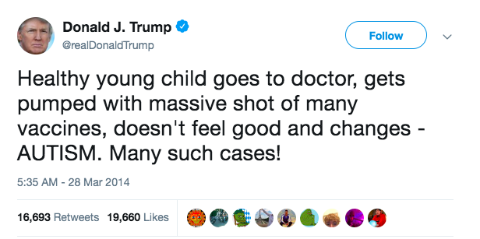

Figure 1: Donald Trump’s tweet

To see how Wakefield’s paper impacted parents’ perceptions on vaccination, Fredrickson et al. (2004) set out to understand why parents were refusing vaccinations for their children. In order to better understand their thoughts and perceptions, 32 focus groups of parents and providers from six different cities were conducted in 1998. Fifty-two percent of respondents said that fear of side effects disseminated through the media was why parents chose not to vaccinate their children. Many parents feared that their child would get autism if they vaccinated them. Most people cited Wakefield’s study, which was published the same year that this study was conducted (Fredrickson, et al. 2004).
Much of the fear that parents have around vaccinating their child can be explained by false information about vaccines appearing in social media. The first social media site created, Six Degrees, was launched in 1996 (McFadden, 2018). This social-networking site allowed users to create profiles and add friends (McFadden, 2018). In 2004, Facebook was created and now is the most widely used social media platform. In fact, 75 percent of U.S adults say they check Facebook at least once a day (Perrin, 2019). In 2005, YouTube was launched and now has over 1.8 billion users every month who watch videos on the site (Perrin, 2019). The following year, Twitter was launched. This platform allows anyone to send news updates in live time. People on Twitter can use hashtags to highlight to others what they are talking about. According to Pew Research, the majority of Twitter users (66 percent) are men.
The two newest social media platforms are Instagram and Snapchat, which were launched in 2010 and 2011, respectively. Instagram allows users to share pictures of experiences they have that will remain on the person’s profile indefinitely (unless they choose to delete it). Snapchat on the other hand, allows people to share live photos for 10 seconds, and then the picture will disappear. Instagram and Snapchat users are predominately women aged 18-24 (Perrin, 2019). Figure 2 shows the history of social media.
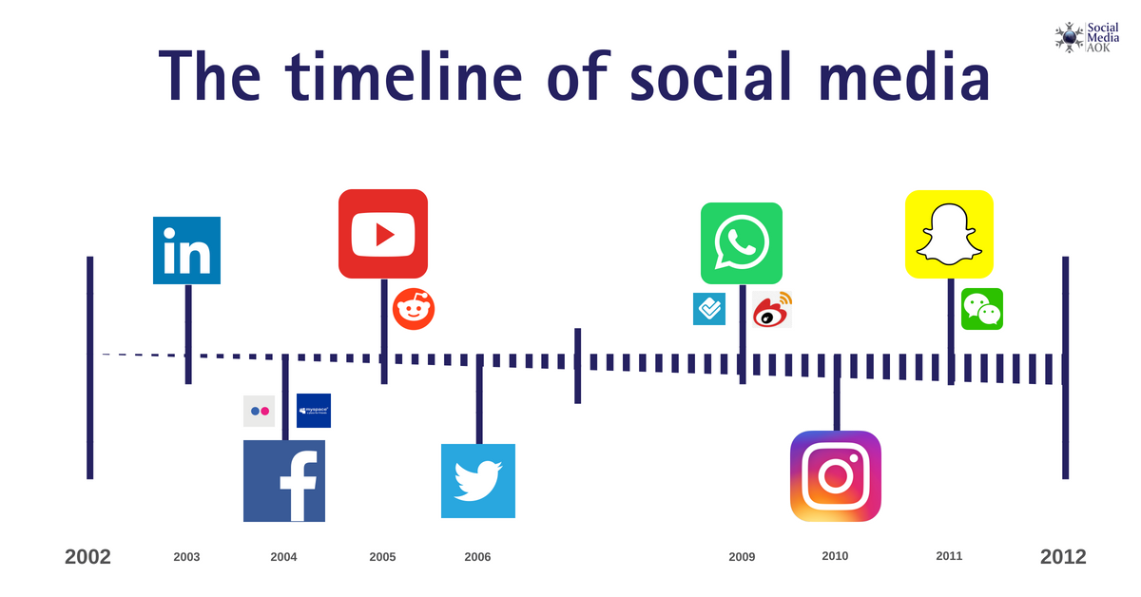

Figure 2: Timeline of social media platforms

Methods
Articles selected were found via a PubMed search. Key terms included “vaccine hesitancy” and “social media impact on vaccination rates.” Articles published before 2004 were excluded. Additionally, articles written in any language other than English were excluded. All references for articles found were scanned for relevance and were followed up, as shown in Figure 3.

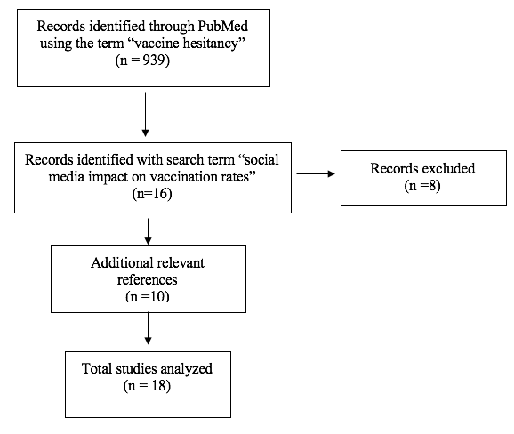

Figure 3: Flowchart of searches

Results

Twitter and Vaccination
In 2015, researchers set out to find out how information about HPV was being disseminated through Twitter. Chakraborty et al. (2017) analyzed tweets that included search terms such as HPV, Gardasil, and cervical cancer from February 7-13, 2015 and collected 20,408 tweets. Of these tweets, 2,000 were randomly selected to code. The results showed that the four main themes were about current events related to HPV vaccination, discussion of possible associations between receiving the vaccine and sexual behavior, safety of the vaccine, and effectiveness of the vaccine. Additionally, 5 percent of the tweets were coded as a negative sentiment, such as discouraging Gardasil vaccine. The most common terms associated with these tweets were “beware,” “destroys lives,” and “mystery illness” (Chakraborty et al. 2017). However, roughly the same number of tweets, 5.2%, were coded as positive. The common terms associated with these were “works well,” “recommend,” “vaccines work,” and “vaccinate your kids” (Chakraborty et al. 2017). Given that there were roughly the same number of pro-vaccination and anti-vaccination tweets, people were likely exposed to both kinds of comments, which can be confusing to parents.
Another study conducted by Dunn et al. (2017) wanted to understand the media’s role in HPV vaccine coverage. To do this, they looked at tweets from October 2013 to October 2015 that contained information about HPV. They then found the location of the users who tweeted them and compared them to state and county data on HPV vaccination coverage. Dunn et al. (2017) obtained 258,418 tweets related to the HPV vaccine. The total number of public Twitter users that may have been exposed to one or more of these tweets was 109.2 million (Dunn et al. 2017). They found that tweet exposures explained 68% of the variance in one dose 2015 HPV vaccine coverage in females, while socioeconomic factors only explained 42% (Dunn et al. 2017). This shows just how large an impact tweets/social media has on vaccination coverage.
To understand how tweets about vaccinations affect vaccination coverage, researchers looked at tweets from August 2009-January 2010. Salathé et al. (2011) found a strong correlation between the sentiments in the tweets and the CDC estimated vaccination rates by region. To take this one step further, they looked at how the negative sentiments would affect vaccination coverage. Using a simulation, they found that negative sentiments led to more unvaccinated people and therefore more disease outbreaks (Salathé et al. 2011). Also, they found that users who are pro-vaccination rarely communicate with those who are anti-vaccination. This illustrates how negative sentiments on Twitter directly impact vaccination coverage and how there is a need for better communication from pro-vaccinators to anti-vaxxers so that parents who are vaccine hesitant see more positive information.
Another study analyzed tweets from February 1- March 9, 2015 after the large measles outbreak in Disneyland in 2015. Radzikowski et al. (2016) found that news organizations had more tweets and retweets related to vaccinations than health organizations. Additionally, they found that residents of Vermont and Oregon contributed most to the tweets obtained. This is interesting because Vermont and Oregon had the most non-medical exemptions to vaccinations than any other states (Radzikowski et al. 2016).
Another study looked specifically at temporal trends of pro and anti-vaccine discourse on Twitter from 2010 to 2019. This period coincides with the publications of the book Vaccine Whistleblower and the Vaxxed documentary. Vaccine Whistleblower is a book that claims that the Centers for Disease Control and Prevention (CDC) covered up data about casual links between the MMR vaccine and autism. Vaxxed is a documentary produced by Dr. Wakefield that claims that there is a casual link between the MMR vaccine and autism (Gunaratne et al. 2019). They found that the proportion of anti-vaccine users doubled (8.1% to 16%) from 2015 to 2018. It is also noted that only 0.2% of all users studied responded to people with opposite viewpoints (Gunaratne et al. 2019).
It is also important to understand how non-humans, such as twitter bots and Russian trolls, promote online health content. Broniatowski et al. (2018) looked at tweets from July 2014 to September 2017 from average users, bots, and trolls. They found that bots and Russian trolls tweeted about vaccination at higher rates. These bots and trolls can be set to spread false information about vaccines, so it is important to combat their messages (Broniatowski et al. 2018). See appendix B for more information on what Twitter is doing to stop bots.

Facebook and Vaccinations
On February 4, 2019. the Western Cape Department of Health in South Africa released its plan to implement a school-based vaccination campaign against HPV on its Facebook page. Wiyeh et al. (2019) analyzed all 157 Facebook comments on the post. They found that 33 percent of the 157 total comments were from people who were vaccine hesitant. Many themes were obtained from the post, with reproductive health concerns emerging as the major theme. Other themes of the vaccine hesitant comments included low perception of risk of contracting HPV, consent, fear that girls are being used for research, vaccine effectiveness, use of the school setting, risk-benefits calculations, and constraints on vaccine availability (Wiyeh et al. 2019). Understanding these factors can help public health officials better address the issue of vaccine hesitancy through social media.
To understand the role of anti-vaxxer Facebook groups, researchers looked at six of the most prominent anti-vaxxers groups. These groups included Fans of the AVN, Dr. Tenpenny on Vaccines, Great Mothers (and Others) Questioning Vaccines, No Vaccines Australia, Age of Autism, and Rage Against the Vaccines. An example of a post on Rage Against Vaccines page can be found in Figure 4. At the time of the study, these pages had a combined total of 231,491 likes (Smith et al. 2017). The major theme on these pages was distrust of government. Most of the discussion centered around moral outrage and structural oppression. The researchers also noted that any comment that was posted that was in favor of vaccines was filtered out/deleted (Smith et al. 2017). This may be a useful tool that public health officials could use stop the spread of false information on social media.
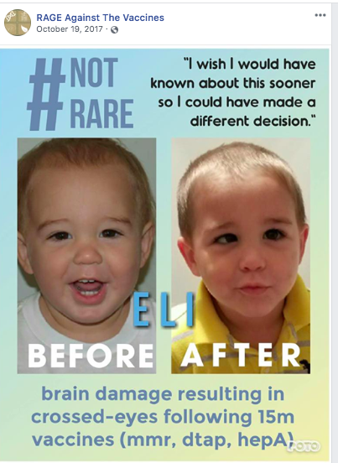

Figure 4: False information on Facebook page RAGE

In 2019, researchers at the University of Pittsburgh found that social media was spreading more than just the falsehood that vaccinations cause autism (Hoffman et al. 2019). The researchers analyzed Facebook comments about a video that encouraged children to get vaccinated against HPV. The video received thousands of anti-vaccination comments and the researchers randomly selected a group of 197 commenters to analyze. They found that the majority of the commenters were mothers and were Donald Trump supporters. Additionally, they found that the anti-vaccination movement was not all about autism but rather four key themes. These themes were trust, alternatives, safety, and conspiracy (Hoffman et al. 2019). Items that fell under conspiracy included comments about the government cover-ups, 9/11 conspiracy, and that pesticides caused polio virus. The researchers hope that identifying these core areas can help pediatricians and public health officials to better address parent’s concerns about vaccines (Hoffman et al. 2019).

Social Media Positively Impacting Vaccination Rates
Researchers conducted a content analysis of posts on Instagram related to HPV vaccine. Of the 150 posts analyzed, 28 percent were pro-vaccination while 7 percent were anti-vaccination (Basch et al. 2019). Posts with the most likes contained the words “cancer” or “HPV screening” such as Figure 5. Knowing which posts get the most likes could be a good way for public health officials to create content that is meaningful for the public. Although there were four times more pro-vaccination posts than anti-vaccination posts, it is important to maintain this for years to come and make sure that pro-vaccination posts greatly outnumber anti-vaccination posts (Basch et al. 2019).

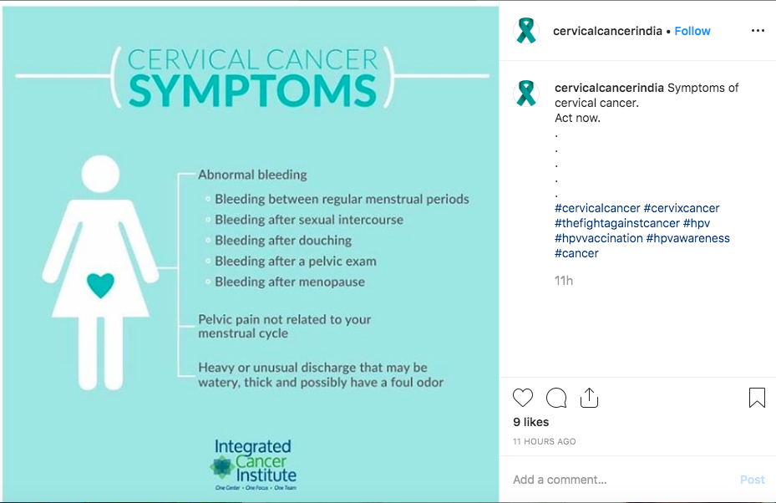

Figure 5: Example of HPV post on Instagram

An example of how people can have a positive impact on vaccination rates through social media is from the case study of Roberto Burioni, a medical microbiologist and virologist. In 2015, he started a social media campaign to counter anti-vaxxers on Facebook. Researchers looked at the “Burioni effect” by seeing how many contacts popular vaccine groups had in 2015 compare to 2018 (Signorelli et al. 2019). The study showed that after 2015, there were drastically more pro-vaccine messages on Facebook. In 2015, Eugenio Serravalle, a prominent anti-vaxxer, led the most popular Facebook page with 12,000 contacts, while Burioni had no contacts (Signorelli et al. 2019). However, in 2018, Burioni had the greatest number of contacts, 321,643, while Eugieno Serravalle only had 27,643 contacts (Signorelli et al. 2019). This shows how active social media campaigns can help combat the spread of false information.
Twitter can also be used as a positive way to spread information about vaccination. In 2015, an unvaccinated child in Spain died from diphtheria. Porat et al. (2019) collected 722,974 tweets from May 1- July 15, 2015. They then analyzed 194 of the most popular tweets (retweeted 100 or more times). The results showed that 58 percent of the tweets were pro-vaccination while none were anti-vaccination. In fact, most of the tweets criticized anti-vaxxers and addressed the effectiveness of the vaccine (Porat et al. 2019).
YouTube can also be used as an effective social media platform to share videos that are pro-vaccination. Covolo et al. (2017) looked at 123 videos using the search term “vaccinations.” They found that f50 percent of the videos were pro-vaccination while only 23 percent were anti-vaccination. Although there were more views of pro-vaccination videos, anti-vaccination videos were liked and shared by more viewers (Covolo et al 2017). Although there were more pro-vaccination videos, they are not getting shared as much. It is important to get the word out to others to like these videos and share these videos so that accurate information can be disseminated.

Discussion
Knowing the specific concerns that parents are posting on social media about vaccines is critical for combating vaccine hesitancy. This information can help public health officials target social media campaigns to combat the spread of misinformation.
Additionally, it is crucial for people with opposing viewpoints on vaccines to communicate with each other. Studies have shown that pro-vaccinators do not communicate with anti-vaxxers and this needs to change (Salathé et al. 2011; Gunaratne et al. 2019). Society cannot ignore people who are spreading false information. People need to address the false information with evidence-based responses. Based on some studies, vaccine coverage could increase if pro-vaccination tweets outweighed anti-vaccination tweets (Salathé et al. 2011). Additionally, it should not have to take a tragedy for more people to advocate on social media for vaccinations. There needs to be constant correct information on social media to combat the spread of false information regarding vaccinations.
Facebook groups allow many people to come together who typically share the same viewpoint. Anti-vaccination groups on Facebook represent thousands of people and help to spread false information about people. In fact, Facebook group moderators remove comments of people who have opposing viewpoints. If Facebook allows this, then Facebook should be allowed to remove the group entirely. Facebook should look into more technology that can remove such groups, as these groups are contributing to the spread of false information.
Social media can also help spread positive information about vaccines. Studies on Instagram and YouTube show that positive information about vaccinations is being spread. It is important for other social media platforms to have continuous pro-vaccination messages. People in healthcare should be encouraged to post positive vaccination messages on social media. Since news outlets on social media get a lot of coverage, scientists and public health officials can work together to create more pro-vaccination posts.

Conclusion
Vaccine hesitancy is a global threat. Different types of safe and effective vaccines are available. To highlight one reason why vaccines are being under-utilized, social media is called into question. A literature review of 18 articles was conducted. The results showed that social media greatly impacts vaccination rates, both positively and negatively. Studies conducted on YouTube and Instagram showed how these outlets were being used to spread positive information about vaccines. These positive results can be implemented on other social media platforms to combat the spread of false information.
Social media allows for the spread of unverified information to be seen by millions of people. The spread of false information leaves parents confused and unsure about whether or not to vaccinate their children. Addressing vaccine hesitant parents starts by promoting the facts about vaccinations. It is crucial to combat the spread of false information by having more people promote vaccinations on social media. Society needs more people to be advocates for vaccines all the time, not just when an outbreak or tragedy occurs. Additionally, social media pages should look into censoring/removing false information. Although freedom of speech is an inherent right in the United States, posts should be removed if they go against the well-being of society. Facebook, Twitter, and YouTube have plans to stop the spread of false information (see Appendices A, B, and C). Additionally, Facebook, Twitter, and YouTube have user agreements that state that harmful messages will not be tolerated. However, these social media platforms have not upheld these agreements. They need to do a better job of upholding these agreements by removing users that spread harmful information. These platforms need society's help too. Society should work together on social media to push the message that vaccines are safe in order to increase vaccination coverage and save lives.

Public Health Relevance
In 2019, the World Health Organization listed vaccine hesitancy in the top ten biggest threats to global health. It is crucial to for public health officials to understand why parents are vaccine hesitant. Vaccines prevent diseases and have saved millions of lives by immunizing people against deadly pathogens, yet vaccines are being under-utilized. This literature review looks at one source of information about vaccinations and helps to identify why some parents choose not to vaccinate their children. By understanding how social media affects vaccination rates, public health officials can think of strategies to combat the dissemination of false information through social media.

Appendix A: Facebook Policies on Misinformation
Direct Statement from Facebook on how they will stop the spread of false information (Mosseri, 2017)

Adam Mosseri, VP, News Feed
Apr 7, 2017
“We know people want to see accurate information on Facebook – and so do we.
False news is harmful to our community, it makes the world less informed, and it erodes trust. It's not a new phenomenon, and all of us — tech companies, media companies, newsrooms, teachers — have a responsibility to do our part in addressing it. At Facebook, we're working to fight the spread of false news in three key areas:
- disrupting economic incentives because most false news is financially motivated;
- building new products to curb the spread of false news; and
- helping people make more informed decisions when they encounter false news (see figure 6).
Disrupting Economic Incentives
When it comes to fighting false news, one of the most effective approaches is removing the economic incentives for traffickers of misinformation. We've found that a lot of fake news is financially motivated. These spammers make money by masquerading as legitimate news publishers and posting hoaxes that get people to visit their sites, which are often mostly ads.
Some of the steps we're taking include:
- Better identifying false news through our community and third-party fact-checking organizations so that we can limit its spread, which, in turn, makes it uneconomical (see figure 6 for an example).
- Making it as difficult as possible for people posting false news to buy ads on our platform through strict enforcement of our policies.
- Applying machine learning to assist our response teams in detecting fraud and enforcing our policies against inauthentic spam accounts.
- Updating our detection of fake accounts on Facebook, which makes spamming at scale much harder.
Building New Products
We're building, testing and iterating on new products to identify and limit the spread of false news. We cannot become arbiters of truth ourselves — it's not feasible given our scale, and it's not our role. Instead, we're working on better ways to hear from our community and work with third parties to identify false news and prevent it from spreading on our platform.
Some of the work includes:
- Ranking Improvements: We're always looking to improve News Feed by listening to what the community tells us. We've found opportunities like the fact that if reading an article makes people significantly less likely to share it, that may be a sign that a story has misled people in some way. We're continuing to test this signal and others in News Feed ranking in order to reduce the prevalence of false news content.
- Easier Reporting: We've always relied on our community to determine what is valuable and what is not. We're testing ways to make it easier to report a false news story if you see one on Facebook, which you can do by clicking the upper right hand corner of a post. Stories that are flagged as false by our community then might show up lower in your feed.
- Working with Partners: We believe providing more context can help people decide for themselves what to trust and what to share. We've started a program to work with independent third-party fact-checking organizations. We'll use the reports from our community, along with other signals, to send stories to these organizations. If the fact-checking organizations identify a story as false, it will get flagged as disputed and there will be a link to a corresponding article explaining why. Stories that have been disputed also appear lower in News Feed.
Helping People Make More Informed Decisions
Though we're committed to doing everything we can to reduce the spread of false news to as close to zero as possible, we also need to make sure we take steps to address the problem when people do encounter hoaxes. To that end, we're exploring ways to give people more context about stories so they can make more informed decisions about what to read, trust and share and ways to give people access to more perspectives about the topics that they're reading.
Some of the work we've been focused on includes:
- Facebook Journalism Project: We are committed to collaborating with news organizations to develop products together, providing tools and services for journalists, and helping people get better information so they can make smart choices about what they read. We are convening key experts and organizations already doing important work in this area, such as the Walter Cronkite School of Journalism and Mass Communication at Arizona State University, and have been listening and learning to help decide what new research to conduct and projects to fund. Working with the News Literacy Project, we are producing a series of public service announcements (PSAs) to help inform people on Facebook about this important issue.
- News Integrity Initiative: We've joined a group of over 25 funders and participants — including tech industry leaders, academic institutions, non-profits and third party organizations — to launch the News Integrity Initiative, a global consortium focused on helping people make informed judgments about the news they read and share online. Founding funders of this $14-million fund include Facebook, the Craig Newmark Philanthropic Fund, the Ford Foundation, the Democracy Fund, the John S. and James L. Knight Foundation, the Tow Foundation, AppNexus, Mozilla and Betaworks. The initiative's mission is to advance news literacy, to increase trust in journalism around the world and to better inform the public conversation. The initiative, which is administered by the CUNY Graduate School of Journalism, will fund applied research and projects, and convene meetings with industry experts.
We need to work across industries to help solve this problem: technology companies, media companies, educational organizations and our own community can come together to help curb the spread of misinformation and false news. By focusing on the three key areas outlined above, we hope we will make progress toward limiting the spread of false news — and toward building a more informed community on Facebook.”

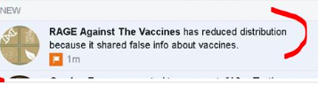

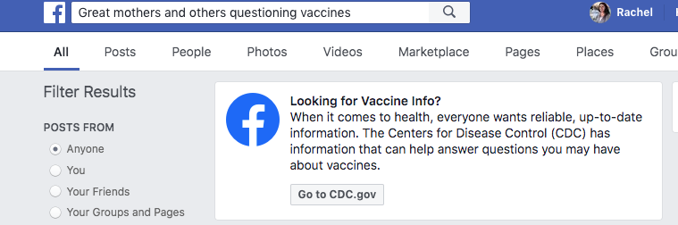

Figure 6: Examples of Facebook trying to help combat the spread of false information

Appendix B: Twitter Statement on Misinformation and Reliable Health Information
Twitter direct statement about misinformation (Crowell, 2017).

Colin Crowell, VP of Public Policy, Gov & Philanthropy at Twitter

“Twitter’s job is to keep people informed about what’s happening in the world. As such, we care deeply about the issue of misinformation and its potentially harmful effect on the civic and political discourse that is core to our mission.
Fake news has become a catchphrase used to describe everything from manufactured news stories, incorrect information and state-supported propaganda, to news some people don't like or points of view with which people disagree.
Twitter’s open and real-time nature is a powerful antidote to the spreading of all types of false information. This is important because we cannot distinguish whether every single Tweet from every person is truthful or not. We, as a company, should not be the arbiter of truth. Journalists, experts and engaged citizens Tweet side-by-side correcting and challenging public discourse in seconds. These vital interactions happen on Twitter every day, and we’re working to ensure we are surfacing the highest quality and most relevant content and context first.
Bots
While bots can be a positive and vital tool, from customer support to public safety, we strictly prohibit the use of bots and other networks of manipulation to undermine the core functionality of our service. We’ve been doubling down on our efforts here, expanding our team and resources, and building new tools and processes. We’ll continue to iterate, learn, and make improvements on a rolling basis to ensure our tech is effective in the face of new challenges.
We’re working hard to detect spammy behaviors at source, such as the mass distribution of Tweets or attempts to manipulate trending topics. We also reduce the visibility of potentially spammy Tweets or accounts while we investigate whether a policy violation has occurred. When we do detect duplicative, or suspicious activity, we suspend accounts. We also frequently take action against applications that abuse the public API to automate activity on Twitter, stopping potentially manipulative bots at the source.
It’s worth noting that in order to respond to this challenge efficiently and to ensure people cannot circumvent these safeguards, we’re unable to share the details of these internal signals in our public API. While this means research conducted by third parties about the impact of bots on Twitter is often inaccurate and methodologically flawed, we must protect the future effectiveness of our work.
We’re committed to doing our part and we’ll continue to share updates along the way.”

Twitter direct statement on helping you find reliable public health information. (Harvey, 2019).

Del Harvey, VP, Trust and Safety, Twitter
10 May 2019

We’re committed to protecting the health of the public conversation on Twitter — ensuring individuals can find information from authoritative sources is a key part of that mission.

We recently launched a new tool so when someone searches for certain keywords associated with vaccines, a prompt will direct individuals to a credible public health resource. In the United States, we partnered with the US Department of Health & Human Services and point people to vaccines.gov, as shown in Figure 7. The new search prompt is available on iOS, Android, and mobile.twitter.com in the United States (in English and Spanish), Canada (in English and French), UK, Brazil, Korea, Japan, Indonesia, Singapore, and in Spanish-speaking Latin American countries. If you search on twitter.com, there’s a pinned Tweet with information from trusted partners.*

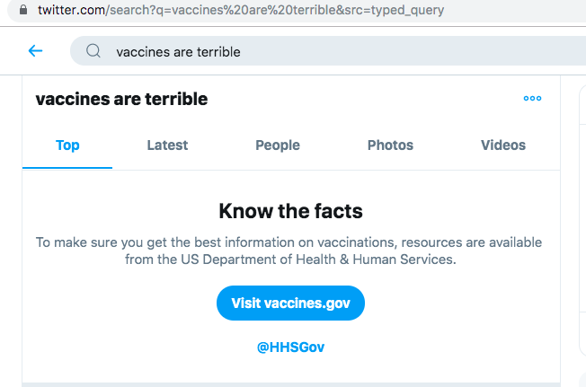

Figure 7: Twitter makes vaccines.gov top search result

Appendix C: YouTube Demonetized Anti-Vax Channels
On Friday February 22, YouTube announced it would demonetize anti-vax channels after Buzzfeed found many advertisements on anti-vaccination videos. The companies who paid for the advertisements had no idea they were being displayed on anti-vaccination videos, and subsequently pulled their ads (O’Donovan, 2019).
YouTube told Buzzfeed, “We have strict policies that govern what videos we allow ads to appear on, and videos that promote anti-vaccination content are a violation of those policies. We enforce these policies vigorously, and if we find a video that violates them, we immediately take action and remove ads.” An example of this can be found in Figure 8 (O’Donovan, 2019).

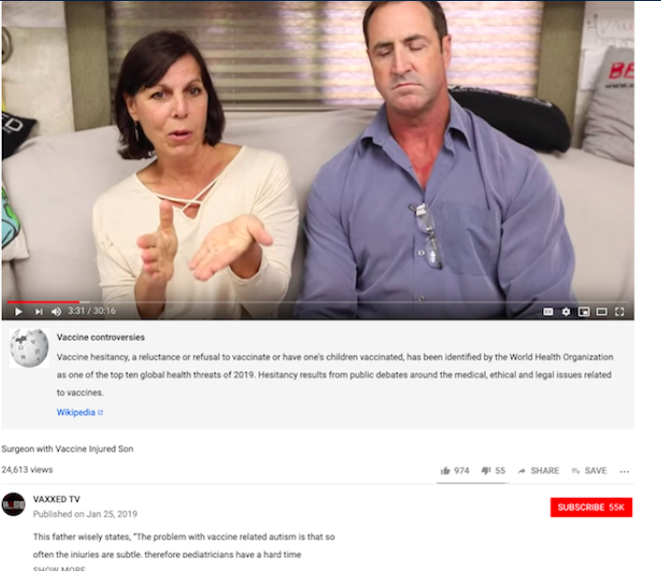
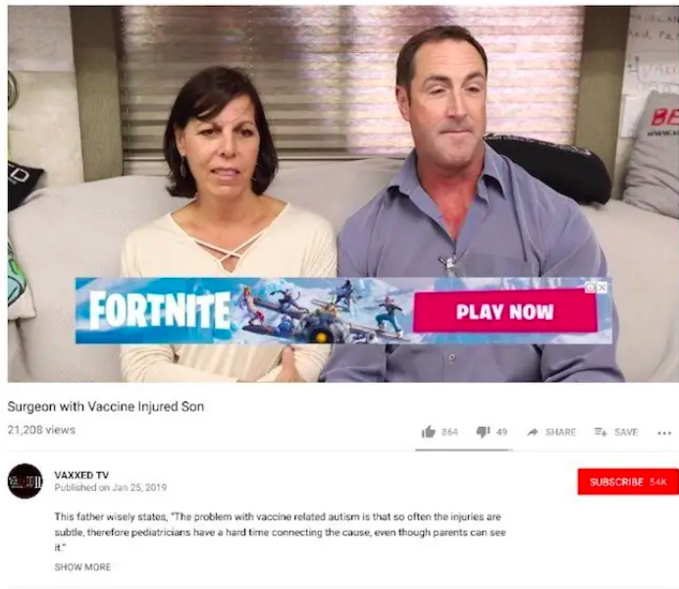

Figure 8: Screenshots of the same YouTube video - 2/14/19 vs. 2/22/19

Bibliography
Basch CH, et al.“A content analysis of HPV related posts on instagram.”Human Vaccine Immunotherapy, 2019. doi: 10.1080/21645515.2018.1560774.

Broniatowski, David et al. “Weaponized Health Communication: Twitter Bots and Russian Trolls Amplify the Vaccine Debate ” American Journal of Public Health, 2018; doi: 10.2105/AJPH.2018.304567.

Carrieri, Vincenzo et al. “Vaccine hesitancy and (fake) news: Quasi‐experimental evidence from Italy.” Health Economics, 2019; https://doi.org/10.1002/hec.3937

Chakraborty, P. et al. (2017). Observation of public sentiment toward human papillomavirus vaccination on Twitter. Cogent Medicine, 4(1), 1390853. https://doi.org/10.1080/2331205X.2017.1390853

“Childhood Vaccination Coverage Trend Report: Birth Years 2011 through 2016” Centers for Disease Control and Prevention, 2017. Retrieved from: https://www.cdc.gov/vaccines/imz-managers/coverage/childvaxview/interactive-reports/trend/index.html

Chiou L. et al."Fake News and Advertising on Social Media: A Study of the Anti-Vaccination Movement," SSRN, 2018. http://dx.doi.org/10.2139/ssrn.3209929

Covolo L. et al.“What arguments on vaccinations run through YouTube videos in Italy? A content analysis.” Human Vaccine Immunotherapy, 2017. doi:10.1080/21645515.2017.1306159

Crowell, Colin “Our approach to bots and misinformation” Twitter, 2017. Retrieved from: https://blog.twitter.com/en_us/topics/company/2017/Our-Approach-Bots-Misinformation.html

Damiani, C. Microbiology 1860: Lecture 2018.

Dunn, Adam et al. “Mapping information exposure on social media to explain differences in HPV vaccine coverage in the United States” Vaccine, 2017; https://doi.org/10.1016/j.vaccine.2017.04.060.

Fredrickson DD, Davis TC, Arnould CL, Kennen EM, Hurniston SG, Cross JT, Bocchini JA Jr. “Childhood immunization refusal: provider and parent perceptions” Family Medicine, 2004. [PubMed]

Gunaratne, Keith. et al. “Temporal trends in anti-vaccine discourse on Twitter” Vaccine, 2019; https://doi.org/10.1016/j.vaccine.2019.06.086.

Harvey, Del “Helping you find reliable public health information on Twitter” Twitter, 2019. Retrieved from: https://blog.twitter.com/en_us/topics/company/2019/helping-you-find-reliable-public-health-information-on-twitter.html

Hoffman, Beth. et al. “It’s not all about autism: The emerging landscape of anti-vaccination sentiment on Facebook.” Vaccine, 2019; DOI: 10.1016/j.vaccine.2019.03.003

Krishnendhu, V K, et al. “Drivers and barriers for measles rubella vaccination campaign: A qualitative study.” Journal of Family Medicine and Primary Care vol. 8,3 (2019): doi:10.4103/jfmpc.jfmpc_73_19

McKee, Chephra. et al. “Exploring the Reasons Behind Parental Refusal of Vaccines.” The Journal of Pediatric Pharmacology and Therapeutics, 2016 doi:10.5863/1551-6776-21.2.104

“Measles” World Health Organization, 2019 Retrieved from: https://www.who.int/news-room/fact-sheets/detail/measles

Meissner, Cody. “Why is herd immunity so important?” American Academy of Pediatrics, 2015. DOI: https://doi.org/10.1542/aapnews.2015365-14

Mohsin, Maryam. “10 Social Media Statistics You Need to Know in 2019” Oberlo, 2019. Retrieved from: https://www.oberlo.com/blog/social-media-marketing-statistics

Mosseri, Adam. “Working to Stop Misinformation and False News” Facebook, 2017 Retrieved from: https://www.facebook.com/facebookmedia/blog/working-to-stop-misinformation-and-false-news

O’Donovan, Caroline. “YouTube Just Demonetized Anti-Vax Channel” Buzz Feed, 2019. Retrieved from: https://www.buzzfeednews.com/article/carolineodonovan/youtube-just-demonetized-anti-vax-channels

Porat, Talya. et al. “Content and source analysis of popular tweets following a recent case of diphtheria in Spain” European Journal of Public Health, 2019; https://doi.org/10.1093/eurpub/cky144

Radzikowski, Jacek et al. “The Measles Vaccination Narrative in Twitter: A Quantitative Analysis.” JMIR Public Health and Surveillance, 2016; doi:10.2196/publichealth.5059

Rao, T S Sathyanarayana. et al.“The MMR vaccine and autism: Sensation, refutation, retraction, and fraud.” Indian Journal of Psychiatry, 2011. doi: 10.4103/0019-5545.82529

Regal, Chris.“Vaccines Save Lives.” AHIP, 2019 Retrieved from: https://www.ahip.org/vaccines-save-lives/

Salathé M. et al.“Assessing vaccination sentiments with online social media: implications for infectious disease dynamics and control.” PLOS Computational Biology, 2011. doi: 10.1371/journal.pcbi.1002199.

Signorelli C. et al. “Four Italian experiences on vaccination policies: results and lesson” Annali di igiene: medicina preventiva e di comunita, 2019. doi: 10.7416/ai.2019.2275

Smith, Naomi et al.“Mapping the anti-vaccination movement on Facebook” Information, Communication & Society, 2017. DOI: 10.1080/1369118X.2017.1418406

“Ten threats to global health in 2019” World Health Organization, 2019. Retrieved from: https://www.who.int/emergencies/ten-threats-to-global-health-in-2019

Terrell, Keith. “A Complete History of Social Media: Social Networking Evolution” 2015. Retrieved from: https://historycooperative.org/the-history-of-social-media/

“Vaccine Types” U.S. Department of Health & Human Services, 2017. Retrieved from: https://www.vaccines.gov/basics/types

Ventola CL. Social media and health care professionals: benefits, risks, and best practices. P T. 2014;39(7):491–520.

Wiyeh, Alison. et al. “Social media and HPV vaccination: Unsolicited public comments on a Facebook post by the Western Cape Department of Health provide insights into determinants of vaccine hesitancy in South Africa” Vaccine, 2019; https://doi.org/10.1016/j.vaccine.2019.09.019.

