PROGRAM EVALUATION OF A STRUCTURAL INTERVENTION AIMED AT IMPROVING MATERNAL HEALTH OUTCOMES IN RURAL ZAMBIA

by
Sarah Sandrian
BS, University of Pittsburgh, 2011

Submitted to the Graduate Faculty of
Infectious Diseases and Microbiology at the
Graduate School of Public Health in partial fulfillment
of the requirements for the degree of
Master of Public Health

University of Pittsburgh
2017

UNIVERSITY OF PITTSBURGH
GRADUATE SCHOOL OF PUBLIC HEALTH

This essay is submitted
by
Sarah Sandrian

on

April 28, 2017
and approved by

Essay Advisor:
Linda Rose Frank, PhD, MSN, ACRN, FAAN _________________________________
Professor of Public Health, Medicine, and Nursing
Director, MPH-MIC Program
Department of Infectious Diseases and Microbiology
Graduate School of Public Health
University of Pittsburgh

Essay Reader:
Martha Ann Terry, PhD _________________________________
Associate Professor and Director, MPH Program
Behavioral and Community Health Sciences
Graduate School of Public Health
University of Pittsburgh

Copyright © by Sarah Sandrian
2017
ABSTRACT

The maternal mortality ratio of Zambia is one of the highest in the world at 480 maternal deaths per 100,000 live births, and only 47% of deliveries are performed by a skilled attendant. Knowing the possible negative consequences of home deliveries, the Mufungu community of Southern Zambia decided to address this issue by adding on to the existing Chiyumbabeenzu Health Post to accommodate more attended births. Mufungu, comprised of 11 villages and 2,670 people, collaborated with the author and the Peace Corps Partnership Program to raise funds for the construction of a three-room birthing center and mother’s shelter. The villages contributed local building materials in the form of pit and river sand, crushed stone, water, and brick. Coupled with volunteered labor, Mufungu’s contributions accounted for over 35% of the monetary value of the project. The project involved over 180 key stakeholders, including Mufungu community members, traditional leaders, Ministry of Health officials, and the Peace Corps Volunteer. After eight months of construction, the building was completed and opened on January 26, 2016. Outcomes and public health significance include that the Chiyumbabeenzu Health Post’s Mother’s Shelter has provided a safe haven and sanitary birthing conditions for its anticipated 144 deliveries per year. In addition, it has built community capacity by creating jobs, strengthening stakeholders’ finance management skills, empowering women with a private place specific for delivery needs, and freeing up more space at the existing health post for other outpatient treatments. This approach to addressing the needs of pregnant women in resource poor settings can serve as a model for other parts of Zambia as well as countries with similar health systems and challenges to improve maternal health and to engage communities in solving local problems through partnerships and collaboration.
Linda Rose Frank, PhD, MSN, ACRN, FAAN

PROGRAM EVALUATION OF A STRUCTURAL INTERVENTION AIMED AT IMPROVING MATERNAL HEALTH OUTCOMES IN RURAL ZAMBIA

Sarah Sandrian, MPH
University of Pittsburgh, 2017

TABLE OF CONTENTS
Acronyms and abbreviations xi
preface xii
1.0 Introduction 1
2.0 Background 2
2.1 Zambia 3
2.2 health in zambia 5
2.2.1 Maternal health 6
2.2.2 Maternal health services 7
2.2.3 General health services delivery 9
3.0 Literature Review of Previous Mother’s Shelter Interventions and barriers to accessing maternal healthcare 13
4.0 Mother’s shelter INTERVENTION in Mufungu 22
4.1 STAKEHOLDERS 23
4.2 PROGRAM PLAN 24
4.2.1 Political and philosophical climate of Nachibanga 24
4.2.2 Community resource assessment 25
4.3 ACTUALIZATION: Timeline of Activities 26
5.0 OUTCOMES 28
5.1 Shelter Opening and community celebration 34
6.0 DISCUSSION 38
6.1 SWOT Analysis 38
6.1.1 Strengths 38
6.1.2 Weaknesses 40
6.1.3 Opportunities 41
6.1.4 Threats 42
6.2 PUBLIC HEALTH IMPLICATIONS AND POTENTIAL IMPACT 43
6.2.1 Maternal health 43
6.2.2 Family and community health 43
6.3 NEXT STEPS 44
6.3.1 Mufungu community 44
6.3.2 Zambia 45
7.0 CONCLUSION 47
APPENDIX: PROGRAM PROPOSAL 49
bibliography 78
List of tables
Table 1. Summary of Articles Reviewed for Maternity Waiting Homes and Barriers to Maternal Healthcare Uptake for Zambian Women 14
List of figures
Figure 1. Map of Zambia 3
Figure 2. Zambia Coat of Arms 5
Figure 3. Diagram of Contributors to Years of Life Lost (YLLs) in Zambia from 1990 to 2015 6
Figure 4. Photograph of Mufungu, Southern Province, Zambia 29
Figure 5. Photograph of Chiyumbabeenzu Health Post in Mufungu, Zambia Pre-Addition 30
Figure 6. His Royal Highness, Chief Moyo with Peace Corps Volunteer, Sarah Sandrian 30
Figure 7. Photograph of Some Members of the Chiyumbabeenzu Health Post Mother's Shelter Committee 31
Figure 8. Photograph of the Mother's Shelter Foundation Digging 31
Figure 9. Photograph of Cemented Mother's Shelter Foundation 32
Figure 10. Photograph of Community Participant Returning Home after the Workday 32
Figure 11. Photograph of Kiolios, the Mason and Two Apprentices Hard at Work 33
Figure 12. Photograph of Progress on the Inside of the Mother's Shelter 33
Figure 13. Photograph of a Great-Grandmother and Mufungu Community Elder 34
Figure 14. Photograph of the Completed Mother's Shelter 35
Figure 15. Photograph of Women Preparing Food for the Mother's Shelter Opening Ceremony 36
Figure 16. Photograph of Community Leaders and the Peace Corps Volunteer Cutting the Mother's Shelter Ceremonial Ribbon 36
Figure 17. Photograph of Women Dancing at the Mother's Shelter Opening Ceremony 37
Acronyms and abbreviations
CHIP Community Health Improvement Project
DHO District Health Office
MMR Maternal Mortality Ratio
MOH Ministry of Health
MWHs Maternity Waiting Homes
NCDs Non-Communicable Diseases
NHC Neighborhood Health Committee
NHSP National Health Strategic Plan
PCV Peace Corps Volunteer
RPCV Returned Peace Corps Volunteer
RHP Rural Health Post
SMAGs Safe Motherhood Action Groups
STIs Sexually Transmitted Infections
SWOT Strengths, Weaknesses, Opportunities and Threats
TB Tuberculosis
US United States
WHO World Health Organization
YLLs Years of Life Lost
ZDHS Zambia Demographic and Health Survey
ZISSP Zambian Integrated Systems Strengthening Program

preface
The intervention discussed in this essay could not have been made possible without contributions from the Mufungu community of Southern Province, Zambia. Various stakeholders including Zambian Ministry of Health officials, traditional leaders, health post staff, community members, and trained bricklayers worked tirelessly to make Chiyumbabeenzu Health Post Mother’s Shelter a successful project.

Introduction
In light of the Millennium Development Goals, Zambia’s Ministry of Health has worked to reduce the burden of maternal mortality on its population. Though the number has dropped in recent years, Zambia’s maternal mortality ratio (MMR) is still high at 480 per 100,000 live births (UNICEF, 2014). Aware of the health issues in the area, the Nachibanga community of Southern Province, Zambia, invited Peace Corps to place a volunteer in the community to assist with health education and prevention in the areas of HIV, maternal and child health, and malaria. After some time integrating into the community, the volunteer and a small rural community within Nachibanga chose to implement a structural intervention to address women’s need to deliver their children at safe, sanitary health facilities rather than in their own homes.
The purpose of this essay is to explore the impact of the structural development project carried out by the author, a Returned Peace Corps Volunteer (RPCV), with members of the Mufungu community. First, the author will explore the current cultural, economic, and health situation in Zambia before looking at how the structural mother’s shelter intervention came about and was implemented. Then the author will present the results of the intervention, followed by an in-depth Strengths, Weaknesses, Opportunities, and Threats (SWOT) Analysis and discussion of the project’s effectiveness. The goal is to provide the reader with an understanding of the unique challenges and rewards that arise when working in resource-challenged settings.

Background
Zambia (Figure 1) is a landlocked country in southeastern Africa that takes its name from the Zambezi River that surrounds it along its eastern and southern borders (Roberts et al., 2017). Though Zambia has 70+ vernacular dialects and tribal groups, its population of 15.3 million (Roberts et al., 2017) peacefully follows the country motto: “One Zambia, One Nation,” which ostensibly has contributed to the continual peace the county has known since its independence in 1964 (Ministry of Health, 2015). Zambia first invited the United States Peace Corps to add a Zambia program in 1993 and began accepting volunteers to increase skilled development labor in 1994 (Peace Corps, 2017). Since that time, approximately 1,280 Peace Corps Volunteers (PCVs) have served in Zambia (Peace Corps, 2017). The author served in Peace Corps Zambia from June 2014 to June 2016 in the Community Health Improvement Project (CHIP). CHIP volunteers work at the community level to address the public health issues of maternal and child health, HIV/AIDS, and malaria, which have been identified by Zambia’s Ministry of Health (MOH) and Peace Corps Zambia as priority health issues.
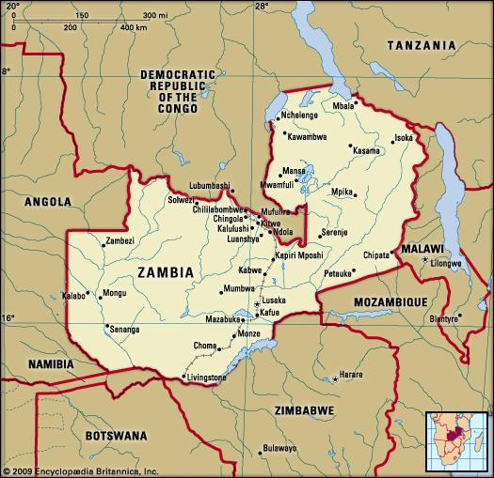
(Roberts et al., 2017)

Figure 1. Map of Zambia

Zambia
Zambia is a small country in the southern part of Sub-Saharan Africa. It is landlocked by The Democratic Republic of the Congo and Tanzania to the north, Malawi and Mozambique to the east, Zimbabwe, Botswana and Namibia to the south, and Angola to the west (Ministry of Health, 2015), as can be seen in Figure 1 above. It was formerly the British colony called Northern Rhodesia but gained its independence from Britain on October 24, 1964; Kenneth Kaunda was its first president (Roberts et al., 2017). Since that time, Zambia has seen six presidents and fluctuations from periods of relative financial stability to dependence on foreign aid (Roberts et al., 2017). Grants, tourism at Victoria Falls and gaming parks, hydropower from Victoria Falls and Lake Kariba, and mining of natural minerals such as copper, cobalt, gold, and silver currently make up the country’s major sources of revenue (Roberts et al., 2017).
Since the 20th century, rural to urban center migration has resulted in demarcations along class lines, with poor folks inhabiting shanty towns at the outskirts of cities and wealthy folks enjoying the benefits of lower population density, technological advances, and modern amenities in urban centers (Roberts et al., 2017). Outside of cities, rural Zambians tend to provide cash for their families on a seasonal basis through agricultural activities such as sustenance farming and herding, or through craft-making such as pottery or woodwork (Roberts et al., 2017). This depiction of rural life very closely matches the observations the author made in Nachibanga, Southern Province, Zambia, where the intervention later described was implemented.
Zambia is a largely Christian nation, immersed in its ties to colonial Britain (Roberts et al., 2017). Despite religious influence from missionaries in the past, Zambian tribes continue to follow past traditions by holding cultural ceremonies every year, like the Lwiindi Gonde ceremony of the Tonga, the N’cwala ceremony of the Ngoni, and the Ku-omboka ceremony of the Lozi (Zambia Tourism, 2017). The author observed that traditional Zambian ceremonies such as the ones mentioned above are reflective of tribal beliefs previously held before missionaries influenced Zambia’s religious traditions.
Zambians are proud of the fact that despite philosophical differences among tribes, they are still able to love and respect their tribal brothers or cousins and adhere to the ‘One Zambia, One Nation’ motto (depicted in Figure 2 below), as previously stated. Because of this attitude of comradery, the country has enjoyed peace and political stability since its independence in 1964 (Ministry of Health, 2015).


(World Atlas, 2016)

Figure 2. Zambia Coat of Arms

health in zambia
Since its independence in 1964, Zambia’s population has increased rapidly from about three million people (Ministry of Health, 2015) to approximately 15.5 million in 2015 (Central Statistical Office, 2016). One of the factors contributing to Zambia’s population increase is its continued high total fertility rate. Today, the total fertility rate in Zambia is 5.6 births per woman (Central Statistical Office, 2016). This high total fertility rate coupled with an increase in life expectancy from 40.5 in 1998 (Central Statistical Office, 2015) to 53.3 in 2015 (Central Statistical Office, 2016) has contributed to the demographic situation of Zambia today: one characterized by a double burden of communicable and non-communicable diseases (NCDs) (Ministry of Health, 2015).
The double burden of disease is a term used to describe the phenomenon developing countries experience when NCDs become a major threat to a country’s health status while the country is still battling a high burden of infectious diseases and child malnutrition (Prentice, 2005). Figure 3 below depicts how the burden of communicable and non-communicable diseases has changed from 1990 to 2015 (University of Washington, 2017). Communicable diseases like malaria, HIV/AIDS, tuberculosis (TB), and sexually transmitted infections (STIs) still make up a large burden of disease indicators in Zambia, while NCDs like mental health, cancers, sickle cell anemia, heart diseases, and diabetes are becoming more common as well (Ministry of Health, 2015). In addition to these issues, maternal and child mortality are also major contributors to Zambia’s years of life lost (Ministry of Health, 2015).

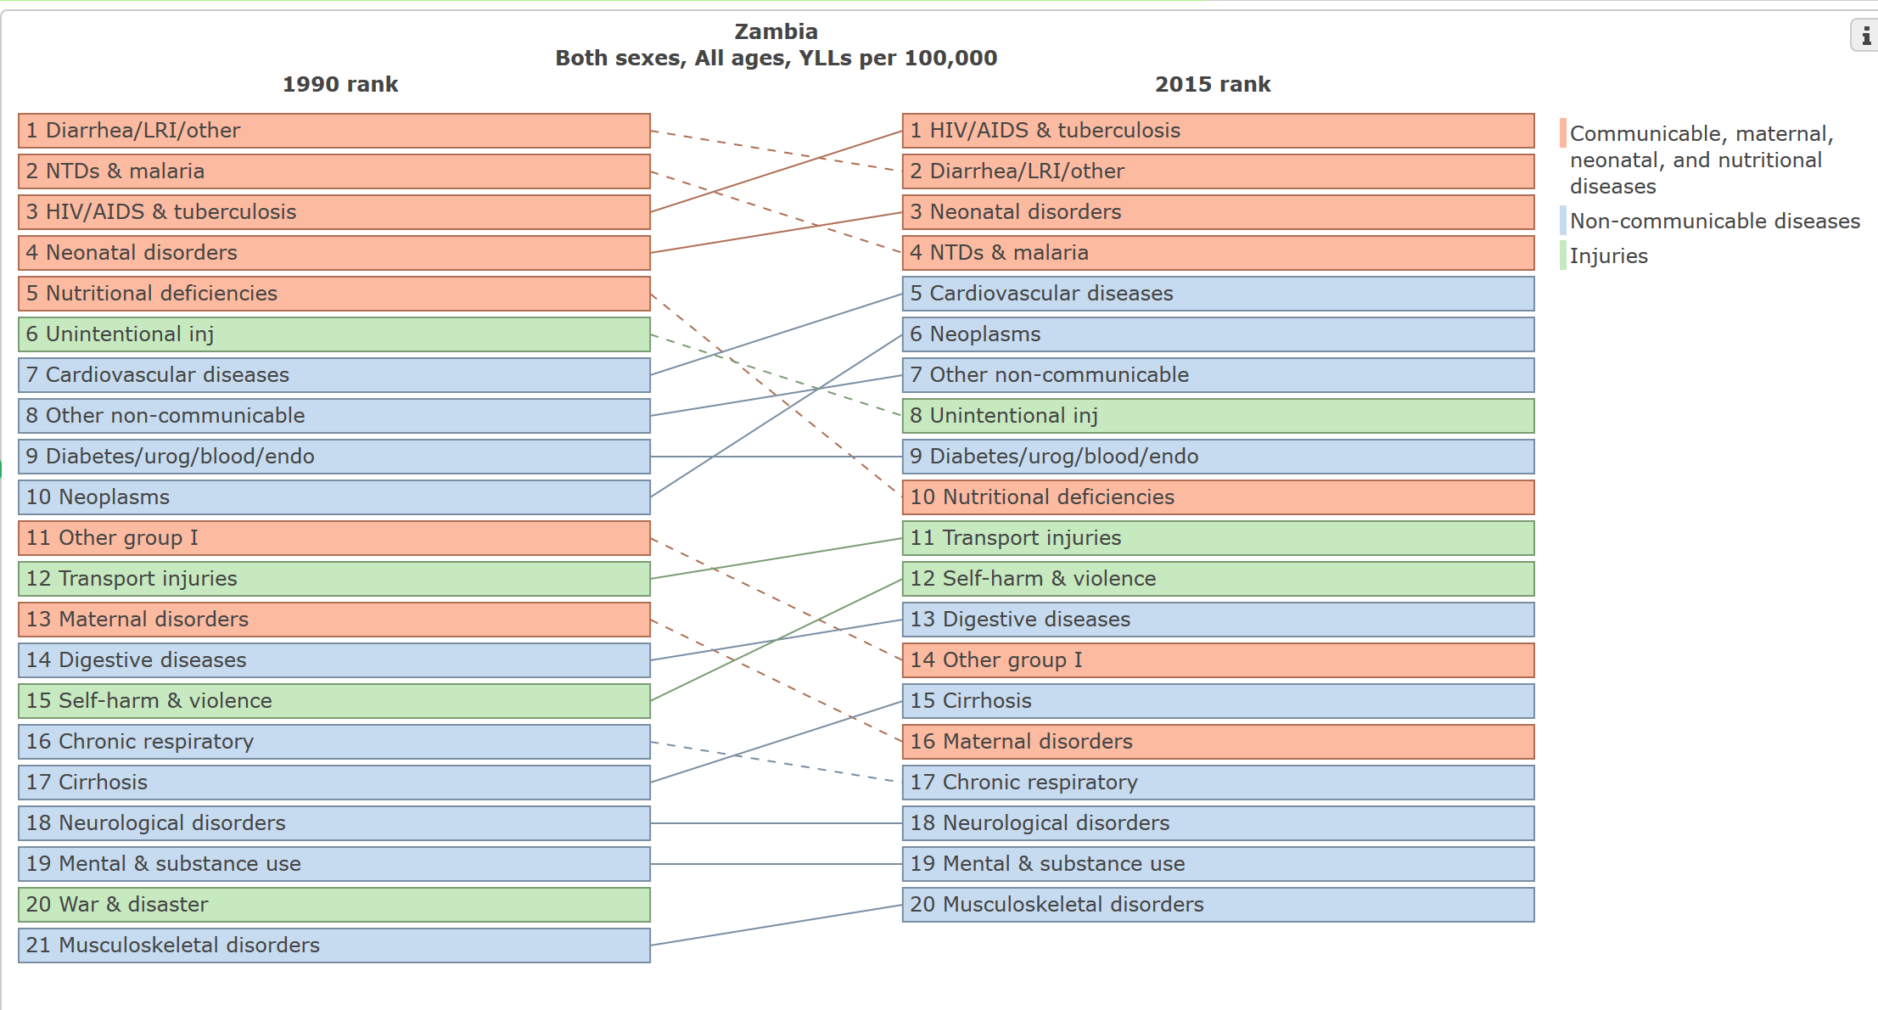
(University of Washington, 2017)

Figure 3. Diagram of Contributors to Years of Life Lost (YLLs) in Zambia from 1990 to 2015

Maternal health
Zambia’s MMR is one of the highest in the world at 480 per 100,000 live births (UNICEF, 2014), and the lifetime risk of maternal mortality is one in 79 (Saving Mothers, Giving Life, 2017). Of note is that while 98.6% of urban women and 94.0% of rural women report receiving antenatal care from a skilled provider, only 84.4% of urban women and 51.4% of rural women deliver at a health facility, according to the Zambia Demographic and Health Survey (ZDHS) of 2013-2014. Total fertility rate for women of reproductive age (15-49) is 6.6 children in rural Zambia compared to 3.7 children in urban areas (Central Statistical Office, 2015). These numbers depict disparities in facility delivery and overall maternal health services access between urban and rural Zambian mothers, which in turn suggests a disparity in MMR between urban and rural mothers, though that statistic is not available.

Maternal health services
Maternal health services in Zambia center around three main types of care: antenatal care, skilled birth attendance, and postnatal care (Central Statistical Office, 2015). According to the ZDHS 2013-14 (2015), antenatal care from a skilled birth attendant is crucial for reducing the risk of maternal and neonatal morbidity and mortality during pregnancy and delivery. Additionally, the World Health Organization (WHO) recommends at least antenatal care visits for pregnant women; more visits or health facility admission may be necessary if complications arise (Central Statistical Office, 2015). Routine antenatal care in Zambia consists of pregnancy screening for complications, health education about the importance proper nutrition and vitamin supplementation, malaria prevention, birth preparedness, facility delivery, and providing postnatal care for both mother and baby (Central Statistical Office, 2015).
Birth preparedness is one of the most important components of antenatal care; women can discuss expectations, create a birth plan, and learn about delivering at a health facility. Helping women plan how and when to travel to the clinic for delivery is important, because delays in traveling to a facility for delivery have been shown to contribute to maternal mortality worldwide (Thaddeus & Maine, 1994). According to the 2013-14 ZDHS (2015), approximately 32.4% of rural women report travel distance and/or lack of transportation to the clinic as one of the greatest barriers to facility delivery.
As previously stated, obstetric care from skilled birth attendants is considered crucial for managing complications that may arise during labor and delivery, and health professionals can help prevent unnecessary maternal and neonatal death and morbidity (Central Statistical Office, 2015). Overcoming barriers to facility delivery is therefore imperative for reducing maternal mortality, because women who deliver at health facilities are more likely to be assisted by a trained health professional than women who deliver in their own homes (Central Statistical Office, 2015). Trained health professionals are expected to be able to manage complications that may arise during labor or to assist women in transferring to more sophisticated medical centers swiftly (Central Statistical Office, 2015).
Receiving postpartum care is also critical to maternal health, because during this time women may develop life-threatening complications (Central Statistical Office, 2015). Zambia’s MOH recommends at least four postnatal checkups: one six hours post-delivery, the second 48 hours following delivery, the third six days after childbirth, and the fourth within six weeks of delivery, to manage any postpartum complications that may arise (Central Statistical Office, 2015). In Zambia, only 54.3% of women in rural areas report a postnatal checkup in the first two days after birth as compared with 81.4% of women in urban areas (Central Statistical Office, 2015). Thirty-seven-point four percent of rural women report no postnatal checkup at all (Central Statistical Office, 2015).
Since 2012, Zambia’s MOH has placed a strong focus on reducing MMR in Zambia through the roll-out of a program called Saving Mothers, Giving Life (Serbanescu et al., 2017). Saving Mothers, Giving Life is funded by USAID as an arm of the Zambia Integrated Systems Strengthening Program (ZISSP), which focuses on strengthening health services quality and delivery (Johns et al., 2014):
Saving Mothers addresses the three delays that prevent women from accessing maternal health services: delay in seeking services, delay in reaching services and delay in receiving quality care. These interventions are focused primarily on the critical 48 hours postpartum, when most maternal deaths and approximately half of newborn deaths occur.
(Saving Mothers, Giving Life, 2013, p. ii)

SMGL addresses the three delays in maternal healthcare uptake by equipping facilities, improving supply systems, training and mentoring, mobilizing the community, strengthening linkages between communities and facilities, and improving data collection (Saving Mothers, Giving Life, 2013). Since its initiation in 2012, Saving Mothers, Giving Life has made major improvements to the maternal health status of Zambia. In communities that participated in Saving Mothers, Giving Life interventions, maternal mortality ratios have fallen by 35% and facility delivery in Saving Mothers, Giving Life districts has increased by 21% (Saving Mothers, Giving Life, 2013). The intervention later described in this essay dovetails neatly with the Zambian Ministry of Health’s dedication to improving maternal health among expectant Zambian women.

General health services delivery
Since 1991, Zambia has practiced a decentralized system of health (Ministry of Health, 2015). It is a complex system that necessitates involvement from stakeholders at community, district, provincial, and national levels, as well as from donor agencies and non-governmental for- and non-profit organizations to operate (Ministry of Health, 2015). At the national level, the MOH coordinates and manages the overall scope and aims of the health sector; provincial health offices coordinate health service delivery in their respective provinces; at the district level, district health offices (DHOs) oversee health service delivery to their district constituents via coordination with rural community health centers and rural health posts (RHPs) in each district; finally, at the community level neighborhood health committees (NHCs), selected during community meetings, are in place to oversee community health education and public health programs (Ministry of Health, 2015). In the private sector, Zambia’s MOH fosters strong partnerships with donor institutions and organizations to supplement health systems delivery and public health programming (Ministry of Health, 2015).
Zambia’s National Health Strategic Plan 2011-15 (2015) summarizes the MOH’s approach to health care delivery in Zambia: “To provide equitable access to cost effective, quality health services as close to the family as possible,” (p.10) through efficiency, transparency, comprehensive care, adequate infrastructure, competent health workers and predictable, stable financing (Ministry of Health, 2015).
The MOH’s mission is equitable health care for all, but achieving parity is not simple. The MOH has attempted to improve health parity through the addition of approximately 5,000 health care workers to Zambia’s health workforce between 2005 to 2009 (Ministry of Health, 2015). Although more employees for every kind of health care position have been recruited since 2005, a large gap still exists between the actual number of employees and the recommended number for Zambia’s population (Ministry of Health, 2015). At the district level where the described intervention takes place, nurses and midwives comprise a large portion staff members, especially at RHPs. This fact is concerning, considering that there is a 57% and 58% gap, respectively, between the recommended number of nurses and midwives and the actual number of the same.
The health post engaged in the later described intervention, Chiyumbabeenzu Health Post, is located in Mufungu, Zambia, a small village in Pemba District in Zambia’s Southern Province. Health care delivery is coordinated by a head nurse, Mrs. Likolo Mwiiya, a trained traditional birth attendant, and three community health workers. Patients are seen on a walk-in basis Monday through Saturday for a variety of health issues from rash and fever to severe malaria and AIDS palliative care. Nurses and staff treat malaria, infections, and diarrhea. They deliver babies and also provide a comfortable, safe place for patients who are at the end of life and cannot afford or do not want to travel to provincial hospitals for more advanced treatment. Ailments like cancer, cavities, deep wounds that require stiches, heart attacks or any condition that require surgery or more advanced equipment than is available at Chiyumbabeenzu Health Post are referred to district or provincial hospitals.
The hospital nearest to Mufungu is about 25 km on dirt roads. The next nearest is approximately 70 km by main roads. Due to a lack of health care infrastructure in Mufungu, there are no ambulances at either Chiyumbabeenzu RHP or the next nearest health post about five kilometers away. To travel to the closest hospital, a patient must hire a taxi for $100 for a one to two-hour drive or wait several hours, until either early morning or late afternoon for public transportation. Hiring a taxi is usually well beyond the means of the average villager who lives on less than a dollar a day. A public transit vehicle such as a minibus or a canter (large truck) takes about three hours to transport a patient to the closest hospital. Though the second closest hospital is located over twice the distance away, it is easier to transport a patient there, because it can be reached by main roads. Regardless, the journey is at least one to three hours.

Literature Review of Previous Mother’s Shelter Interventions and barriers to accessing maternal healthcare
In this section, literature on the usefulness of maternity waiting homes (MWHs) is reviewed to give context to the later described intervention that was carried out in a similarly resource-challenged setting. The publications reviewed are cross-sectional studies, literature reviews, and meta-analyses. As a point of clarification, mother’s shelters are referred to using the nomenclature maternity waiting homes in the literature. The literature shows an overall positive view of maternity waiting homes among both caregivers and mothers in resource-challenged settings and also shed light on barriers to accessing maternal healthcare in settings that may benefit from the maternity waiting homes. Table 1 on the following pages provides a summary of literature available on maternity waiting homes and barriers to accessing obstetric care in Zambia and similarly resource-challenged settings. Additionally, the discussion below highlights some of the findings summarized in Buser & Lori’s scoping review (2017) of maternity waiting homes.
Maternity waiting homes are spaces designed to cater to women’s perinatal care. They may provide any of the following: a safe place to await childbirth, a sanitary ward for delivery, a place for postnatal care check-ups. Maternity waiting homes increase access to maternal health care services in rural settings by addressing the three delays model of maternal health. In the three delays model, the first delay refers to barriers women may have in planning to deliver their
Table 1. Summary of Articles Reviewed for Maternity Waiting Homes and Barriers to Maternal Healthcare Uptake for Zambian Women
First Author, title (year) | Location | Methods | Aims | Sample | Results | Implications
Figa’-Talamanca, Maternal mortality and the problem of accessibility to obstetric care; The strategy of maternity waiting homes (1996) | Various (Bangladesh, Brazil, Colombia, Conakry Guinea, Cuba, Egypt, Ethiopia,  Ghana, Ivory Coast, Malawi, Nicaragua, Nigeria, Uganda, Zimbabwe) | Qualitative review | To analyze the role of MWHs in increasing access to maternal healthcare in various settings and to make recommendations for the planning and implementation of MWH interventions | Not specified | - MWHs provide for timely skilled attendance of high risk women  - In Cuba, the implementation of MWHs contributed to the drop in its maternal mortality rate from 118 to 29 per 100,000 between 1962 and 1989  - Implementing MWHs is a practical, cost-effective way to help manage maternal mortality and morbidity so long as communities define the following before implementation  - Which women will be referred to MWHs  - Gestational age requirement for MWH use  - Who will refer women to MWHs  - Type of care to be provided  - How high risk women will be transferred from MWHs to hospitals | Useful for communities in the planning stages of MWH implementation
Gabrysch, The influence of distance and level of care on delivery place in rural Zambia: A study of linked national data in a geographic information system (2011)  Table 1 Continued | Zambia | Linkage of ZDHS 2007 and Zambian Health Facility Census (ZHFC) 2005 data via geographic information system and multivariable, multilevel logistic regression analyses | To quantify how distance and level of care available impacts women’s use of health facilities for delivery care | ZDHS 2007 and ZHFC 2005 data | - One-third of Zambian women deliver at health facilities  - Half of all births occurred among women who lived 25 km or more from the nearest health facility with basic emergency obstetric care (BEmOC)  - As distance to the closest health facility doubled, the odds of facility delivery dropped by 29%  - Increased level of care available increased the odds of facility by 26% | Increase in nearby, quality care is crucial to overcoming barriers Zambian women face in seeking facility deliver
Jacobs, Predictors of antenatal care, skilled birth attendance, and postnatal care utilization among the remote and poorest rural communities of Zambia: A multilevel analysis (2017) | Zambia | Cross-sectional baseline household survey | To study the patterns and predictors of the three forms of perinatal care (antenatal care, skilled birth attendance, and 48-hour postnatal follow-up) utilization in rural Zambia | n=551 | - Antenatal care, skilled birth attendance, and 48-hour postnatal follow-up care rates were 30%, 37%, and 28%, respectively  - The availability of HIV testing and preventative malaria treatment were positive predictors of antenatal care uptake  - Receiving antenatal care was a significant predictor of skilled birth attendant and 48-hour postnatal follow-up utilization  - Women in centralized rural areas were more likely to use skilled birth attendants than remote rural women | Targeting of remote rural women with maternal healthcare programs and strategies may lead to an increase in perinatal care utilization and with that, reductions in maternal and neonatal mortality and morbidity
Kelly, The role of a maternity waiting area (MWA) in reducing maternal mortality and stillbirths in high-risk women in rural Ethiopia (2010) | Ethiopia | Retrospective cohort study | To compare maternal mortality and stillbirth rates between women using maternal waiting areas prior to delivery to women admitted to the same facility for immediate delivery in rural Ethiopia | n= 24,148 | - Maternal mortality among the MWA group was 89.9 per 100,000 live births and 1333.1 per 100,000 live births among non-MWA women  - Still birth rates among MWA women were 17.6 per 1,000 live births and 191.2 per 1,000 live births among non-MWA women | Access to MWAs, also known as MWHs, in advance of the onset of labor can significantly reduce the risk of maternal and neonatal mortality in rural settings
Lori, Promoting access: The use of maternity waiting homes to achieve safe motherhood (2013)  Table 1 Continued | Liberia | Exploratory, qualitative study via focus groups and interviews | To explore the impact of MWHs on improving access to facility childbirth in rural areas of post-war Liberia | Focus groups were conducted with a total of 75 participants and interviews with 13 participants | - 29 women had utilized MWHs in the past, 32 had not  - Post-war efforts have been made to meet maternal healthcare needs and communities have worked together to build MWHs, to their benefit  - Shortages of skilled providers remains a problem, but MWHs were reported to be a step towards improving maternal healthcare access, nonetheless  - Distance from services was noted as a barrier to maternal healthcare uptake, but MWHs were perceived as helpful in addressing this issue  - Husbands’ approval of MWHs was a positive predictor in women’s utilization of the same | Availability of MWHs may provide linkage to maternal healthcare utilization in post-war areas, areas with low provider availability, remote rural areas  Husbands’ approval of MWH usage may be beneficial to increasing MWH utilization in the future
Masters, Travel time to maternity care and its effect on utilization in rural Ghana: A multilevel analysis (2013) | Ghana | Multilevel analysis using GIS and Ghana Demographic and Health Survey (GDHS) data | To test the idea that travel time to health facilities negatively impacts the uptake of facility delivery | GDHS | - Travel time had a significant effect on the prospects of seeking facility delivery and antenatal care  - Provider capacity was found not to impact utilization of perinatal care services | Increased availability of obstetric care services and improvement of roadway infrastructure may have a positive impact on maternal healthcare utilization in resource-challenged settings
Sacks, Postnatal care experiences and barriers to care utilization for home- and facility-delivered newborns in Uganda and Zambia (2017)  Table 1 Continued | Uganda, Zambia | Exploratory, qualitative study | To study experiences with and barriers to accessing postnatal care services in Uganda and Zambia | 48 focus groups conducted with an unspecified number of participants | - Most women who accessed care reported positive experiences, particularly in Zambian health facilities compared to the Ugandan reports  - Low postnatal care utilization was reportedly due to lack of awareness of the need, fear of mistreatment from health facility staff, cost, and distance  - Half of the focus group discussions highlighted the personal experiences or knowledge of denial of postnatal care because of home delivery | Awareness of the barriers to postnatal care utilization may help in the creation of incentive strategies aimed at increasing facility delivery
Sialubanje, Improving access to skilled facility-based delivery services: Women’s beliefs on facilitators and barriers to the utilization of maternity waiting homes in rural Zambia (2015) | Zambia | Exploratory, qualitative study | To look at women’s beliefs and experiences concerning the use of MWHs in rural Zambia | n=32 | - Most women interviewed noted the importance of MWHs in improving access to maternal care services  - Several factors impede women’s use of MWHs, including decision-making autonomy, gender inequities, low socioeconomic status, and socio-cultural norms  - Lack of funds remove many women from MWH utilization eligibility because of the inability to purchase goods required for facility delivery  - Some barriers to MWH use include lack of at-home child care and concerns about sanitary and quality care provided at MWHs | Reduction of the gap between awareness of the importance of utilizing MWHs and lack of uptake due to the concerns and barriers laid forth in this study may be a crucial component to increasing MWH utilization in resource-challenged settings
Sialubanje, Husbands’ experiences and perceptions regarding the use of maternity waiting homes in rural Zambia (2016) | Zambia | Exploratory, qualitative study | To investigate men’s beliefs regarding the use of MWHs before childbirth in rural Zambia | n=24 | - Many men interviewed reported positive perceptions about the role of MWHs in improving maternal and neonatal health outcomes  - Reported barriers to the decision to use MWHs included limited financial resources and poor conditions at the MWHs of interest | Interventions aimed at reducing cost of facility delivery improving men’s perceptions of the quality of care delivered at MHWs may expand access of MWHs in rural Zambia
Table 1 Continued

child at a health facility; the second delay refers to barriers in traveling to a health facility; and the third delay refers to barriers in receiving quality care after arriving at a health facility (Thaddeus & Maine, 1994). Maternity waiting homes combat barriers of the three delays in maternal healthcare access through the following: allowing women to plan to deliver at a facility while creating their birth plan rather than at the moment labor begins; bridging the distance barrier many women in developing nations face by providing a safe space for women to stay before delivery; and by (ostensibly) providing access to higher quality care than a woman would receive at home (Buser & Lori, 2016; Gabrysch et al., 2011; Kelly et al., 2010; Lori et al., 2013; Lori et al., 2017; Sacks et al., 2016; Sialubanje et al., 2015; Vermeiden & Stekelenburg, 2017).
Maternity waiting homes are not a new concept; they have been employed for centuries in various settings around the world in the past in places such as Europe, Canada and the US (World Health Organization, 1996). Some more recent experiments began in the 1950s with the introduction of ‘Maternity Villages’ in Nigeria (World Health Organization, 1996). The literature shows that today, maternity waiting homes, or similar concepts of a different name, are used to reduce maternal mortality and morbidity and improve the health of neonates in locations such as Cuba (Figa’-Talamanca, 1996), Lao (Eckermann & Deodato, 2008), Nicaragua (Garcia Prado & Cortez, 2012), Ethiopia (Gaym et al., 2012; Poovan et al., 1990), Liberia (Lori et al., 2013; Millard, Bailey & Hanson, 1991), Zimbabwe (Tumwine & Dungare, 1996), and Guatemala (Ruiz et al., 2013). The results of MWHs built in these locations are reviewed in Buser & Lori (2017), one of the most comprehensive reviews available on the subject of maternity waiting homes.
Additional benefits of maternity waiting homes include the reduction of neonatal mortality via increased surveillance of potential infections, birth complications, and other intrapartum conditions that can threaten a baby’s health during the critical first hours and days of life (Buser & Lori, 2016; Chandramohan et al., 1995; Jacobs et al., 2017; Lori et al., 2013; Masters et al., 2013; van Lonkhuijzen et al., 2003); prevention of low birth weight in neonates in Zimbabwe (Jacobs et al., 2017; Kelly et al., 2010; Tumwine & Dungare, 1996); and the ability to transfer women who are at high risk of pregnancy complications to facilities with more sophisticated care more easily (Lori et al., 2013; World Health Organization, 2015). Though neonatal health outcomes are looked at in the context of maternity waiting homes (Buser & Lori, 2016; Chandramohan et al., 1995; Jacobs et al., 2017; Kelly et al., 2010; Lori et al., 2013; Masters et al., 2013; van Lonkhuijzen et al., 2003), more research is still needed to gain greater understanding of the significance of MHWs in improving neonatal health (Buser & Lori, 2016).
Several authors note the importance of patient satisfaction and community involvement in propagating use of maternity waiting homes. Lori et al. (2017, p. 1) state that “satisfaction and perception of care will likely affect future decisions regarding the utilization and recommendations for use of health care facilities.” Sacks et al. (2016) and Sialubanje (2016) both found that one of the greatest reported barriers to uptake of postnatal care services was the perception that women who delivered at home would receive poor quality of care or be denied treatment at the maternity waiting home because they delivered their children at home. Siabulanje et al. (2015, p. 10) stated that “most women appreciate the important role that MWHs play in improving access to skilled birth attendance and improving maternal health outcomes,” but that some barriers like “dependence on their husbands for decision-making, non-availability of funds to buy the requirements for the baby and mother to use during labor at the clinic, concerns about a relative to remain at home and take care of the [other] children, and concerns about the poor state of the maternity waiting homes” (Sialubanje et al., 2015, p.10).
Although there are some barriers to accessing maternity waiting homes, as mentioned above, MWHs are still recommended as one of the best strategies available for reducing the burden of maternal mortality and morbidity in communities that have them (World Health Organization, 1996). By addressing the three delays in obtaining maternal healthcare, MWHs play an important role in increasing healthcare access to expectant mothers. As research continues to be conducted on the effectiveness of MWHs, it is expected that similar improvements to what has already been shown for maternal health will also be found for neonatal health.

Mother’s shelter INTERVENTION in Mufungu
After three months of training, the author and her fellow PCVs were placed at their final work sites for the following two years. The author was placed in Nachibanga, Southern Province Zambia, where she spent the first few months familiarizing herself with the terrain, the people, and the community’s expectations of a PCV. She spent many days simply exploring on her bicycle, kicking up the red earth of Southern Province, travelling to the many surrounding villages and observing the dynamics of Zambia’s health system. That time was used to identify trustworthy community counterparts who could help the volunteer achieve development goals and health education projects.
During this period of community entry, the author discovered two small rural health posts on the border of the health center’s catchment area. She found that despite their small sizes, the two health posts were manned by highly motivated teams of community health workers who were eager to work with the PCV. They did everything in their power to utilize the PCV’s expertise and training in HIV, malaria, and maternal and child health to continue developing their communities. The Luyando Mother’s Shelter project materialized because of these two communities’ commitment to improving health for their people.

STAKEHOLDERS
As previously mentioned, several key stakeholders made this project a success. First and foremost, His Royal Highness Chief Moyo, the chief of Nachibanga area, which includes Moyo, Mufungu, Ndondi, and Nachibanga neighborhoods, gave his blessing for the project to move forward, allowing the PCV and community members to proceed. At the local government, Pemba District MOH officials were responsible for providing specific mother’s shelter building plans, project approval, and quality control checks throughout construction. Mufungu’s health post, Chiyumbabeenzu Rural Health Post, had a staff of one head nurse and five community health workers who performed the everyday tasks of seeing patients and health post maintenance. They assisted throughout the course of the project, including recruiting and engaging community members, calling group meetings, creating a mother’s shelter construction committee, and continually motivating the community to finish the project. At the community level, traditional leaders, including the chief, headmen and headwomen, and the mother’s shelter construction committee mobilized laborers and construction materials. Women and children of the community also had a vested interest in the success of this project because of the health implications it could have for their families and friends. Women and children typically helped with tasks around the construction site, like cooking, bringing construction materials, and fetching water for the bricklayers.

PROGRAM PLAN
Before implementing a structural intervention, the Mufungu community had to take several steps. First and foremost, the political and philosophical climate was at the perfect juncture to create a window of opportunity for the Chiyumbabeenzu Health Post Mother’s Shelter Development Project to come to fruition: traditional and political leaders backed the project with their full support, and community stakeholders were prepared to implement a structural maternal health intervention. The community’s willingness to begin this intervention met the characterization of the preparation phase of the Transtheoretical Model of behavior change: willingness to change and planning steps towards making the change (Prochaska et al., 1998). They began the process by conducting a community resource assessment to determine the best first steps to take.

Political and philosophical climate of Nachibanga
The political and philosophical climate of Mufungu in early 2015 was such that there was a window of opportunity for implementing an infrastructure-focused development project. Encouraged by a wise and motivational leader in Chief Moyo, Chiyumbabeenzu RHP’s staff was committed to improving the health of its community by any means possible. Chief Moyo also requested and accepted any development programs that presented the opportunity to improve health or education in Nachibanga. Along the same lines, Pemba District health officials were also eager to work with outside partners on infrastructure-based projects.
As a rural community located approximately 25km from the main road, Mufungu saw development opportunities infrequently. The community was poised and ready to work with the PCV as previous volunteers and organizations had overlooked them in the past. As soon as they heard that a new volunteer would be living in Nachibanga, they sought her partnership for building and educational programs. The Mufungu community and RHP staff was so eager to work with the PCV that a community resource assessment was scheduled before the end of their first encounter with her.

Community resource assessment
As previously mentioned, Chiyumbabeenzu RHP was run by a strong leader in its head nurse, Likolo Mwiiya. She commanded a group of five devoted community health workers who mobilized the surrounding villages and urged individuals to seek health care at the health posts. The nurses and health workers saw cases related to everything from HIV and malaria to prenatal care and child birth, and many issues in between. The above-mentioned assets of the Mufungu community healthcare system were apparent strengths from the outset of this project. Some other resources that came to light during the first community resource meeting and assessment were efficient and practical use of the space they had, the ability to sterilize water and equipment by storing and chlorinating water, and a strong network of motivated community members and head(wo)men.
Some challenges also came to light during the community assessment: no running water, no electricity, and very little space in the four rooms of the existing RHP. Another major challenge was the amount of space the health post had to devote to expectant mothers: one room, approximately nine square feet, filled with one hospital bed and the relevant equipment. The major issue with the size of the delivery ward was that there was no safe space for women to wait to give birth. Women traveled to the health post on foot about a month before their due date to await the child’s arrival. Because there was no safe space for expectant mothers and their escorts to stay while they waited, they slept outside, exposing themselves to risks like contracting malaria or attack by wild animals or drunk folks walking home from the local bar. By the end of the community assessment, there was unanimous agreement from those in attendance that a mother’s shelter addition was the most pressing health need for the Mufungu community. They had the drive and the knowhow to build an addition but lacked the funding or the means to fundraise the amount necessary to create a building that met MOH guidelines.

ACTUALIZATION: Timeline of Activities
Once Mufungu community members unanimously agreed that a mother’s shelter was the most pressing need for Mufungu, the project took off immediately. Within the first two community meetings about the mother’s shelter, a mother’s shelter committee was formed with representatives from each village in the area. The community also devised a plan to hold each village responsible for locally sourced materials like building sands (pit and river), crushed stones, and bricks and contacted the district health officials to approve the project. The committee and the author worked together to create a budget and to obtain a $5,000 Peace Corps Partnership Program grant for the purchase of any building materials not locally sourced.
From start to finish, the mother’s shelter project took just over a year. The construction alone took about eight months. There were many successes and failures along the way. A consistent strength throughout the course of the project was the involvement of countless community members. Men and women from all over the health post’s catchment area traveled to the construction site day after day, to bring building materials or to assist the builders by carrying water or cooking them meals. The project committee took the time to interview and vet several contractors before selecting Kiolios, who accepted the job at a great discount. Throughout the course of the project, Kiolios and the committee guided the author on which materials needed to be purchased and from which hardware stores the materials should be purchased. The district health officials supported the project by any means possible and conducted periodic site visits to ensure the quality of the construction. They also worked with the MOH to provide a solar unit for the new building, installed upon the project’s completion. The building was completed by the end of December 2015.

OUTCOMES
Many positive community level changes resulted from the Chiyumbabeenzu Health Post Mother’s Shelter Development Project. Some of the results include increased community capacity through job creation and strengthened financial management skills; increased space at the existing health post for additional outpatient procedures; increased women’s empowerment through the provision of a private space catered specifically to women’s needs; creation of a safe haven and sanitary birthing facility for Mufungu’s anticipated 144 deliveries per year; and increased awareness of the importance of seeking skilled antenatal, perinatal, and postnatal care through promotion of community involvement in the development program.
The implementation of this structural intervention ensured collaboration among many stakeholders. Thirteen community leaders headed the mother’s shelter committee and oversaw the budget, resource collection, community engagement, and project construction. In each of the 11 Mufungu villages, at least 10 volunteers helped transport their village’s locally sourced materials to the clinic for the construction project. Two traditional leaders (a headman and a vice headman) from each of the 11 villages collaborated on the development project by encouraging community mobilization and participation. Six individuals from Pemba’s DHO made regular progress appraisals to ensure the integrity of the structure. The five-person health post staff provided guidance for the project as well as assistance with community engagement. A team of six local masons contributed skilled, discounted labor to the project. Dozens of community members assisted with jobs like fetching water, cooking for construction workers, and tidying the construction site. Totaled, over 180 Mufungu community members participated in bringing the Chiyumbabeenzu Health Post Mother’s Shelter to fruition. Figures 4 through 13 below depict the Mufungu area and progress of the mother’s shelter project from February 2015 to December 2015.

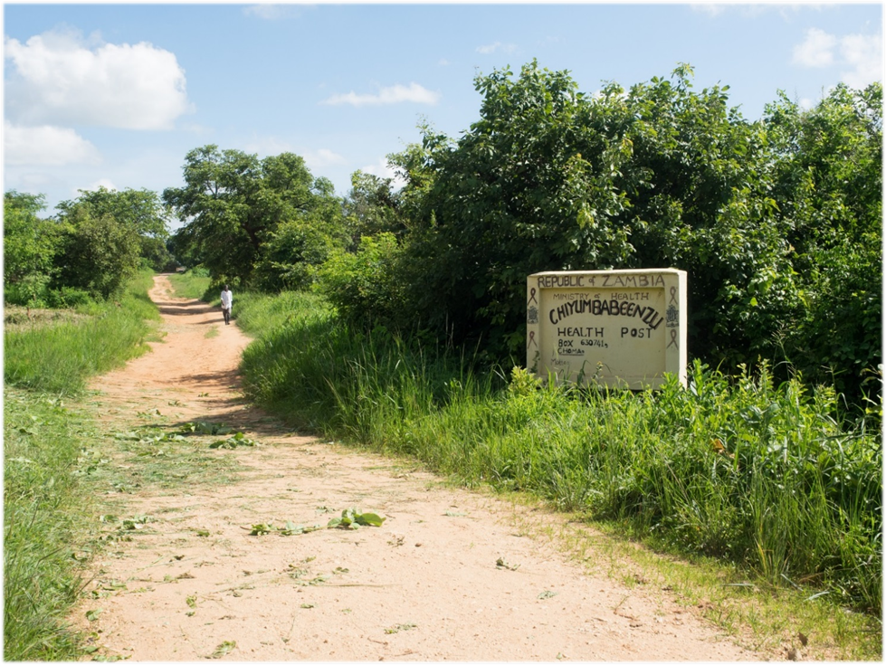
© Sarah Sandrian 2015
Figure 4. Photograph of Mufungu, Southern Province, Zambia

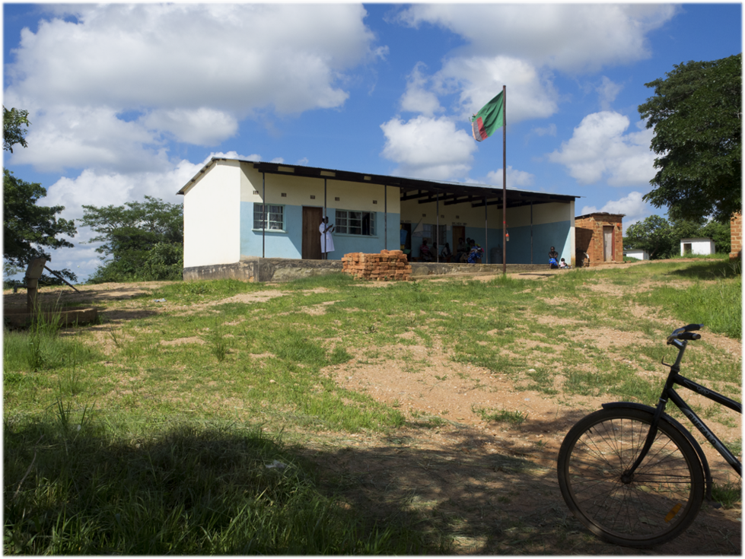
© Sarah Sandrian 2015
Figure 5. Photograph of Chiyumbabeenzu Health Post in Mufungu, Zambia Pre-Addition

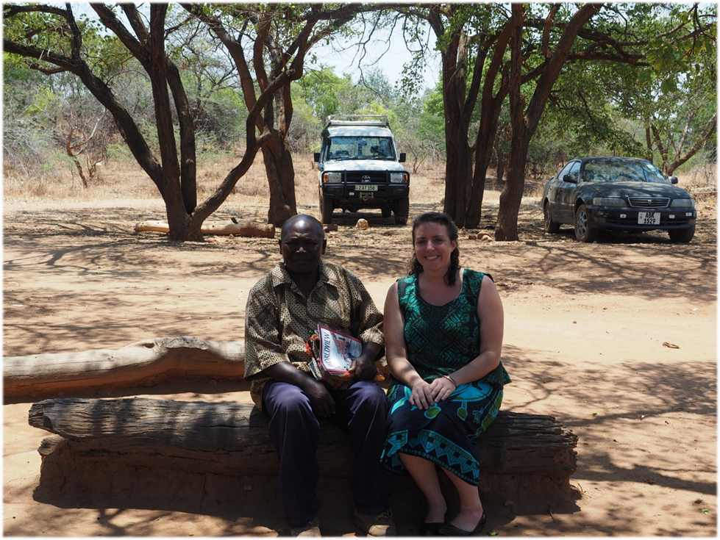
© Sarah Sandrian 2015
Figure 6. His Royal Highness, Chief Moyo with Peace Corps Volunteer, Sarah Sandrian
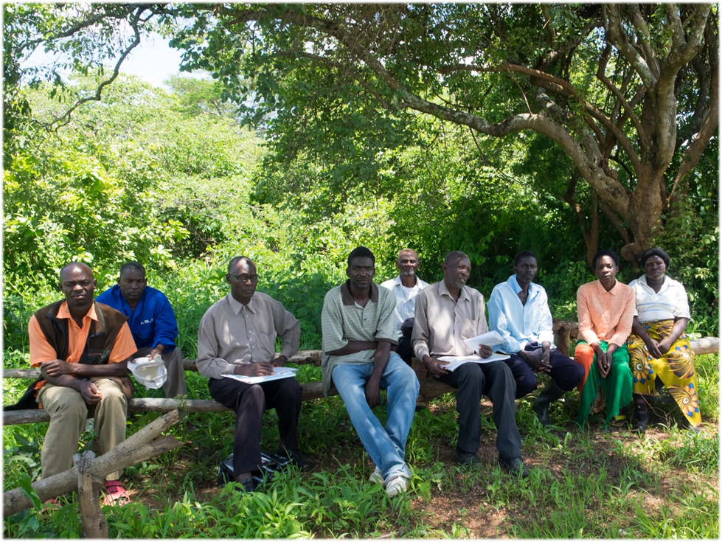
© Sarah Sandrian 2015
Figure 7. Photograph of Some Members of the Chiyumbabeenzu Health Post Mother's Shelter Committee

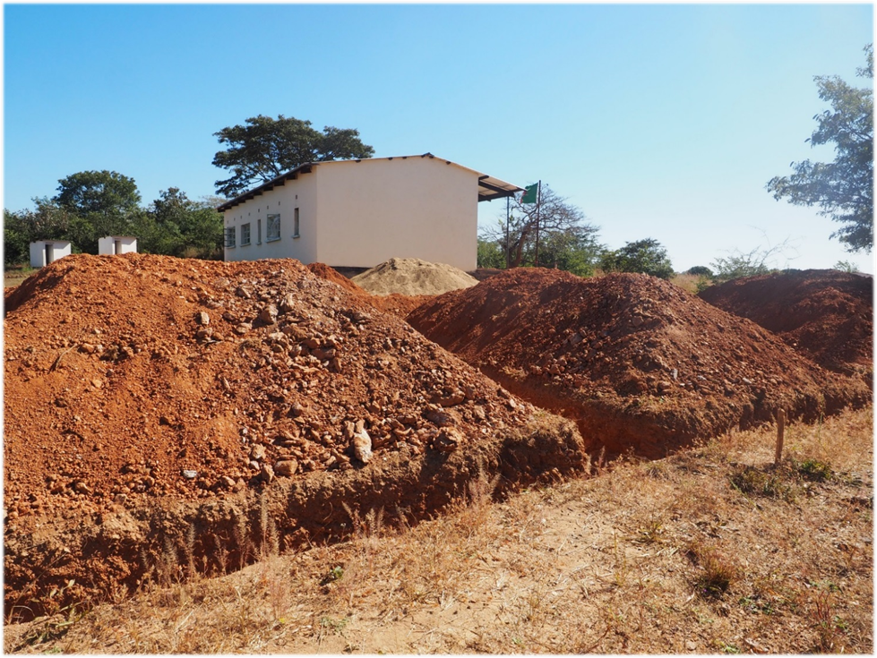
© Sarah Sandrian 2015
Figure 8. Photograph of the Mother's Shelter Foundation Digging
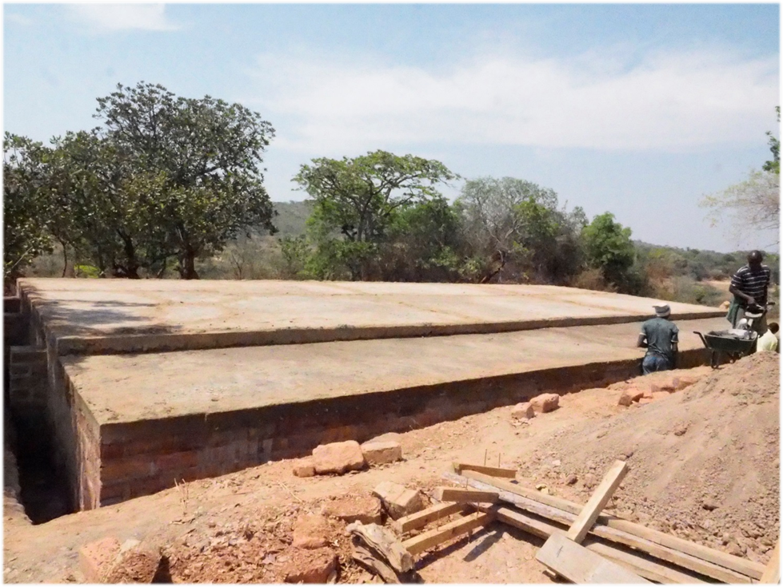
© Sarah Sandrian 2015
Figure 9. Photograph of Cemented Mother's Shelter Foundation
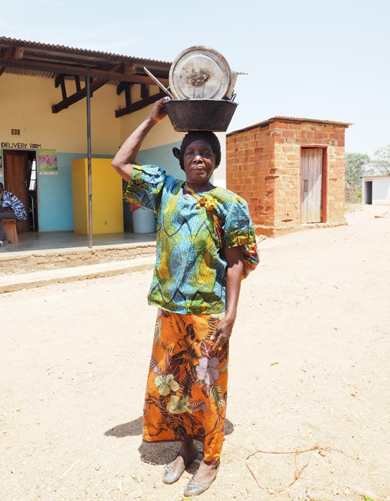
© Sarah Sandrian 2015
Figure 10. Photograph of Community Participant Returning Home after the Workday
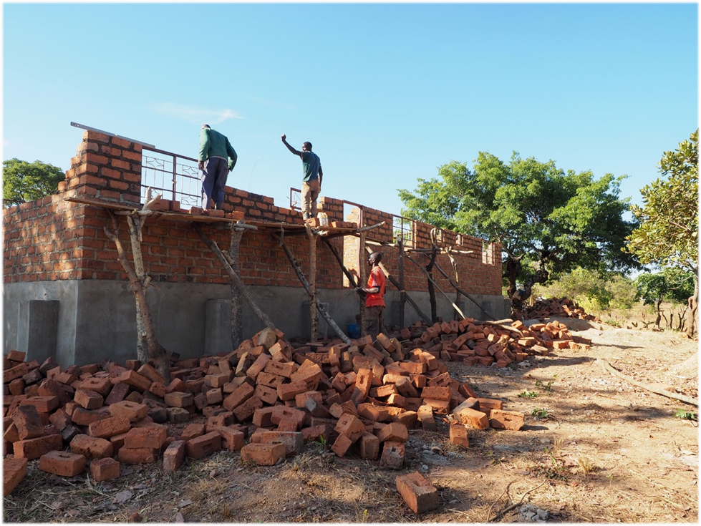
© Sarah Sandrian 2015
Figure 11. Photograph of Kiolios, the Mason and Two Apprentices Hard at Work

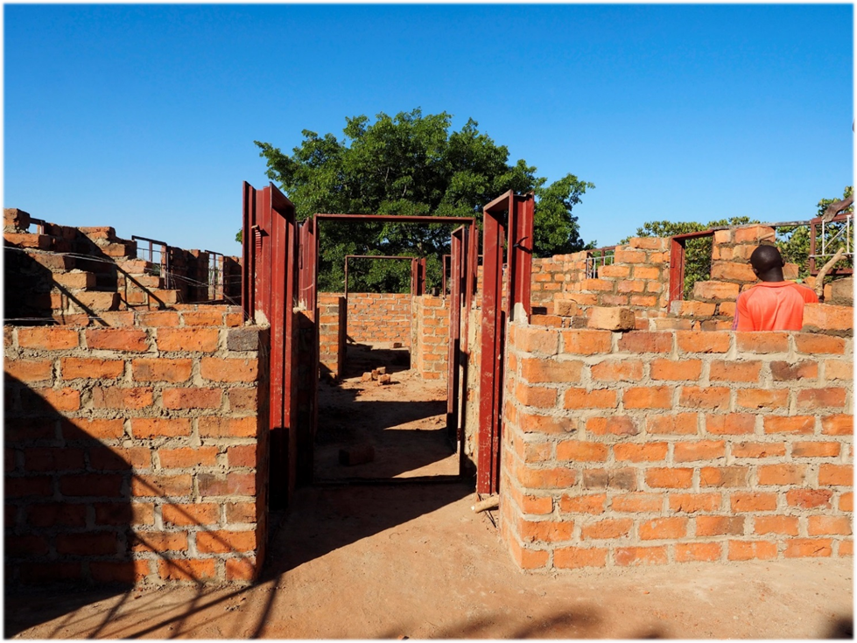
© Sarah Sandrian 2015
Figure 12. Photograph of Progress on the Inside of the Mother's Shelter
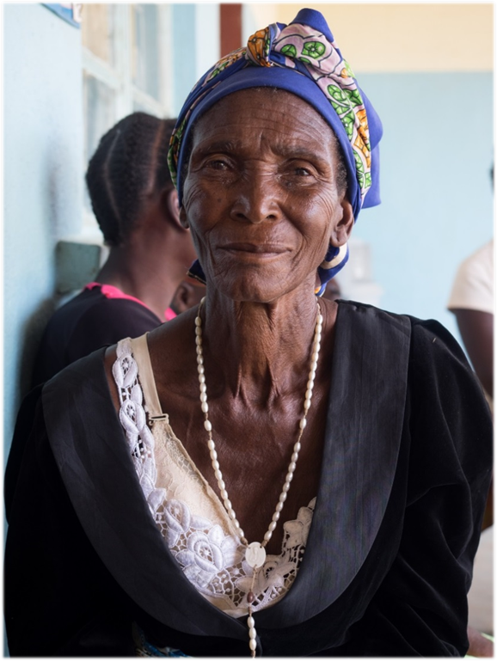
© Sarah Sandrian 2015
Figure 13. Photograph of a Great-Grandmother and Mufungu Community Elder

Shelter Opening and community celebration
On January 26, 2016, the author, the Mufungu community came together to celebrate the completion and official opening of the Chiyumbabeenzu Health Post Mother’s Shelter. Over 200 district officials, traditional leaders, health care workers, and community members came to the ceremony to dance and to give presentations lauding the benefits of the freshly completed mother’s shelter. Chief Moyo and district officials complimented Mufungu’s dedication to such an important project. Community members thanked donors for their generous contributions to Mufungu maternal health improvement. The PCV thanked the community for making the mother’s shelter project the success that it was. Figures 14-17 below display the finished mother’s shelter and the exuberance of the Mufungu community during the Luyando Mother’s Shelter opening ceremony on January 26, 2016.

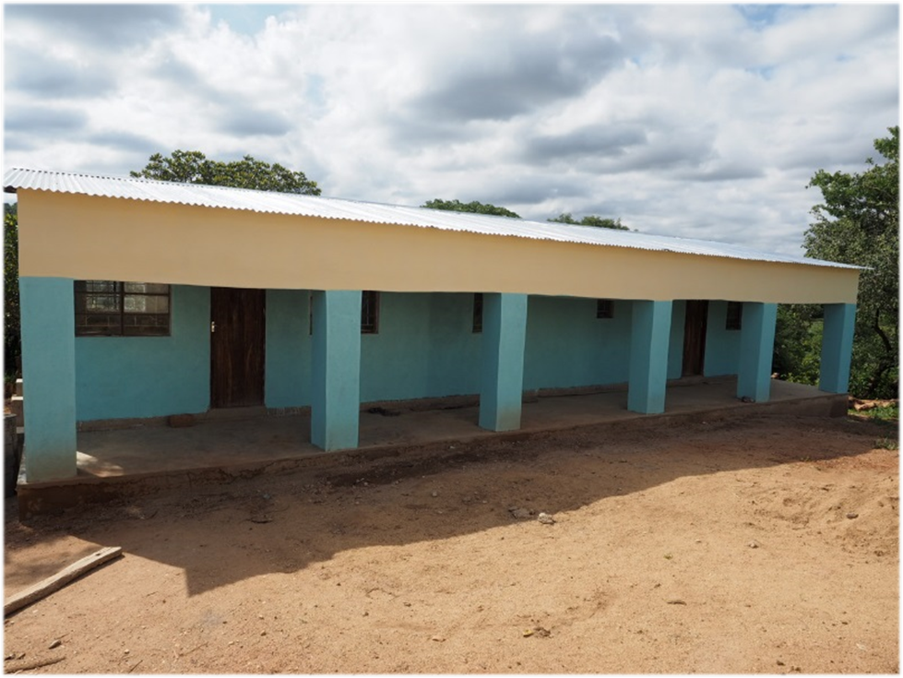
© Sarah Sandrian 2016
Figure 14. Photograph of the Completed Mother's Shelter

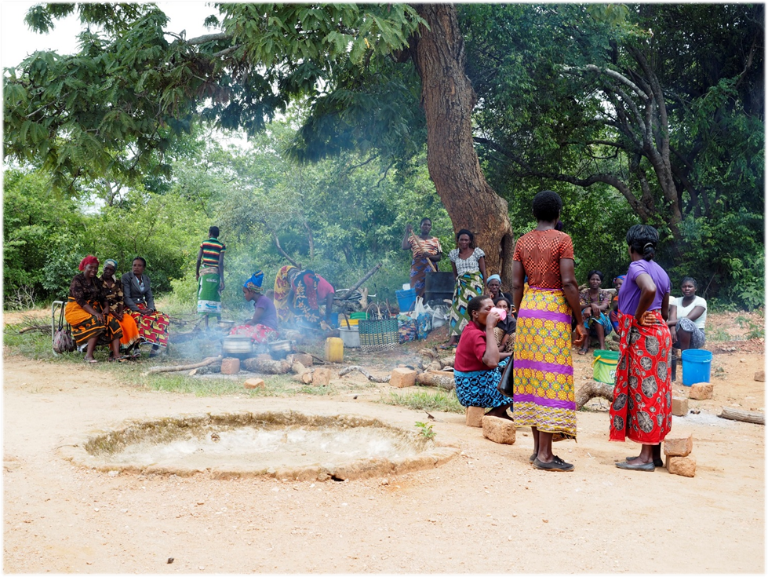
© Sarah Sandrian 2016
Figure 15. Photograph of Women Preparing Food for the Mother's Shelter Opening Ceremony

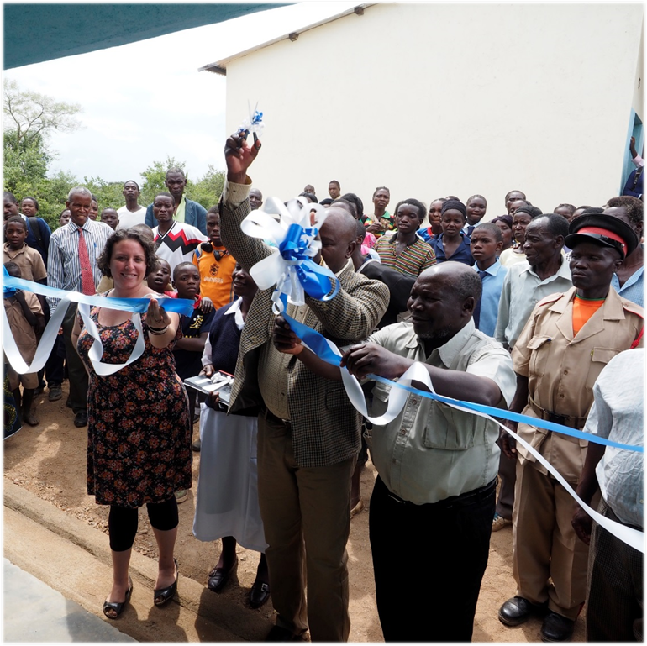
© Sarah Sandrian 2016
Figure 16. Photograph of Community Leaders and the Peace Corps Volunteer Cutting the Mother's Shelter Ceremonial Ribbon
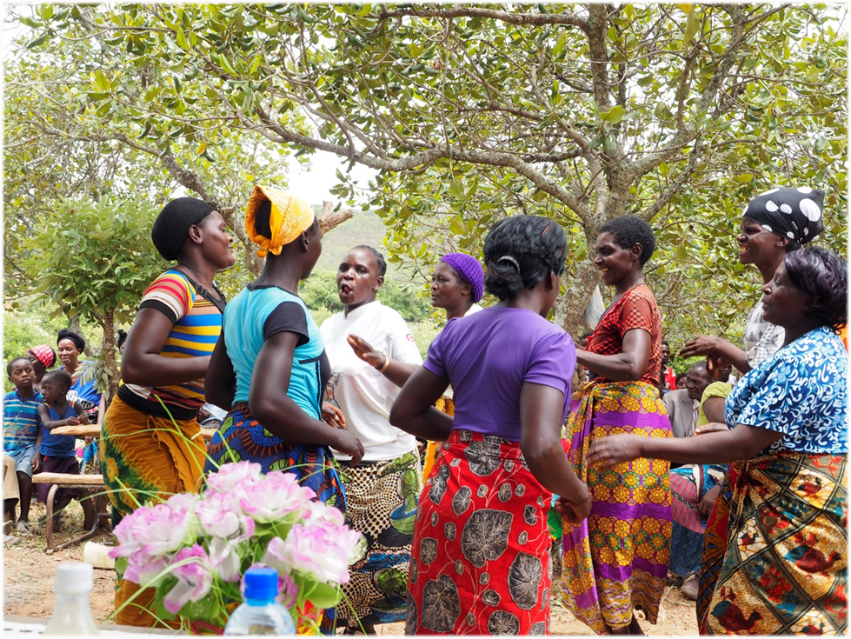
© Sarah Sandrian 2016
Figure 17. Photograph of Women Dancing at the Mother's Shelter Opening Ceremony

DISCUSSION
As the described intervention was under way, many events and circumstances occurred up that either enabled progress or hindered the project in some way. Many public and maternal health impact implications came out of the work that was done. In this section, a SWOT analysis of the mother’s shelter implementation is presented, and potential impact as well as recommended next steps are discussed.

SWOT Analysis

Strengths
Throughout the course of implementing this infrastructural capacity-building intervention, the author encountered many factors that enabled the project to carry out successfully. The greatest and most consistent strength or enabling factor was the involvement of and ownership by Mufungu community members. Men and women from all over Chiyumbabeenzu Health Post’s catchment area traveled to the construction site every day to bring building materials or to assist the builders. Cultural norms prevented women from participating in the actual bricklaying and masonry of the project, but they contributed to the construction by hauling the water used to mix cement or by cooking meals for the bricklayers. As previously stated, over 180 community members, or nearly 10% of the Mufungu community contributed to the mother’s shelter addition in one way or another. In this way, the Mufungu community claimed ownership of the addition, even though the project was largely funded by a Peace Corps Partnership Program grant.
Another strength of this project was the dedication to its completion on the part of stakeholders like Pemba District MOH officials, health post staff, the mother’s shelter committee, and the PCV. Each of these stakeholders took their role in the project very seriously and contributed various and complementary abilities to carry out necessary tasks. For example, the district officials’ periodic site visits and contributions of mother’s shelter beds, equipment, and solar unit, were critical to ensuring quality construction of the addition and use of the building for the appropriate medical procedures thereafter. Health post staff worked as liaisons between district officials, the PCV, the mother’s shelter committee, and community members by notifying folks of meetings, keeping construction materials secure at the health post, and by generally serving as a sounding board for the committee and the PCV around navigating any political or cultural issues that might have arisen. The mother’s shelter committee made the effort to select the best contractor, Kiolios, from a pool of contractors who bid for the project. Kiolios worked with committee members to guide the PCV in purchasing necessary materials and negotiating fair prices for items. The PCV enabled the project by writing the PCPP grant application and by working with the mother’s shelter committee to coordinate and manage the donation of locally sourced materials as well as the purchase of non-locally sourced building materials.
All of the above-mentioned strengths point to a more general, intangible asset of the Mufungu community: its dedication to improving the health of its people. This asset was observed by the author on numerous occasions throughout the project’s implementation, in the timely contribution of large quantities of building materials by each of the 11 villages in Mufungu, by daily work at the construction site for eight months, and the opening celebration, which participation from over 250 community members and stakeholders.

Weaknesses
Overall, the mother’s shelter construction intervention was carried out successfully, but there were challenges along the way and improvements that could be made in future iterations of similar concepts. Some of challenges that arose related to communication barriers between the PCV and the builder and mother’s shelter committee. Zambians typically keep time by considering weather patterns rather than day-to-day tasks and time schedules. At the outset of the project, the PCV, committee, and head builder discussed a six-month timeline from grant-writing to construction completion. The PCV was unaware at the beginning of the project that setting a six-month implementation schedule would translate to a one-year timeline.
Another challenge for the author was working with Pemba District MOH officials. This partnership was problematic at times, because it was difficult to fit Mufungu’s modest maternal health infrastructure improvement needs with country-wide MOH standards that district officials were insistent on using. Originally, Mufungu wanted to build a smaller, two-room addition onto Chiyumbabeenzu Health Post. Creating a smaller addition would have left some room in the budget to conduct a SMAG training that would have increased use of the mother’s shelter addition. Unfortunately, Pemba District officials had to follow guidelines set for all of Zambia’s mother’s shelters, and therefore Mufungu had to adhere to the same guidelines when constructing its mother’s shelter.
Another major limitation in the implementation of this project was the inability to gather evidence of the impact of the mother’s shelter on maternal health in Mufungu. The project was completed only three months before the end of the PCV’s service in Mufungu, so it was not possible to determine if having access to the mother’s shelter increased the number of births taking place at Chiyumbabeenzu Health Post or decreased the number of maternal deaths in the area.

Opportunities
As mentioned in the previous section, Mufungu community and the author were interested in adding an educational training component to the project in addition to the mother’s shelter construction. Because a training could not be addressed with the available funding, it did not take place, but remains a complementary next step for the community in improving maternal health. This component involves finding two literate representatives from each of the community’s 11 villages to participate in a week-long Safe Motherhood Action Group (SMAG) training. The training, a plan for which is laid out in the appendix of this paper (Sandrian, 2017), touches on numerous factors involved in safe pregnancy monitoring like PMTCT, proper nutrition, and pregnancy warning signs. Trained SMAG members are also responsible for encouraging women to deliver their children at the health post and for assisting them with travel to the facility.
Another opportunity this project brings to Mufungu is the potential for the government to hire more trained personnel to join the Chiyumbabeenzu Health Post’s staff. Pemba District MOH officials were very impressed by the Mufungu community’s dedication to health promotion and the mother’s shelter project. As such, the officials are likely to recommend the hiring of another health post staff member, most likely in the form of a nurse. Having another trained health professional on the team will increase Chiyumbabeenzu Health Post’s capacity for treating outpatient procedures and reduce the burden of workflow that is currently being managed by five staff members. A second nurse will also help in managing potential workflow surges brought about by increased facility deliveries. An additional government hire will also provide the benefit of swelling economic growth in Mufungu. As a salaried member of the Zambian work force, a nurse will have the ability to purchase produce, livestock, and building materials from local community members which will have a cascade effect of enabling merchants and farmers to better provide basic needs for their families.

Threats
Because of community and stakeholder buy-in, the construction project was completed and there are very few physical or climatic threats to the mother’s shelter. Rather, the major threat to the success of this project is a lack of increased trained health professional capacity at Chiyumbabeenzu Health Post. Just as this project provides the perfect opportunity to increase health professional capacity in Mufungu, there is a possibility that government officials would choose not to place another health professional in the community or not have the resources to do so. At the time that this project was implemented, it seemed likely that government officials were likely to increase health professional capacity at Chiyumbabeenzu Health Post, but it was contingent upon receiving the appropriate funding allocations from provincial and national MOH authorities. If Mufungu does not receive another health personnel, the mother’s shelter might increase the number of facility deliveries to a point that the available staff would not be able to handle the workflow.

PUBLIC HEALTH IMPLICATIONS AND POTENTIAL IMPACT

Maternal health
The mother’s shelter at Chiyumbabeenzu Health Post may have a great impact on maternal health in the Mufungu community, although specific changes in maternal mortality remain to be seen. It is expected to address the three delays in perinatal health service uptake by increasing awareness of the importance of a facility-based delivery (first delay); by alleviating the issue of traveling to a health facility on foot while in labor by providing them a safe space to stay in advance (second delay); and by providing a clean, safe environment and access to quality care at the health facility (third delay). An additional benefit of the mother’s shelter that speaks to the third delay is that delivering at the clinic will enable care providers to transport patients who require more sophisticated care more quickly than if a woman who delivers at her home some distance from the health facility.

Family and community health
By improving maternal health in Mufungu, it is expected that a positive improvement in health will be seen in families and the rest of the Mufungu community. Family and community health go hand-in-hand, especially in Zambia where one’s neighbor is considered as a brother or sister. In Zambian culture, it is customary for mothers to serve as the family’s primary caregiver, responsible for cooking, childcare, childrearing, and cleaning. If a woman dies during childbirth and leaves children behind, the eldest daughter, even if very young, is expected to take on the duties of her mother. This takes a child from school causing a ripple effect and puts her at greater risk for poor health outcomes in the future- gender-based violence, child marriage and HIV, and deteriorated health from early pregnancy, lack of birth spacing, and high fertility rates. Evidence suggests that when a girl stays in school longer, she improves her chances of avoiding the poor health outcomes mentioned above. Therefore, if maternal mortality is reduced in rural areas of Zambia where it is most pervasive, it follows that their children, and particularly their daughters, will have the chance to have better health outcomes by being able to remain in school longer, to delay marriage, and to reduce lifetime fertility.

NEXT STEPS

Mufungu community
As previously mentioned, Mufungu can take several steps in the future to increase the community’s maternal health capacity. One of the first steps is the implementation of a program plan for increasing SMAG members in the community. Trained SMAG members will have the ability to improve maternal health outcomes by increasing antenatal care, facility delivery, and postnatal care among women of reproductive age in Mufungu. SMAGs can also create a network of women working towards improving the health and economic status of fellow women in their community. When women have better perinatal health and nutritional status, they will be able to participate in community based organizations, such as women’s empowerment groups, community gardens, and income-generating activities that will allow women to provide sustenance and income for their families in more efficient, team-centered ways. One of the goals of this project is to create greater awareness of the need to prioritize maternal health in the Mufungu community. Out of that awareness, the author hopes that women in Mufungu will feel empowered and impassioned for the cause of maternal health such that one of more will aspire and train to become nurses or midwives who can provide skilled care for communities like the one they come from.

Zambia
Country-wide recommendations for improving maternal health in the future center around technological and data transparency improvements. In addition to continued scale-up of SMAG trainings, the MOH must concentrate its efforts on improving data collection and allocating resources to appropriate recipients, or communities most in need of maternal health services. As Jacobs et al. point out in their 2017 publication, policymakers are aware that maternal health service utilization is lower in rural parts of Zambia compared to urban centers, but just what those utilization rates are is unclear. Jacobs et al. (2017) explored maternal health services uptake in a few communities of Luapula Province, Zambia, and found that the percentage of rural women receiving maternal health services in their study (n=551) was lower than reported findings for rural women in the 2013-2014 ZDHS. For example, in the Luapula communities of interest, only 69% of women had at least one antenatal visit and 29% had at least four antenatal visits (Jacobs et al., 2017).
The 2013-2014 ZDHS (2015) reported that 94% of rural women received some form of antenatal care during their most recent pregnancy and that 73.4% of rural women had four or more antenatal care visits. These differences point to a discrepancy between country-level data and more targeted, community-specific information. If Zambia wants to improve health outcomes for its most vulnerable citizens, it must work to improve data collection practices so that resources can be appropriately directed to communities that need them most.

CONCLUSION
The subject of this paper was a structural intervention aimed at improving maternal health outcomes in rural Zambia. Two years living and working in Zambia as a Peace Corps Volunteer provided the author with the unique opportunity to partner with a local community to implement a health infrastructure improvement intervention. Aware of the barriers women in the community faced, Mufungu community of Southern Province, Zambia decided to construct a mother’s shelter addition at Chiyumbabeenzu Health Post. The result of the year-long project was the construction of a three-room, mother’s shelter addition that will serve the community’s 2670 people and anticipated 144 births per year.
Integral to the Peace Corps’ mission and success of the project was involvement of numerous stakeholders in the Mufungu community, from the PCV and US private donors to Pemba District MOH representatives, Chiyumbabeenzu Health Post staff, and Mufungu community members. Stakeholders obtained and utilized a $5,000 Peace Corps Partnership Program grant to fund the purchase of goods and services that could not be locally sourced, and the community donated approximately $2,000 worth of in-kind contributions to the project in the form of locally sourced materials and volunteered labor.
Although the PCV and various stakeholders encountered challenges along the way, the project was completed successful and has many public health implications for improving maternal health in the Mufungu community. This project is expected to improve maternal health indicators by addressing the three delays in accessing maternal healthcare. This project is also anticipated to improve health of neonates by providing access to care during the first critical moments of life and of the entire Mufung community by improving health of mothers, who provide essential family functions in both the reproductive and productive spheres. As Zambia continues to develop and take steps to reduce maternal mortality, it must focus on continuing to provide infrastructural improvements that will better accommodate expectant mothers and on improving data collection and transparency so that available resources can be allocated to communities that need them most.

APPENDIX: PROGRAM PROPOSAL

Found in this appendix is the unpublished program plan “Scale-Up of Safe Motherhood Action Groups in Rural Zambia,” written by the author of this paper in April 2017. The proposal beginning on the following page is intended as the next step for improving maternal health outcomes in the Mufungu community.
United States Agency for International Development
1300 Pennsylvania Ave NW
Washington, DC 20004
Subject: Annual Program Statement Number: APS-22144-879-2015 Innovation for Health

Scale-Up of Safe Motherhood Action Groups in Rural Zambia
SMAG-RZ

Dear Prospective Officers,

Zambia’s maternal mortality ratio is one of the highest worldwide due to lack of healthcare personnel as well as poor health and community infrastructure. In many parts of the country, women have difficulty getting to health facilities to deliver their children because they have to travel long distances on foot. The evidence-based intervention, Saving Mothers, Giving Life (SMGL), has been shown to be effective in parts of Uganda and Zambia in the past. Through funding from this grant, Luyando Maternal Health International (LMHI) seeks to reduce maternal mortality in Zambia by partnering with the Ministry of Health and SMGL to modify and adapt a new rollout of their Safe Motherhood Action Group (SMAG) training. This rollout will be different from past iterations of SMAG because it will target some of the rural regions missed in past interventions. By training dedicated community members in SMAG, LMHI will increase the number of folks at the community level who are knowledgeable about safe maternal health practices. The program will create a team of community health workers specifically devoted to monitoring pregnant women and assisting them to seek skilled antenatal, delivery, and postnatal care. Attached to this document is a detailed description of the SMAG-RZ. We at Luyando Maternal Health International hope that you will find SMAG-RZ a worthwhile joint venture for the advancement of maternal health in Zambia.

Sincerely,
Sarah Sandrian
Executive Director
Luyando Maternal Health International (LHMI)
130 De Soto Street
Pittsburgh, PA 15217
LIST OF ACRONYMS

ANC Antenatal Care
CBOs Community Based Organizations
CHW Community Health Workers
DHO District Health Office
EBI Evidence-Based Intervention
LMHI Luyando Maternal Health International
M & E Monitoring and Evaluation
MMR Maternal Mortality Ratio
PCZ Peace Corps Zambia
PMTCT Prevention of Mother to Child Transmission of HIV
RHP Rural Health Post
RPCV Returned Peace Corps Volunteer
SMAG-RZ Scale-up of Safe Motherhood Action Groups in Rural Zambia
SMAGs Safe Motherhood Action Groups
SMART Specific, Measurable, Attainable, Relevant, Time-bound [Objectives]
SMGL Saving Mothers, Giving Life
WHO World Health Organization

TABLE OF CONTENTS
- TECHNICAL APPROACH
  - Statement of the Problem
  - Results Framework
  - Goals and Objectives
  - Intermediate Results and Activities
  - Implementation Plan
    - Timeline of Activities
    - Logic Model
    - Gantt Chart
  - Staffing Plan
    - Key Personnel
    - Organizational Structure
  - Collaboration with Stakeholders and Partners
    - Description of Stakeholders
    - Diagram of Relations and Interactions with Stakeholders
  - Management Plan
    - Collaborating with USAID and Other Partners
    - Sub-Grantee Partner Roles
  - Performance Reporting
    - Annual Work, Performance Management, and Evaluation Plan
      - Short-term Work, Performance Management, and Evaluation Plan
      - Medium-term Work, Performance Management, and Evaluation Plan
      - Long-term Work, Performance Management, and Evaluation Plan
    - Quarterly, Annual, and Final Evaluation Reports
  - Sustainability Plan
    - Sustaining Positive Outcomes of SMAG Scale-up
    - Future Funding Sources
- ORGANIZATIONAL CAPACITY
- COST PROPOSAL
  - Summary Budget, Annual Budget and Justification
- LETTERS OF SUPPORT
- REFERENCES CITED

- TECHNICAL APPROACH
  - Statement of the Problem
Zambia’s maternal mortality ratio is one of the highest in the world at 480 per 100,000 live births (UNICEF, 2014), and the lifetime risk of maternal mortality is 1 in 59 (UNICEF, 2014). Of note is that while 98.6% of urban women and 94.0% of rural women report receiving antenatal care from a skilled provider, only 84.4% of urban women and 51.4% of rural women deliver at a health facility, according to the Zambia Demographic and Health Survey of 2013-2014. These numbers clearly depict a disparity of facility delivery access between urban and rural Zambian mothers. Delays in traveling to a facility for delivery have been shown to be a great contributor to maternal mortality worldwide (Thaddeus & Maine, 1994). It follows then, that regions of Zambia with less access to facility delivery also have higher maternal mortality, though that statistic is not available.
Two years living and working in rural Zambia provided the opportunity to observe many nuances of the health care system and the dissemination of resources in the rural villages of Southern Province, Zambia. It is highly plausible that available data have a low level of accuracy or large gaps, because clinic staff and volunteers responsible for collecting this information are often overwhelmed by patient flow or have not been formally trained in data collection. Furthermore, data collected are often reported only in terms of quantitative information, rather than qualitative information. More qualitative data is necessary for several reasons: to gain an understanding of where exactly high rates of maternal mortality are occurring in Zambia and why, and to access invaluable information from all stakeholders about where rural Zambian mothers are giving birth, the complications that arise during labor, and feasible, attractive solutions to accessing assisted delivery care.
The evidence-based intervention (EBI) Saving Mothers, Giving Life (SMGL) has been shown to be successful in both Uganda and Zambia at addressing the ‘Three Delays’ in accessing maternal healthcare i.e., delays in: seeking services, traveling to health facilities for delivery, and receiving timely, quality care once facilities are reached (Serbanescu et al., 2017,). SMGL has been implemented successfully in both Uganda and Zambia. Uganda has seen a 30% drop in maternal mortality ratio, a 62% increase in facility delivery, as well as 35% reduction in maternal mortality ratio in the first year of program implementation (Serbanescu et al., 2017). Zambia has seen similar reductions in maternal mortality ratio, and a 35% increase in facility delivery (Serbanescu et al., 2017).
The implementation team on this grant will use qualitative and quantitative research focused in rural areas of Southern Zambia to evaluate SMGL’s effectiveness and to modify the program to be more successful. This research, conducted and analyzed over the course of one year, will be used to inform and to improve a second rollout of SMGL, specifically the component of training Safe Motherhood Action Groups (SMAG) in rural parts of Pemba District, Southern Zambia.
  - Results Framework
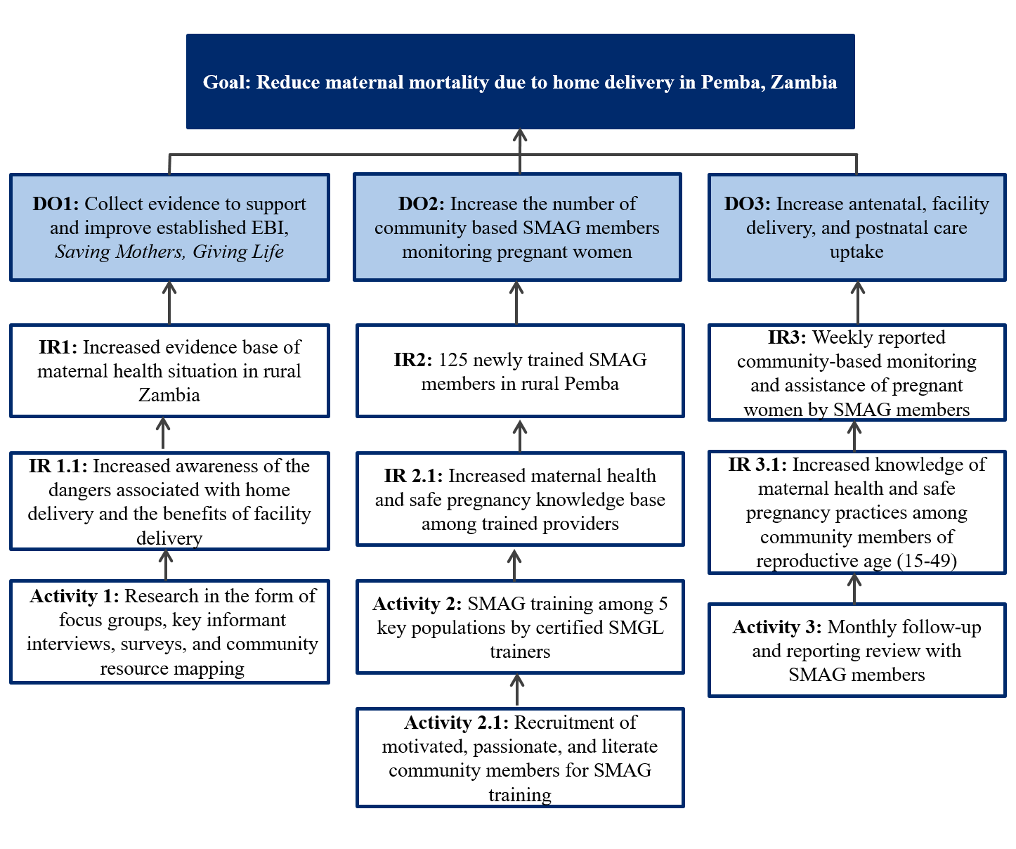
  - Goals and Objectives
The overall aim of this project is to reach 300 women of reproductive age from each of five rural health posts in Pemba District, Zambia, 1500 women total over the course of three years, with access to skilled maternal health care. The grant funds will enable Luyando Maternal Health International (LMHI) to reduce the burden of maternal mortality in Zambia by implementing a two-pronged program that addresses the need for skilled birth assistance and increased facility delivery. LMHI’s two-pronged approach will address maternal mortality by first increasing the base of evidence about maternal health access at the Zambian village level, where it is currently unavailable and arguably most needed, through a series of mixed-methods data collections, and second by adapting the successful SMGL to train a successful, sustainable cohort of SMAG members. Once a successful pilot is carried out in Pemba District, Southern Zambia, the program will then be disseminated to other districts of Southern Province, Zambia as well as provinces throughout the country.
  - Intermediate Results and Activities
The first intermediate result, IR1, of SMAG-RZ is an increased evidence base about the maternal health situation in rural parts of Zambia to improve the already established EBI, SMGL. While accomplishing this goal, the team also aims to increase awareness of the dangers associated with home delivery and of the benefits of facility delivery in Pemba (IR 1.1). IR1 and IR 1.1 will be accomplished via extensive data collection and analysis in the form of focus groups, key informant interviews, surveys, and community resourcing during the first year of the program. The information collected during the first year of the intervention will then be used to implement an adapted version of SMGL’s SMAG training in the second year. This activity cannot be successful without first recruiting motivated, passionate, and literate community members to participate in SMAG trainings. These activities will help LHMI to accomplish IR2 and IR 2.1, training of 125 SMAG members in rural Pemba and increased knowledge of maternal health and safe pregnancy measures among trained providers, respectively. The final intermediate result, IR3 is weekly community based monitoring of and assistance for all pregnant women in the community by new SMAG members, which also coincides with IR 3.1, increased knowledge of maternal health and safe pregnancy practices among community members of reproductive age (15-49). This result will be accomplished beginning in the third year of the intervention through monthly report reviews of SMAG member reports by the District Health Office (DHO), health post staff, and SMAG members.
  - Implementation Plan
The SMAG-RZ program will be implemented over a period of three years. Maternal health status data will be collected in the first year, SMAG trainings conducted during the second, and sustainability monitoring during the third. Monitoring and evaluation of every step of SMAG-RZ will be conducted throughout the three-year program and evidence of such will be compiled for a final evaluation report. A detailed layout of objectives, activities and timeline is provided in the following sections in the form of a logic model, Gantt chart, and activity timeline.
    - Timeline of Activities
The first phase of the project, carried out over the course of the first year, will involve mixed methods data collection by all members of the research staff via focus groups, key informant interviews, surveys, and community mapping sessions. These research methods will be conducted with several different groups of Zambians, namely, district level MOH officials, health post staff, political leaders, traditional leaders, and women and men living in rural villages of Pemba. The team will conduct two focus groups with each of the previously listed groups of stakeholders with 6-12 participants each, five community mapping sessions with 25 community members each, 50 key informant interviews with 10 informants from each of the five target communities, 125 surveys with 25 community members from each of the five health post catchment areas. Qualitative data collected will then be used to modify, adapt, and implement SMGL’s EBI, SMAG training.
The second phase of the program, SMAG training, will be conducted in coordination with Pemba District health officials and two certified SMAG trainers from Southern Province. Before carrying out the SMAG trainings, health post staff and community leaders from each of the five targeted health posts in Pemba will select 25 SMAG trainees who have proven to be literate, motivated, and passionate about improving maternal health in Pemba District. The 125 SMAG recruits will be trained and certified during a series of five two-week trainings, one training for each of the five targeted health posts. The five SMAG trainings will take place over the course of the second year of the program.
During the third phase and year of the SMAG-RZ program, the new SMAG cohort will be responsible for working their health post catchment areas to conduct health education discussions with community members in addition to weekly monitoring and assistance of all pregnant women in their region. SMAG members will be responsible for creating weekly written reports of their findings during pregnancy monitoring. SMAG members will have monthly meetings with district health officials and health post staff to review weekly reports from the previous month and discuss any urgent or troubling pregnancy cases to determine appropriate next steps. During the third year, LHMI will work closely with the new SMAG cohort and health post staff to facilitate the previously described activities in any way possible.

    - Logic Model
Inputs |  | Activities | Participation | Short Term | Medium Term | Long Term
Grant funds, Time (three years), Office Supplies and Equipment | 8 Staff Members | 10 focus group discussions, 50 key informant interviews, 125 surveys, and 5 community resource mapping sessions | 400-420 Pemba community members, health post staff, district health officials, traditional and political leaders | Increase awareness of the dangers associated with home delivery and the benefits of facility delivery | Increase evidence of the maternal health situation in rural Zambia | Reduce maternal mortality due to home delivery in Pemba, Zambia
 | Questionnaires, Interview and focus group materials, Tape recorder, Office supplies
 | 2 SMAG Trainers, health post staff, community leaders | 125 trainee recruitment and 5 SMAG trainings | 125 recruits | Increase maternal health and safe pregnancy knowledge base among trained providers in Pemba | Certify 125 new SMAG members in rural Pemba
 | Educational materials for trained SMAG members | 125 trainee recruitment and 5 SMAG trainings | 125 recruits |  | Increase the number of community based SMAG members monitoring pregnant women
 | Health post staff, district MOH officials, SMAG-RZ staff | On-going weekly community monitoring and reporting | Pregnant women in health post catchment areas | Increase knowledge of maternal health and safe pregnancy practices among community members of reproductive age in Pemba | Weekly reported community-based monitoring and assistance of pregnant women by SMAG members and monthly report reviews
 | Health post staff, district MOH officials, SMAG-RZ staff | On-going monthly review meetings | New SMAG cohort, pregnant women in health post catchment areas |  | Increase antenatal, facility delivery, and postnatal care uptake by women of reproductive age in Pemba
Assumptions: Grant resources are available; cultural competence training for entire implementation prior to intervention; Health Belief Model: stakeholders are interested in improving maternal health but have not yet had access to infrastructure to overcome barriers.
External Factors: Barriers include: seasonal changes that would prevent community members from attending meetings, like heavy rain or harvest season; the Zambian cultural practice of attending functions late; language and communication. Facilitators include: Zambian enthusiasm for increased health care access, a skilled team of researchers; collaboration with Zambian MOH.

    - Gantt Chart
 |  | PY1 |  |  |  | PY2 |  |  |  | PY3
ACTIVITY | PERSONS INVOLVED | Q1 | Q2 | Q3 | Q4 | Q1 | Q2 | Q3 | Q4 | Q1 | Q2 | Q3 | Q4
PHASE I
Develop all research materials | Project Manager (PM), Research Team- 6 Members (RT)
Conduct all research methods | PM, RT
Analyze collected data | RT, CFO
PHASE II
Educational materials collection | SMAG Trainers I & II
Recruit SMAG trainees | Health Posts Staff, Community Leaders
Conduct 5 SMAG trainings | SMAG Trainers I & II
PHASE III
Weekly community monitoring and reporting | SMAG Cohorts I, II, III, IV & V
Monthly report review | SMAG Cohorts I-V, Health Posts Staff, MOH District Officials
MONITORING & EVALUATION
Ongoing monitoring and evaluation of program activities | PM, RT, Health Posts Staff, MOH District Officials, Community Leaders, CFO
Final evaluation | PM, RT, CFO

  - Staffing Plan
This project requires an implementation team of several well qualified and trained staff members. A project manager (PM), chief financial officer (CFO), Zambian researchers/translators, and American researchers have been selected from LMHI to participate in SMAG-RZ after a rigorous, open-hire application process. The specific roles are described in further detail in the sections that follow. Salary information is later detailed in sections 3.1 and 3.2.
    - Key Personnel
Project Manager: The program manager and point of contact is Sarah Sandrian, a MPH and Returned Peace Corps Volunteer who has specific knowledge and trust of the target community. She will be responsible for overall project management, community engagement, data collection and analysis assistance and collaboration with partners and stakeholder.
Chief Financial Officer: The chief financial officer, to be announced (TBA) will be a certified financial adviser and statistician with an MBA in Humanitarian Program Management. S/he will perform daily budgeting tasks and grant fund management, oversee all financial expenditures, and assist with statistical analysis of collected data.
Zambian Researchers/Translators I & II: During the hiring process, LMHI will select two applicants, TBA, who not only hold PhDs in Behavioral Epidemiology, but are also fluent in Zambian native languages and English. The two Zambian team members will be responsible for data collection, stakeholder and participant engagement, general conversation translation, and transcript translation in coordination with their four English-speaking counterparts.
General Researchers I-IV: LMHI will also select four general researchers with either MPH or PhD degrees in Behavioral and Community Health Sciences, Epidemiology and Biostatistics. The four general researchers will be responsible for conducting quantitative and qualitative research collection, USAID and partner engagement, data analysis, and general administrative tasks.
SMAG Trainers I & II: LMHI has contracted with two certified SMAG trainers located Southern Province, Zambia. The two trainers will work together to conduct five two-week SMAG trainings. The SMAG trainers will coordinate all training materials in advance of the program.
SMAG Participants (125): As stated previously, a total of 125 SMAG participants will be selected, 25 from each of five targeted communities in rural parts of Pemba District, Southern Zambia. The trainees will participate in one of five two-week SMAG trainings during which they will learn about and be tested on topics like community engagement, birth spacing and safe pregnancy, pregnancy warning signs, PMTCT, patient follow-up and health facility travel accompaniment.

    - Organizational Structure
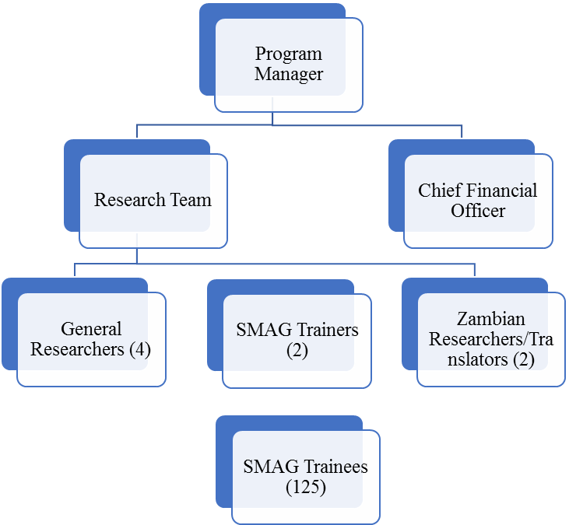

  - Collaboration with Partners and Stakeholders
To carry out a successful SMAG-RZ intervention, collaboration with partners and stakeholders is critical. Because Zambians tend to be extremely friendly and helpful, navigating stakeholder and partner relationships will be simple, as long as proper procedures are taken. Culturally, it is important to give deference to elders and to community leaders, like health officials, political officials, chiefs, headmen and health workers. The first three are on a similar respect level while headmen and health workers are regarded at the next level, above lay community members.
    - Description of Stakeholders
Pemba District has a wealth of stakeholders essential to the success of the SMAG-RZ program. LMHI considers the entire Pemba community to be a partner in this program’s implementation, but dissecting the community down further, several additional stakeholders also bear mentioning: MOH district officials, His Royal Highness Chief Moyo, district level political leaders, headmen, and health staff. The implementation team has approached MOH district officials, district level political leaders, and Chief Moyo to discuss the purview of the project, to gain their input and expertise in project development, and ultimately to gain their approval for the program’s implementation. Once grant funds are awarded, the implementation team will work with those same players to gain the trust and buy-in of other key stakeholders such as headmen, health staff, and the general Pemba community. SMAG-RZ staff will work with traditional leaders and health post staff from each of the five targeted regions of rural Pemba to conduct focus groups, key informant interviews, surveys, and community resource mapping; health post staff and traditional leaders will help with recruitment and enrollment by calling community resource meetings, sending focus group invitation letters to their villages, and by recruiting 125 SMAG training participants. Community members are another key stakeholder charged with the role of expert informants for focus groups, in-depth interviews, community resource mapping, and surveys.

    - Diagram of Relations and Interactions with Stakeholders

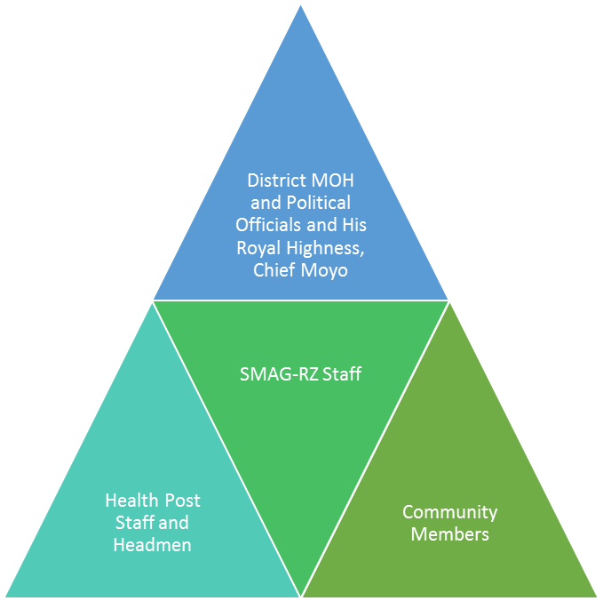

  - Management Plan
    - Collaborating with USAID
USAID is also a key stakeholder in this project. The SMAG-RZ team will reach out to the USAID project liaison with quarterly progress reports and as well as invite representatives to the final monitoring and evaluation presentation. The SMAG-RZ team will also be in constant contact with the project liaison to ensure that all USAID project implementation requirements are met.

    - Sub-Grantee Partner Roles
The success of SMAG-RZ also hinges on collaboration with two sub-grantee partners: SMGL SMAG trainers and SMAG training participants. The SMAG-RZ staff will work closely with trainers to ensure successful trainings at each of the five target communities. The implementation team will also work closely with SMAG participants to provide any resources possible to assist them in successful pregnant mother monitoring. For at least one year following their training, SMAG-RZ staff will still be present in the community to shadow and monitor the quality of care SMAG members are giving.
  - Performance Reporting
    - Annual Work, Performance Management, and Evaluation Plan
To ensure the success of this program, specific steps will be taken throughout the delivery process to collect data, evaluate impact and efficacy, and monitor program quality and cultural competence. The intent of the processes explained below is to incorporate local care providers and stakeholders as often as possible so that they can continue to progress towards maternal mortality elimination after the intervention has ended. The implementation team has identified Specific, Measureable, Attainable, Relevant and Time-bound (SMART) Objectives for the short-term, medium-term, and long-term of the project and expanded upon how the objectives will be met in sections 1.9.1.1-1.9.1.3 below.
      - Short-term Work, Performance Management, and Evaluation Plan
Short-term Outcome SMART Objectives (By one-year mark):
- From baseline, increase evidence about Pemba District’s maternal health situation and quality of care, by 100%.
- From baseline, increase awareness of the dangers associated with home delivery and the benefits of facility delivery by 65%.
The short-term SMART objectives will be met through a series of qualitative and quantitative data collection methods and tools, by various personnel and community partners. The collected data will aim at creating a base of evidence of each of the following: perceived barriers to facility delivery, reported quality of maternal health care, reported travel distance and methods to maternal care center, self-reported fertility rates and reasons for delivery locations, suggested solutions to barriers, reported use of skilled birth attendants, perceived importance/benefits of seeking skilled delivery assistance at health facilities, and perceived dangers associated with home delivery. To collect this information, 50 baseline key informant interviews (10 in each community) will be administered by the implementation team and one trusted and respected community health worker, recommended by the head nurse of each targeted health post. This interview will be administered again at the end of the three-year intervention to compare results.
Baseline surveys will be followed by focus groups (three in each community-one with men, one with women, one mixed men and women), one community resource mapping session in each community, and 25 orally administered surveys in each of the five target communities. Again, these methods will be carried out by the implementation team and a community health worker. Each of the topics listed above will be addressed in at least two of the methods mentioned here: focus groups, community resource mapping, and oral surveys. At this time, there are no comprehensive data sets that cover all of the topics mentioned above, so this data collection scheme will increase the available data on maternal health in Pemba District by 100%.
The second objective will be met by anticipated word of mouth in the community after the data collection methods described above are carried out. Repeated, widespread mention of maternal health will spark curiosity and grassroots discussion among community members. Additionally, data collectors will host optional question and answer sessions following each interview, survey, mapping session, and focus group to address any maternal health issues community members like.
      - Medium-term Work, Performance Management, and Evaluation Plan
Medium-term Outcome SMART Objectives (By two-year mark):
- From baseline, increase maternal health and safe pregnancy knowledge among trained providers by 60%.
- Certify 125 SMAG members, 25 in each of the five targeted communities, who will achieve at least 80% on SMAG certification post-test.
- Weekly reporting of community monitoring and education by 100% of newly certified SMAG members.
After SMAG recruits have been vetted for commitment, literacy, some baseline knowledge of the importance of perinatal care, and recommended for training target communities (20 recruits-men and women- from each community), they will be enrolled in one of five two-week SMAG trainings. Trainings will be conducted by certified SMAG trainers who will teach recruits methods of safe pregnancy monitoring and PMTCT, how to recognize pregnancy danger signs, proper pregnancy nutrition, importance of facility delivery, dangers of home delivery, health communication tools for community health ‘talks,’ and SMAG monitoring and evaluation responsibilities. The trainers will evaluate recruit preparedness through knowledge and practice based pre- and post-tests. In order to become certified, SMAG recruits must achieve an 80% on post-tests which is anticipated to be a 60% increase from the pre-tests. Once trained, SMAG members will begin their tasks of monitoring pregnant women in the community weekly and disseminating safe pregnancy information to community members through monthly health ‘talks’ in their respective villages. SMAGs’ weekly monitoring reports will be reviewed monthly with SMAGs by health post staff and a DHO representative for quality assurance. As the in three-year intervention is being carried out, one or two members of the implementation will also attend the monthly reviews and conduct surprise site visits with SMAGs to make sure they are performing their duties regularly and correctly.
      - Long-term Work, Performance Management, and Evaluation Plan
Long-term Outcome SMART Objectives (three-year & five-year marks):
- Over three-year implementation, increase antenatal, assisted delivery, and 48-hour postnatal follow-up care by 45% above baseline.
- Five years after the beginning of the intervention, reduce maternal mortality by 40%.
Antenatal, assisted delivery, and postnatal follow-up care are currently monitored in monthly reports for the DOH. As this intervention is carried out, the implementation team will work with health post staff to ensure quality of collection and reporting methods. The implementation team will also collect these indicators monthly throughout the three-year period to observe any changes from baseline indicators. At the three-year mark, all three indicators are expected to be 45% above baseline. Five years after the beginning of the intervention, one Zambian team member will return to the health posts to collect the same indicators and forward the information to the program director.
    - Quarterly, Annual, and Final Evaluation Reporting
All quantitative and qualitative data will be collected, compiled, coded if necessary, and analyzed on a quarterly basis. From the compiled and analyzed data, summary reports will be written and disseminated to health posts and the DHO. Once a year, one representative from each of the targeted communities, health posts staff, Pemba DHO, Southern Province Maternal and Child Health officials, Provincial SMAG officials, MOH officials, and donors will be invited to two-day conference to present relevant findings, discuss strengths and challenges of the program and implementation, and to receive feedback and input from community stakeholders and partners. All reports will also be made available to donors and interested parties electronically.
  - Sustainability Plan
Sustainability is a crucial factor to consider for any community-based intervention, especially for one with implications to reduce maternal mortality as much as this intervention does. Several measures will be put into place to ensure the continued success of SMAG-RZ after the program is rolled out.
    - Sustaining Positive Outcomes of SMAG Scale-up
The sustainability of this project lies in community engagement at every step of the intervention. Not only will community members feel invested as key experts informing qualitative and quantitative research, but several folks will also be trained with tangible, high-demand antenatal care skills. SMAG trainees will be vetted in advance to determine their dedication to improving maternal health in their community. Furthermore, this training and community level work will be worthwhile to continue as it will provide opportunities for newly trained SMAG members to participate in future, paid health trainings conducted by Zambia’s Ministry of Health. Once the knowledge and training has been disseminated among a group of energetic and committed SMAG members, Zambia’s MOH, the greater Pemba community, traditional leaders and health post staff will act continue to as a system of checks and balances to hold trained individuals responsible for the duties they agree to carry out and the numbers that they report on a weekly basis.
    - Future Funding Sources
As the program is carried out and objectives are met, the project will be scaled up. This will be accomplished through continued generosity of donors such as USAID, as well a constant search for appropriate partnerships with organizations like Merck, Johnson & Johnson and the Bill & Melinda Gates Foundation, all of whom have funding power and value projects such as this.
- ORGANIZATIONAL CAPACITY
Luyando Maternal Health International is very well prepared to take on the challenge of reducing maternal mortality in Zambia. The organization was established in 2006 by Returned Peace Corps Volunteer (RPCV), Sarah Sandrian, following the receipt of her MPH at the University of Pittsburgh. Her passion for maternal health and community engagement, particularly in Zambia led to the establishment of an organization focused on the same. Since 2006, LMHI has grown from a start-up of three employees to over 30. Each year since 2006, the organization has rolled out four similar projects in different parts of Southeast Africa, including Luapula Province, Zambia, Southern Malawi, and Northern Mozambique. After completing three successful projects and organizing two currently on-going projects, LMHI feels confident in its ability to deliver a successful intervention aimed at reducing maternal mortality.

- COST PROPOSAL
  - Budget Summary, Annual Budget and Justification
BUDGET SUMMARY: TOTAL PROJECT COST
Cost Component | Cost
Personnel | $550,000.00
Fringe | $209, 000.00
Travel | $18,784.00
Equipment* | $105,000.00
Supplies* | $18,000.00
Contractual* | $85,000.00
Other* | $73, 500.00
ONE YEAR SUB-TOTAL | $1,059,284.00
THREE YEAR TOTAL | $2,614,852.00
NOTE: Categories denoted with an asterisk (*) are one-time costs.
ANNUAL BUDGET AND JUSTIFICATION
LINE ITEM | Name | Annual Salary | Level of Effort  (FTE) | Funder Request
Personnel
Executive Director/ Program Director  Ms. Sandrian will be responsible for overseeing the project strategizing, daily and weekly tasks and connecting with stakeholders. | S. Sandrian | 75,000.00 | 1.000 | $75,000
Chief Financial Officer  The CFO will have a background in project finance and budgeting and will be responsible for maintaining funds throughout the projects’ implementation. | To be hired | 85,000.00 | 1.000 | $85,000
Zambian Researchers/ Translators (2 positions)  The Zambian team members will be responsible for qualitative and quantitative data collection as well as translating conversations and event transcripts. | To be hired | 65,000.00 | 1.000 | $130,000
Qualitative Researchers (4 positions)  The researchers will be responsible for all quantitative and qualitative data collection, scheduling community events, and conducting administrative tasks that keep the project moving forward. | To be hired | 65,000.00 | 1.000 | $260,000
Personnel Wage Subtotal |  |  |  | $ 550,000.00
Fringe Benefits  Calculated at 38% of applicable salary for employee health insurance, FICA, Workers Compensation, Life Insurance, Long-term Disability, and Unemployment Insurance. |  |  |  | $ 209,000.00
TOTAL PERSONNEL |  |  |  | $ 759,000.00
Travel
Local Travel  Provincial and Capital Meetings  4 x month x 12 months x 300 x $0.70 |  |  |  | $10,080
International Conferences (2 staff x 2 conferences/year)  Airfare: $1500 x 2 staff = $3000  Registration: $400 x 2 staff = $800  Hotel: $250 x 5 nights x 2 staff = $2500  Mileage: 350 x 2 staff x $0.56 = $392  Per Diem: $60 x 3 days x 2 staff = $360 |  |  |  | $8,704
TOTAL TRAVEL |  |  |  | $18,784.00
Equipment
Toyota 4Runner Vehicles 3 @ $35000 |  |  |  | $105,000
TOTAL EQUIPMENT |  |  |  | $105,000.00
Supplies
Solar unit 1 @ $1200 |  |  |  | $1,200
Postage @ $200/mo x 12 months |  |  |  | $2,400
Mobile Phones 7 @ $600 = $4200 |  |  |  | $4,200
Laptop Computers7 @ $1200 |  |  |  | $8,400
General Office Supplies @ $150/mo x 12 months |  |  |  | $ 1,800.00
SUPPLIES |  |  |  | $ 18,000.00
Contractual
Safe Motherhood Action Group (SMAG) Trainings
SMAG Trainers (2 staff - Choma, Zambia)  The training portion of the intervention will be implemented by a team of two trainers, folks whose whole work is dedicated to conducting SMAG trainings throughout Southern Province, Zambia. The contract covers travel, food, housing, educational materials, per diem and incidentals for one-week trainings.  2 staff x $1000 x 5 trainings | To be hired |  |  | $10,000
SMAG Participants (125 community members - Pemba, Zambia)  Each SMAG intervention will be conducted with 25 participants each. The contract covers travel, food, housing, per diem and incidentals for two-week trainings.  25 participants x $300 x 2 weeks x 5 trainings | To be hired |  |  | $75,000
TOTAL CONTRACTED |  |  |  | $ 85,000.00
Other
HIV Rapid Test Kits 1000 @ $12.50 |  |  |  | $12,500
Rapid Malaria Test Kits 1000 @ $35.00 |  |  |  | $35,000
Focus Groups, Needs Assessment, & Interview Incentives  Kits (mosquito nets, condoms, biscuits, softies (soda), soap): 350 people x $25.00  Food: $250 x 'event' x 25 events  Travel: 350 people x $10.00 |  |  |  | $18,500
Printing: Educational Brochures and Literature  20,000 x $0.20 |  |  |  | $4,000
Special Events - 10 events @ $350  Health fairs, neighborhood festivals, etc |  |  |  | $3,500
Total Other |  |  |  | $ 73,500.00
Total Direct Charges |  |  |  | $1,059,284.00

- LETTERS OF SUPPORT
United States Agency for International Development
1300 Pennsylvania Ave NW
Washington, DC 20004
Subject: Annual Program Statement Number: APS-22144-879-2015 Innovation for Health

Scale-Up of Safe Motherhood Action Groups in Rural Zambia
SMAG-RZ

Dear Prospective Officers,

I am writing to you today in support of Luyando Maternal Health International’s proposal for a Scale Up of Safe Motherhood Action Groups in Rural Zambia.

Over half of Zambia’s population resides in rural areas. As such, Zambian mothers may have to travel upwards of 20 kilometers to give birth in a safe facility with medically trained personnel. Safe Motherhood Action Groups have been the answer of the Zambian Ministry of Health in mitigating this issue by training local women in basic antenatal and postnatal skills. Luyando Maternal Health International acknowledges the work that the Ministry has been doing and will add to it with this intervention.

Luyando Maternal Health International has been working since 2006 in southeast Africa and understand the risks rural Zambian women face when pregnant. In partnership with our Ministry of Health, the number of women who deliver their babies safely will increase exponentially. It is our hope that this proposal receives funding as it will save the lives of thousands of future Zambians.

Sincerely,

Simon Banda
Minister of Health
Lusaka, Zambia

United States Agency for International Development
1300 Pennsylvania Ave NW
Washington, DC 20004
Subject: Annual Program Statement Number: APS-22144-879-2015 Innovation for Health

Scale-Up of Safe Motherhood Action Groups in Rural Zambia
SMAG-RZ

Dear Prospective Officers,

As the father of thirteen children, I can assure you that maternal health is an issue near to my heart. The work that Luyando Maternal Health International has been doing since 2006 is exemplary and I am eager to partner with them to bring this work to Pemba District.

Mothers living in Pemba District are unfortunately faced with an additional challenge when pregnant and that is how to give birth safely. Many are already mothers to several children and while mother shelters are available at some clinics, care for other children becomes an issue. When Luyando Maternal Health International is able to train 125 women in safe motherhood techniques, including antenatal and postnatal care, mothers in Pemba District will no longer have to worry. The support that mothers will be privy to will increase and so will the number of babies born healthily in Pemba.

I urge you to support the partnership of Luyando Maternal Health International and Pemba District by funding this proposal. Your support will help to shape the future of Pemba District.

Sincerely,

Dr. Best Gnombe
District Health Officer
Pemba District

United States Agency for International Development
1300 Pennsylvania Ave NW
Washington, DC 20004
Subject: Annual Program Statement Number: APS-22144-879-2015 Innovation for Health

Scale-Up of Safe Motherhood Action Groups in Rural Zambia
SMAG-RZ

Dear Prospective Officers,

I am writing to you today in support of Luyando Maternal Health International’s proposal for a Scale Up of Safe Motherhood Action Groups in Rural Zambia.

Over half of Zambia’s population resides in rural areas. As such, Zambian mothers may have to travel upwards of 20 kilometers to give birth in a safe facility with medically trained personnel. Safe Motherhood Action Groups have been the answer of the Zambian Ministry of Health in mitigating this issue by training local women in basic antenatal and postnatal skills. Luyando Maternal Health International acknowledges the work that the Ministry has been doing and will add to it with this intervention.

Luyando Maternal Health International has been working since 2006 in southeast Africa and understand the risks rural Zambian women face when pregnant. In partnership with our Ministry of Health, the number of women who deliver their babies safely will increase exponentially. It is our hope that this proposal receives funding as it will save the lives of thousands of future Zambians.

Sincerely,

Esther Hangomba
Program Director
Saving Mothers, Giving Life
Zambia Chapter
Lusaka, Zambia

- REFERENCES CITED
Central Statistical Office. 2013-14 Zambia Demographic and Health Survey. Retrieved from file:///C:/Users/Sarah/Downloads/ZDHS%202013-2014.pdf
Serbanescu, F., Goldberg, H. I., Danel, I., Wuhib, T., Marum, L., Obiero, W., ... & Conlon, C. M. (2017). Rapid reduction of maternal mortality in Uganda and Zambia through the saving mothers, giving life initiative: results of year 1 evaluation. BMC Pregnancy and Childbirth, 17(1), 42.
Thaddeus, S., & Maine, D. (1994). Too far to walk: maternal mortality in context. Social science & medicine, 38(8), 1091-1110.
UNICEF. November 2014. The State of the World’s Children 2015: Executive Summary. Retrieved on 3 March 2017 from https://www.unicef.org/publications/files/SOWC_2015_Summary_and_Tables.pdf.

END OF APPENDIX
bibliography
Buser, J. M., & Lori, J. R. (2017). Newborn Outcomes and Maternity Waiting Homes in Low and Middle-Income Countries: A Scoping Review. Maternal and Child Health Journal, 21(4), 760-769. doi:10.1007/s10995-016-2162-2
Central Statistical Office. (2015). Zambia Demographic and Health Survey 2013-14. Retrieved from Rockville, Maryland, USA: file:///C:/Users/Sarah/Downloads/ZDHS%202013-2014.pdf
Central Statistical Office. (2016). Zambia Demographics at a Glance. Retrieved from http://zambia.opendataforafrica.org/efhbnl/zambia-demographics-at-a-glance
Chandramohan, D., Cutts, F., & Millard, P. (1995). The effect of stay in a maternity waiting home on perinatal mortality in rural Zimbabwe. J Trop Med Hyg, 98(4), 261-267.
Eckermann, E., & Deodato, G. (2008). Maternity waiting homes in Southern Lao PDR: the unique 'silk home'. J Obstet Gynaecol Res, 34(5), 767-775. doi:10.1111/j.1447-0756.2008.00924.x
Figa’-Talamanca, I. (1996). Maternal mortality and the problem of accessibility to obstetric care; the strategy of maternity waiting homes. Soc Sci Med, 42(10), 1381-1390.
Gabrysch, S., Cousens, S., Cox, J., & Campbell, O. M. R. (2011). The influence of distance and level of care on delivery place in Rural Zambia: a study of linked national data in geographic information system. PLoS Med, 8. doi:10.1371/journal.pmed.1000394
Garcia Prado A, Cortez R. Maternity waiting homes and institutional birth in Nicaragua: policy options and strategic implications. Int J Health Plann Manage. 2012;27(2):150-166.
Gaym, A., Pearson, L., & Soe, K. W. (2012). Maternity waiting homes in Ethiopia--three decades experience. Ethiop Med J, 50(3), 209-219.
Jacobs, C., Moshabela, M., Maswenyeho, S., Lambo, N., & Michelo, C. (2017). Predictors of Antenatal Care, Skilled Birth Attendance, and Postnatal Care Utilization among the Remote and Poorest Rural Communities of Zambia: A Multilevel Analysis. Frontiers in Public Health, 5, 11. doi:10.3389/fpubh.2017.00011
Kelly J, Kohls E, Poovan P, Schiffer R, Redito A, Winter AH, et al. (2010). The role of a maternity waiting area (MWA) in reducing maternal mortality and stillbirths in high risk women in rural Ethiopia. BJOG: An Int J Obstet Gynaecol. 1179 2010;117(11):1377–83.
Lori, J. R., Munro, M. L., Rominski, S., Williams, G., Dahn, B. T., Boyd, C. J., . . . Gwenegale, W. (2013a). Maternity waiting homes and traditional midwives in rural Liberia. International journal of gynaecology and obstetrics: the official organ of the International Federation of Gynaecology and Obstetrics, 123(2), 114-118. doi:10.1016/j.ijgo.2013.05.024
Lori, J. R., Munro-Kramer, M. L., Shifman, J., Amarah, P. N. M., & Williams, G. (2017). Patient Satisfaction With Maternity Waiting Homes in Liberia: A Case Study During the Ebola Outbreak. Journal of Midwifery & Women's Health, n/a-n/a. doi:10.1111/jmwh.12600
Lori, J. R., Wadsworth, A. C., Munro, M. L., & Rominski, S. (2013b). Promoting Access: The Use of Maternity Waiting Homes to Achieve Safe Motherhood. Midwifery, 29(10), 1095-1102. doi:10.1016/j.midw.2013.07.020
Masters, S. H., Burstein, R., Amofah, G., Abaogye, P., Kumar, S., & Hanlon, M. (2013). Travel time to maternity care and its effect on utilization in rural Ghana: a multilevel analysis. Soc Sci Med, 93, 147-154. doi:10.1016/j.socscimed.2013.06.012
Millard, P., Bailey, J., & Hanson, J. (1991). Antenatal village stay and pregnancy outcome in rural Zimbabwe. Cent Afr J Med, 37.
Ministry of Health. (2015). National Health and Strategic Plan 2011-2015. Retrieved from http://www.mcdmch.gov.zm/sites/default/files/downloads/National%20Health%20Strategic%20Plan%20-%202011%20-%202015.pdf
Peace Corps. (2017). Zambia. Retrieved from https://www.peacecorps.gov/zambia/
Poovan, P., Kifle, F., & Kwast, B. E. (1990). A maternity waiting home reduces obstetric catastrophes. World Health Forum, 11(4), 440-445.
Prochaska, J., Johnson, S., & Lee, P. (1998). The transtheoretical model of behavior change. In S. Schumaker, E. Schron, J. Ockene & W. McBee (Eds.), The Handbook of Health Behavior Change, 2nd ed. New York, NY: Springer.
Prentice, A. M. (2006). The emerging epidemic of obesity in developing countries. International Journal of Epidemiology, 35(1), 93-99. doi:10.1093/ije/dyi272
Roberts, A. D., Williams, G. J. Hobson, R. (Updated 12 April 2017). Zambia. Britannica Online. Retrieved from https://www.britannica.com/place/Zambia
Ruiz, M. J., van Dijk, M. G., Berdichevsky, K., Munguia, A., Burks, C., & Garcia, S. G. (2013). Barriers to the use of maternity waiting homes in indigenous regions of Guatemala: a study of users' and community members' perceptions. Cult Health Sex, 15(2), 205-218. doi:10.1080/13691058.2012.751128
Sacks, E., Masvawure, T. B., Atuyambe, L. M., Neema, S., Macwan’gi, M., Simbaya, J., & Kruk, M. (2017). Postnatal Care Experiences and Barriers to Care Utilization for Home- and Facility-Delivered Newborns in Uganda and Zambia. Maternal and Child Health Journal, 21(3), 599-606. doi:10.1007/s10995-016-2144-4
Sandrian, S. (2017). Scale-Up of Safe Motherhood Action Groups in Rural Zambia. Unpublished manuscript. University of Pittsburgh Graduate School of Public Health.
Saving Mothers, Giving Life. (2013). Annual Report 2013: Making Pregnancy & Childbirth Safer in Uganda & Zambia. Retrieved from http://savingmothersgivinglife.org/docs/SMGL_Annual_Report_2013.pdf
Saving Mothers, Giving Life. (2017). Our Work: Zambia. Retrieved on 18 March 2017 from http://savingmothersgivinglife.org/our-work/zambia.aspx
Serbanescu, F., Goldberg, H. I., Danel, I., Wuhib, T., Marum, L., Obiero, W., . . . Conlon, C. M. (2017). Rapid reduction of maternal mortality in Uganda and Zambia through the saving mothers, giving life initiative: results of year 1 evaluation. BMC Pregnancy and Childbirth, 17, 42. doi:10.1186/s12884-017-1222-y
Sialubanje, C., Massar, K., Kirch, E. M., van der Pijl, M. S. G., Hamer, D. H., & Ruiter, R. A. C. (2016). Husbands’ experiences and perceptions regarding the use of maternity waiting homes in rural Zambia. International Journal of Gynecology & Obstetrics, 133(1), 108-111. doi:https://doi.org/10.1016/j.ijgo.2015.08.023
Sialubanje, C., Massar, K., van der Pijl, M. S. G., Kirch, E. M., Hamer, D. H., & Ruiter, R. A. C. (2015). Improving access to skilled facility-based delivery services: Women’s beliefs on facilitators and barriers to the utilisation of maternity waiting homes in rural Zambia. Reproductive Health, 12(1), 61. doi:10.1186/s12978-015-0051-6
Stekelenburg, J., Lonkhuijzen, L. V., Spaans, W., & Roosmalen, J. V. (2006). Maternity waiting homes in rural districts in Africa; A cornerstone of safe motherhood? Current Women’s Health Rev, 2. doi:10.2174/157340406778699914
Thaddeus, S., & Maine, D. (1994). Too far to walk: maternal mortality in context. Soc Sci Med, 38. doi:10.1016/0277-9536(94)90226-7
Tumwine, J. K., & Dungare, P. S. (1996). Maternity waiting shelters and pregnancy outcome: experience from a rural area in Zimbabwe. Ann Trop Paediatr, 16(1), 55-59.
United Nations Children’s Fund (UNICEF). November 2014. State of the World’s Children 2015: Executive Summary. Retrieved on 3 March 2017 from https://www.unicef.org/publications/files/SOWC_2015_Summary_and_Tables.pdf.
United Nations Children’s Fund (UNICEF). February 2011. State of the World's Children. New York: UNICEF. Retrieved on 13 January 2014 from http://www.unicef.org/sowc2011/pdfs/SOWC-2011-Main-Report_EN_02092011.pdf
University of Washington. (2017). GBD 2015: Zambia. Retrieved from https://vizhub.healthdata.org/gbd-compare/
van Lonkhuijzen, L., Stegeman, M., Nyirongo, R., & Roosmalen, J. (2003). Use of maternity waiting home in rural Zambia. Afr J Reprod Health, 7. doi:10.2307/3583343
Vermeiden, T., & Stekelenburg, J. (2017). Maternity Waiting Homes as Part of an Integrated Program for Maternal and Neonatal Health Improvements: Women's Lives Are Worth Saving. Journal of Midwifery & Women's Health, n/a-n/a. doi:10.1111/jmwh.12618
World Atlas. (2017). Zambian Flag. Retrieved from http://www.worldatlas.com/webimage/countrys/africa/zambia/zmflags.htm
World Health Organization (WHO). 1996. Maternity waiting homes: a review of experiences. Available on: [http://www.who.int/reproductivehealth/publications/maternal_perinatal_health/MSM_96_21/en/], accessed on 11th January,2015.
World Health Organization (WHO). (2015). WHO recommendations on health promotion interventions for maternal and newborn health. http://apps.who.int//iris/bitstream/10665/172427/1/9789241508742_report_eng.pdf?ua=1 Published 2015.
Zambia Tourism. (2017). Festivals in Zambia. Retrieved from http://www.zambiatourism.com/about-zambia/people/festivals

