ANIMAL BITE AND RABIES POST-EXPOSURE PROPHYLAXIS
REPORTING IN CENTRAL ZONE, ALBERTA, CANADA

by
Julia V Draghiciu
B.Sc, La Roche College, 2014

Submitted to the Graduate Faculty of
Graduate School of Public Health in partial fulfillment
of the requirements for the degree of
Master of Public Health

University of Pittsburgh
2016

ABSTRACT
UNIVERSITY OF PITTSBURGH
Graduate School of Public Health

This essay is submitted
by
Julia V. Draghiciu

on

April 27, 2016
and approved by

Essay Advisor:
Jeremy J. Martinson, DPhil ______________________________________
Associate Professor
Department of Infectious Diseases and Microbiology
Graduate School of Public Health
University of Pittsburgh

Essay Reader:
Kristen J. Mertz, MD, MPH ______________________________________
Department of Epidemiology
Graduate School of Public Health
University of Pittsburgh

Copyright © by Julia V Draghiciu
2016
Jeremy J. Martinson, DPhil
ANIMAL BITE AND RABIES POST-EXPOSURE PROPHYLAXIS REPORTING IN CENTRAL ZONE, ALBERTA, CANADA
Julia V Draghiciu, MPH
University of Pittsburgh, 2016
Description of the Problem and Objectives: Rabies risk assessment and follow up in Central Zone, Alberta, Canada can be time consuming and, given that Environmental Public Health (EPH) receives an average of 615 animal exposure reports every year, this program is resource-intensive. Evaluation of this program requires accurate information, and it was believed that the EPH database that reports animal exposures was incomplete. The aim of this project was to improve the quality and efficiency of the animal bite and rabies post exposure prophylaxis (PEP) reporting process in Central Zone, Alberta, Canada by investigating the sources of the present errors in the current EPH database, facilitating discussion on how to mitigate those errors for future reporting processes, and identifying indicators for the EPH program to evaluate the efficiency of the animal bite response process. This project was carried out in two stages.
Method(s) Used: The first stage aimed to understand why the EPH database was incomplete. The Communicable Disease Control (CDC) database was used as a “gold standard” for all cases who had been offered PEP from January 2011 through May 30, 2015. The EPH database and Animal Exposure Investigation Report files were searched for these cases, and reports missing from the EPH database were identified. Errors in the reporting process were listed and categorized using a fishbone analysis diagram. The second stage was data analysis and query development. First, any CDC PEP referrals missing from the EPH database were entered into the EPH database to create a single source with a complete list of the cases of interest. Descriptive statistics were generated for parameters of interest for all of the PEP referrals and for a domestic animal subset using Microsoft Excel and pivot tables.
Results: There were 198 PEP referrals in the CDC database for the time period in question of which, only 141 were recorded by the EPH database. It was identified that 30% of the PEP referrals were missing from the EPH database of which, 14% were due to in-zone exposures and 15% were due to out of zone exposures. The fishbone analysis diagram showed that the most prevalent category of error that led to an incomplete EPH database was data entry such as illegible handwriting on the original form. The evaluation process in stage two showed that 60% of the PEP referrals were due to provoked animal exposures. In 84% of the victims who were offered PEP, the mechanism of exposure was a bite, 47% of which were bites to the hand. It was also found that approximately 40% of the PEP referrals were due to domestic animal exposures of which, 71% were to domestic dogs. Furthermore, 60% of the domestic animal exposures for which PEP was offered was due to a provoked exposure, 70% of which were from domestic dogs. It was further identified that only 12% of the domestic animals involved in an incident roamed unsupervised, but approximately 60% of the domestic animals involved in an incident were not available for quarantine.
Discussion: The fishbone analysis demonstrates that there are many errors that contribute to the current incomplete EPH database, most notably, data entry. Data evaluation identified that PEP recommendations include many apparently low risk exposures, based on the summary statistics, however the incomplete and inconsistent nature of many of the reports does not permit a robust conclusion. This is public health relevant because although rabies infection leads to fatal encephalitis once clinical symptoms manifest, rabies PEP may not be cost-effective in a low rabies risk country. These results were discussed with the Central Zone public health team responsible for animal bite risk assessment and follow up, who identified that more work is required to understand how practitioners decide how to code different exposures, and how this would inform the interpretation of the summary statistics from this project. They plan to organize an EPH committee who will oversee improvement in the collection, storage and use of animal bite data; as well as to ensure that resources are utilized effectively.

TABLE OF CONTENTS
preface x
LIST OF ACRONYMS xi
1.0 Introduction 1
1.1 Rabies Epidemiology 2
1.2 Process of Animal Bite Investigation 3
1.3 Database quality improvement 9
2.0 Assessment of animal bite investigation process 16
2.1 methods 16
2.2 results 18
2.3 Discussion 25
APPENDIX A: ALBERTA HEALTH SERVICES ZONE MAP 27
APPENDIX B: ALBERTA HEALTH SERVICES ANIMAL EXPOSURE INVESTIGATION REPORT FORM 29
APPENDIX C: ALBERTA RABIES POST-EXPOSURE PROPHYLAXIS REPORT 31
bibliography 33

List of tables
Table 1: Percentage of CDC Referrals Missing in the EPH Database 2011-2015 14
Table 2: Percentage of CDC Referrals Missing in the EPH Database Due to In-Zone vs Out of Zone - 2011-2015 14

List of figures
Figure 1: Process of Animal Bite Investigation in Central Zone, Alberta 5
Figure 2: Out of Zone/Province Referral Process 6
Figure 3: Risk Assessment and Post Exposure Management for Exposure to Domestic Dogs/Cats/Ferrets (Non-Stray) 7
Figure 4: Risk Assessment and Post Exposure Management for Exposure to Wild Animals 8
Figure 5. Analysis of Errors Leading to an Incomplete EPH Database 15
Figure 6: Number of Victims Offered PEP by Gender after Animal Exposure 20
Figure 7: Number of Victims Offered PEP by Site and Method of Exposure Following Animal Incident 20
Figure 8: Number of Victims Offered PEP by Exposure to Animal Type 21
Figure 9: Number of Victims Offered PEP after Exposure to Animal Species and Type 21
Figure 10:Number of Victims Offered PEP Following an Exposure to a Domestic Animal 22
Figure 11: Number of Victims Offered PEP Following Type of Exposure to Domestic Animal 22
Figure 12: Number of Victims Offered PEP by Domestic Animal Contact with Wild Animal Contact 23
Figure 13: Number of Victims Offered PEP by Domestic Animal Roaming Status 23
Figure 14: Number of Victims Offered PEP by Domestic Animal Condition Following Quarantine 24
Figure 15: Number of Victims Offered PEP by Domestic Animal Quarantine Apprehended Status 24

preface
I would like to acknowledge and thank the Alberta Health Services Central Zone team for their guidance and expertise throughout this project especially Dr. Deena Hinshaw, Julie Stanley, Dr. Silvina Mema, the CDC nurses, and the EPH team.

LIST OF ACRONYMS
AHS Alberta Health Services
AH&W Alberta Health & Wellness
ARECCI A Project Ethics Community Consensus Initiative
CDC Communicable Disease Control
CFIA Canadian Food Inspection Agency
DSOP Department Standard Operating Procedure
EPH Environmental Public Health
MOH Medical Officer of Health
PEP Post-Exposure Prophylaxis
PHAC Public Health Agency of Canada
PHI Public Health Inspector
RABV Rabies Virus
RIG Rabies Immunoglobin
WHO World Health Organization

Introduction
Rabies virus (RABV) causes a zoonotic disease that leads to fatal encephalitis once clinical symptoms manifest. The virus is transmitted from rabid animals to humans via close contact with infectious saliva usually following a deep animal bite or scratch.¹ Although mortality rates due to rabies are highest among the poor and vulnerable populations of Asia and Africa, it has been estimated that half of all Americans have been bitten by an animal at some point in their lives.¹ The burden of animal bites and the number of persons potentially at risk for rabies is large, although the prevalence of rabies in North America is much lower than in other parts of the world.¹
Fortunately, rabies is preventable through post-exposure prophylaxis, or PEP. Aside from proper local treatment of the wound, PEP consists of a course of four potent and effective rabies vaccines that meet World Health Organization (WHO) recommendations, and the administration of rabies immunoglobulin (RIG) if necessary.² The PEP regimen may differ depending on if a patient has previously received a complete course of rabies vaccines or not, or if the patient is immune suppressed or currently on anti-malarial drugs.¹ According to the WHO, it has been estimated that each year 15 million people worldwide receive post-exposure prophylaxis to prevent rabies disease and that this is believed to effectively prevent hundreds of thousands of rabies deaths annually.² Although rabies PEP is effective in preventing clinical disease, there is much debate regarding its cost-effectiveness in a low rabies risk setting.³

Rabies Epidemiology
Although the scope of this project was to specifically look at rabies risk assessments in one part of Alberta, only one of ten provinces in Canada, it is prudent to note how rabies reporting and surveillance functions at a national level. In Canada, the primary role of public health in investigating animal exposures is rabies risk assessment, management, and prevention. The prevalence and incidence of rabies infection is difficult to determine given that human cases are rare and only suspected rabid animals are submitted for testing. In Canada, the animals that are most often found to have rabies are bats, skunks, and foxes, with some variation in species-specific epidemiology between provinces and territories.⁴ Determining the rabies positive population among sampled animals is an approximate indicator of how prevalent the disease may be. As rabies is a notifiable disease in Canada, all suspected cases in animals must be reported to the Canadian Food Inspection Agency (CFIA) and confirmed cases in humans are reported to the Public Health Agency of Canada (PHAC). ^{4, 5} Suspect animal cases are sent to CFIA labs and tested for rabies virus using a fluorescent antibody test.⁴ The CFIA reports annually and monthly the number of samples submitted for testing per province and of those submitted, how many of those are rabies positive.⁴
For example, in 2014, 1,918 animal cases were submitted for rabies testing in Canada, out of which 92 samples tested positive for rabies, less than 5% of all the cases submitted.⁴ Out of those 1,918 samples, Alberta submitted 293 of which four (1.4%) tested positive for rabies.⁴ All positive cases were bats.⁴ The CFIA has archived records of annual animal rabies cases in each province and territory since 1998. Since then, 51 animals from Alberta have tested positive for rabies: 45 bats, 3 cats, 2 dogs, and 1 fox.⁴

Process of Animal Bite Investigation
In Canada, healthcare services are allocated to the provincial level. In Alberta, healthcare services are delivered by Alberta Health Services (AHS) which is organized into five zones; North Zone, Edmonton Zone, Central Zone, Calgary Zone, and South Zone (Appendix A). Although each zone of the Province must follow strict provincial guidelines, the process of animal exposure investigation may slightly differ in each zone. In this paper, the process of animal exposure investigation is described as per Central Zone protocol.
In the event of human exposure to an animal bite, scratch, or lick to non-intact skin or mucous membranes, the victim will typically seek medical attention. In the Central Zone, health care providers treating animal bite victims have been asked to report any animal exposure incident to Public Health Inspectors (PHIs). The PHIs then record the incident information on to an Animal Exposure Investigation Report Form (Appendix B) which is then transferred into the Environmental Public Health (EPH) database by the EPH clerk. A complete and comprehensive risk assessment following strict provincial and zone guidelines allows the PHI to identify if a Medical Officer of Health (MOH) should be consulted for possible PEP recommendation. The Department Standard Operating Procedure (DSOP) outlines the requirements and standards for investigating an animal bite/exposure incident, determining the risk of rabies transmission, reporting and referring investigation results to other stakeholders.⁶ Figure 1 outlines the process of animal bite investigation in Central Zone, Alberta. First, the animal exposure incident is identified as either a high risk exposure or a low risk exposure.⁶ A high risk exposure is defined as an unprovoked attack by a wild animal or an animal suspected to be rabid; and any animal bite or exposure to the head or neck of the victim.⁶ A low risk exposure is defined as a provoked attack by a domestic animal; however other criteria for consideration are relevant.⁶ For example, identifying the health and vaccination status of the domestic animal and if it has had contact with any wild animals are critical in this consideration.⁶ Figure 3 and 4 shows the risk assessment algorithms for domestic animal exposures and wild animal exposures, respectively. If the PHI concludes that the victim is at low risk for rabies exposure, nothing more is usually done. For precautionary purposes, a ten day observation period may be recommended. If the PHI finds that the victim may indeed be at risk for infection, the MOH is consulted and the MOH makes the recommendation for PEP which should also be documented in the EPH database. If PEP has been recommended by the MOH, the PHI forwards the victim’s information to a Communicable Disease Control (CDC) nurse who will facilitate the administration of RIG and vaccine series to the victim following proper protocol. This data should be recorded into the CDC database and is further reported to Alberta Health (Appendix C). In the instance where the victim is from another zone or province, a different process occurs, which is shown in Figure 2.
This risk assessment process and follow up can be time-consuming and, given that Central Zone EPH receives an average of approximately 615 animal exposure reports every year, this program is resource-intensive. Given that many of the exposures are caused by domestic animals, that Alberta has no endemic rabies in dogs and cats, and that the risk of rabies in domestic animals is small, the risk of rabies transmission in most of these exposures is negligible. This project focused on quantifying the numbers of animal bite victims who were bitten by an animal who were offered rabies PEP and assessing the common features of these exposures. The goal was to see whether the Alberta Health guideline could be adjusted to ensure that AHS optimizes the use of its resources towards the highest risk situations.

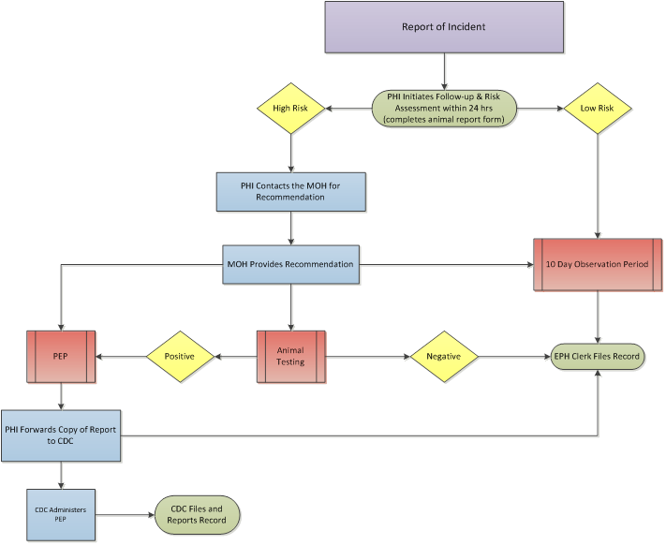
Figure 1: Process of Animal Bite Investigation in Central Zone, Alberta

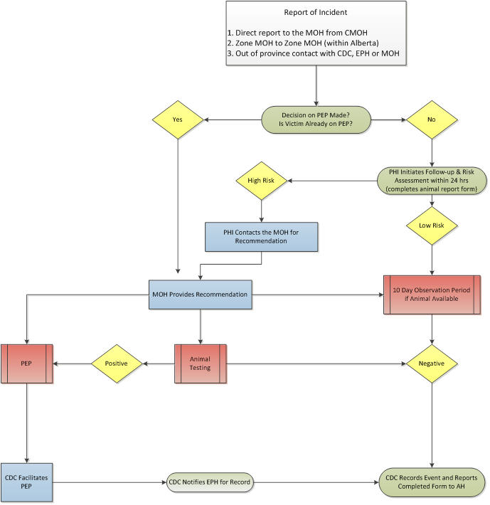
Figure 2: Out of Zone/Province Referral Process

Figure 3: Risk Assessment and Post Exposure Management for Exposure to Domestic Dogs/Cats/Ferrets (Non-Stray)

Figure 4: Risk Assessment and Post Exposure Management for Exposure to Wild Animals

Database quality improvement
Although the main objective of this project was to identify how many animal bite victims who were bitten by their own family pet went on to receive rabies PEP, the barrier that prevented this from being easily determined was due to the incomplete EPH database. Because of this, the first stage of this project used quality improvement methodology to assess and categorize database errors, as well as identifying a subset of cases that could be verified against a “gold standard” and used for the second stage of the project.
Prior to reviewing retrospective administrative data, second-reviewer ethics approval was obtained via “A Project Ethics Community Consensus Initiative” (ARECCI). A teleconference meeting was held on June 12, 2015 where the project was assessed as low risk and approval was granted.
The timeline that was chosen for the study was January 1, 2011 to May 30, 2015, as a new EPH Animal Exposure Investigation Report Form was implemented on January 1, 2011.
The first stage of the study searched all reports of animal exposures in the Central Zone EPH database from January 1, 2011 to May 30, 2015 for which rabies PEP was offered. The total number of cases identified was much smaller than expected for the time period (only 50 cases were identified through this method). Subsequent to the identification of the unexpectedly small numbers of cases in the EPH database, a “gold standard” list of PEP referrals was drawn from the CDC. Once victims were identified for years 2011 through 2015 in the CDC database, they were searched for by name in the EPH database and the Animal Exposure Investigation Report Forms were retrieved and a copy was made for each victim for further evaluation. Victims that were in the CDC database but were not in the EPH database and/or had no Animal Exposure Investigation Report Forms were identified. In order to identify why these victims were missing from the EPH database and/or had missing Animal Exposure Investigation Report Forms, Rabies PEP reports were retrieved from the CDC nurses and were analyzed. Notes were taken for each of the missing victims to identify any common themes found in the PEP reports. For victims that also had missing PEP reports, the missing relevant victim PEP information was retrieved via MediTech (the Central Zone’s electronic medical record). Errors in the CDC and EPH databases and in Animal Exposure Investigation Report Forms were noted and a Fishbone analysis was performed. Summary statistics of categories of errors were also generated. The fishbone analysis diagram, or cause-and-effect diagram, is a graphical analysis tool that allowed the MOH and EPH teams to understand that there are many causes that may contribute to an incomplete EPH database. It displays the relationship of the causes to each other and the end effect and further identifies areas for improvement and is often used in quality improvement and quality assurance projects.⁷
From 2011 through 2015, 200 rabies PEP referrals have been reported by the CDC, of which, 198 were offered PEP in the Central Zone (the denominator). The remaining two cases were reported incorrectly or accidentally by the CDC as they were never offered or received PEP in the Central Zone. Of those 198 cases, 141 had original Animal Exposure Investigation Report Forms filed on site and were populated in the EPH database. Therefore, 71.2% of PEP cases reported by the CDC are reported in the EPH database and have corresponding Animal Exposure Investigation Report Forms. In total, 57 PEP referrals (approximately 30%) were missing from the Central Zone EPH database (Table 1).
In order to identify why these cases were missing from the EPH database and/or had missing Animal Exposure Investigation Report Forms, victim Post-Exposure Prophylaxis Reports were retrieved from the Central Zone CDC nurses. Approximately half of all missing CDC referrals in the EPH database were due to out of zone, province, or country animal exposure incidents (Table 2). In these instances, an Animal Exposure Incident Report Form would not necessarily be required, as this reporting would have happened outside of the zone, and the absence of the form in the Central Zone database would not be considered an error. The other 50% of missing CDC referrals in the EPH database were in-zone animal exposure incidents (Table 2). When analyzing the CDC PEP reports for the missing EPH cases, several scanned copies of Animal Exposure Incident Report Forms filled out by Central Zone PHIs were found attached. These 27 missing in-zone Animal Exposure Investigation Report Forms may not have been sent to the EPH clerk to enter into the EPH database and to further file with Animal Incident Exposure records. The EPH clerk receives victim Animal Exposure Incident Report Forms from PHIs most commonly via interoffice mail. They have also been delivered personally by the PHI if they work in the same facility, and they are rarely sent via email.
When attempting to identify the 57 missing victims in the EPH database via CDC PEP reports, it was discovered that three of the 57 needed PEP reports were missing from the CDC records. In order to obtain the relevant PEP information for the missing victims, the CDC nurse retrieved the patient information by using a medical electronic records system called MediTech. It was also prudent and relevant to identify why these three PEP offered victims had missing PEP reports. After reviewing CDC nurse comments in the CDC database, it was concluded that two of the cases were either out of zone, province, or country residents or incidents. Confirmation with the Central Zone CDC nurses indicated that PEP reports for out of zone victims may have been referred back to the CDC nurses in the zone or province in which the victims reside.
The EPH database gaps were then looked at in more detail. In 2011, 50% of the CDC reported victims were found in the EPH database and had original Animal Exposure Investigation Report Forms. The majority of PEP referrals who were not listed in the EPH database also had missing Animal Exposure Investigation Report Forms. Specifically, in 2011 the CDC reported 34 PEP referrals where 17 of those were recorded in the EPH database and Animal Exposure Investigation Report Form was filed or found. Animal exposure reporting improved by 2012 with 57 reported CDC PEP referrals, 44 of which were found in the EPH database and/or had Animal Exposure Investigation Report Forms. In 2013, the CDC reported 46 PEP referrals, 36 of which were in the EPH database and/or had Animal Exposure Investigation Report Forms. The CDC reported 51 cases in 2014 where 40 were in the EPH database and/or had reports. At the cutoff date of May 30, the 2015 data shows 10 CDC reported PEP referrals of which only six cases were found in the EPH database and of those, four had the Animal Exposure Investigation Report Forms. Table 1 shows these results.
A fishbone analysis was conducted to determine root causes of error leading to an incomplete EPH database. During animal bite data analysis, many errors were identified in the reporting process. The categories for error have been identified as Data Entry, Animal Report Filing Error, Missing Animal Report Files, Missing PEP Reports and Inability to Report Available Data. Data Entry is the largest and most prevalent source of error in regards to the EPH database. For example, EPH reports victims who have been involved in an animal exposure incident, yet patients’ names are misspelled and incorrect patient date of birth filed (i.e. MM/DD/YYYY instead of DD/MM/YYYY or vice versa). Furthermore, the PHI filling out the Animal Exposure Investigation Report Form often has illegible handwriting therefore allowing the opportunity for the EPH clerk to populate the EPH database according to the report form incorrectly. This therefore explains the common trend in incorrect victim data in the EPH database. Consequently, these preventable errors make searching the EPH database very difficult.
Moreover, as the EPH clerk files the Animal Exposure Incident Report Forms by year of reported incident and alphabetically by victim last name, filing errors occur. Several victim forms were found filed incorrectly. For example, a victim from 2014 with last name beginning with “C” was filed in the 2014 “M” folder. Although this too is an error, it is important to note that this filing error does not affect the EPH database accuracy.
Finally, data analysis showed that out of 198 PEP referrals reported by the CDC, only 161 cases had actually received rabies PEP, raising the question of why 37 victims who were recommended by an MOH for rabies PEP, did not receive it. Although generating possible explanations for this outcome would be relevant to this project, the data did not permit this due to inconsistency and a lack of reliability. It was determined that there is discrepancy among the CDC nurses what “RIG Released” and “Vaccine Initiated” means. In the CDC database, these two fields are populated with “yes,” “no,” or “declined” (assuming they are not left blank). For example, the CDC database shows for some victims that RIG was not released and the vaccine was not initiated, however, the victim declined PEP. Another example would be where the CDC nurses entered that PEP was released for a victim who was offered PEP per MOH recommendations but did not actually receive anything.
In summary, between January 1, 2011 and May 30, 2015, a total of 198 cases were referred to CDC nurses for rabies prophylaxis. In 2011, 50% of the CDC reported cases were missing from the EPH database and improved each following year with only a quarter of cases missing. In 2015, 50% of the cases were once again missing from the EPH database, however, many of these missing cases are related to out of zone exposures. A fishbone analysis was used to identify five categories of error that contribute to the incomplete EPH database in Central Zone, Alberta. This diagram illustrates the current errors present as well as areas for potential resolutions that may mitigate these errors for future reporting processes.

Table 1: Percentage of CDC Referrals Missing in the EPH Database 2011-2015
YEAR | NUMBER OF CASES REFERRED TO CDC | NUMBER OF CDC REFERRALS MISSING IN THE EPH DATABASE | PERCENTAGE OF CDC REFERRALS MISSING FROM EPH (%)
2011 | 34 | 17 | 50%
2012 | 57 | 13 | 23%
2013 | 46 | 10 | 22%
2014 | 51 | 11 | 22%
2015* | 10 | 6 | 60%
TOTAL | 198 | 57 | 29%

* Data shown for 2015 does not represent for the entire year. Only January 1 through May 30, 2015.

Table 2: Percentage of CDC Referrals Missing in the EPH Database Due to In-Zone vs Out of Zone - 2011-2015
YEAR | NUMBER OF CASES REFERRED TO CDC | NUMBER OF IN ZONE CDC REFERRALS MISSING IN THE EPH DATABASE/ NO REPORT FORM | NUMBER OF OUT OF ZONE/PROVINCE/COUNTRY CDC REFERRALS MISSING IN THE EPH DATABASE/ NO REPORT FORM | PERCENTAGE OF IN ZONE CDC REFERRALS MISSING FROM EPH (%)
2011 | 34 | 10 | 7 | 29%
2012 | 57 | 6 | 7 | 11%
2013 | 46 | 2 | 8 | 4%
2014 | 51 | 7 | 4 | 14%
2015* | 10 | 2 | 4 | 20%
TOTAL | 198 | 27 | 30 | 14%

* Data shown for 2015 does not represent for the entire year. Only January 1 through May 30, 2015
Figure 5. Analysis of Errors Leading to an Incomplete EPH Database

Assessment of animal bite investigation process

methods
Once it was identified that there were 57 missing CDC referrals in the EPH database, the next step was to enter all missing historical PEP case referrals into the EPH database. Once the EPH database was updated to include all 198 PEP referrals found in the CDC database, our next aim was to develop indicators to understand and to further assess the performance of the current animal bite investigation process. This was done first for all 198 exposures, and then for a sub-set of the sample focusing on domestic animal exposures.
The data was first assessed by extracting all of the 198 PEP referrals (including the newly populated PEP referrals) from the EPH excel database and importing it into a Pivot Chart. Queries were triggered to evaluate the features of interest and tables and charts representing these features were created. Animal exposure incidents were analyzed by the following parameters and descriptive statistics were generated for each:

• Gender of victim (M/F)
• Type of exposure (provoked vs unprovoked)
• Method of exposure (bite, scratch, saliva)
• Site of exposure (head, hand, arm, etc.)
• Type of animal (domestic, wild, stray)
• Animal species (dog, cat, bat, etc.)

Once the first analysis was done, the next objective was to evaluate the 73 animal exposures coded as domestic in the database, to attempt to determine why these victims were offered rabies PEP, and to identify any common themes among domestic exposures. This was intended to be evaluated by assessing the MOH recommendations in the EPH database and creating categories of common and repeating MOH recommendation. Unfortunately, the current database lists vague MOH recommendations lacking in specific detail that would be necessary for accurate assessment and evaluation, therefore, this objective was not completed. Instead, summary statistics for key parameters were generated. Once again, the data was assessed by extracting the relevant PEP referrals from the EPH database and importing it into a Pivot Chart. Queries were triggered to evaluate the features of interest and tables and charts representing those features were created. Victims offered PEP following domestic animal exposures were analyzed by the following parameters present in the current EPH database:

• Contact with wild animal
• Roams unsupervised
• Quarantine animal condition
• Quarantine animal apprehended

results
As a caveat to the following results, it should be noted that since the CDC PEP reports have different fields compared to the Animal Bite Investigation Report Forms, the records for the 57 CDC PEP referrals that were not originally present in the EPH database have missing data/information when compared with those that were originally in the EPH database resulting in a lack of consistency and reliability for some specific parameters. Some of the parameters that were not present in the CDC PEP report forms include victim date of birth and victim address. Furthermore, the CDC database is also very different than the EPH database in the parameters that are present. Currently, the CDC database merely records date of report, victim name, victim date of birth, victim age, gender, city/town, rabies RIG released, rabies vaccine series initiated, date form was faxed to AH&W, CDC nurse, and a comments section for each victim.
Evaluation of the PEP cases show that out of the 198 victims who were offered PEP, 117 were due to provoked animal exposures with approximately 54% being among female victims (Figure 6). Furthermore, 167 of the victims who were offered PEP were exposed to the animal via bite, of which 78 were incidents to the hand, 28 to the leg, 28 to the arm, 22 to the head, 5 to the trunk, 4 were unknown, and 2 were to the foot (Figure 7).
It was essential to identify how many of the PEP referrals were due to domestic, wild, and stray exposures. Figure 8 shows that out of the 198 PEP referrals, 73 were due to domestic animal exposures, 59 were due to wild animal exposures, 52 were due to stray animal exposures, and 14 were unknown. Figure 9 shows that out of the 73 PEP referrals following an exposure to a domestic animal, 52 were due to domestic dogs, 19 were due to domestic cats, one was due to a domestic ferret, and one was due to a horse. Of the 73 domestic animal exposures, 64 were via bite, 6 via scratch, one unknown, and 2 via saliva (Figure 10). Of the 64 victims offered PEP after exposure to a domestic animal bite, 26 were bites to the hand, 15 to the head, 13 to the leg, 9 to the arm, and 1 to the trunk (Figure 10).
Figure 11 shows the number of victims who were offered PEP following type of exposure to a domestic animal which is described here. Out of the 73 victims who were offered PEP following a domestic animal exposure, 45 incidents were due to provoked exposures of which 31 were from domestic dogs, 13 from domestic cats, and one from a domestic ferret. There were 17 unprovoked exposures of which 13 were from dogs and four from cats. Finally, there were 11 unknown exposures of which eight were from dogs, two from cats, and one from a horse.
Figure 12 shows the number of victims offered PEP by whether or not the domestic animal had had contact with wild animals. The data shows that 48 of the domestic animal exposures did not have contact with wild animals, 13 domestic animals did have contact with wild animals, and 12 were left blank in the EPH database.
Additionally, we were interested if whether or not the domestic animal roamed unsupervised which is shown in Figure 13. This data shows that out of the 73 domestic animals involved in an incident resulting in PEP referral, 52 of the domestic animals involved did not roam unsupervised, nine did, and 12 were left blank in the EPH database.
Identifying the number of victims offered PEP by the domestic animal condition following quarantine was another relevant parameter, shown here in Figure 14. This data shows that there were 19 dead domestic animals following the 10 day observation period, 11 healthy, 3 were sick, 27 were listed as unknown in the EPH database, and 13 were left blank in the EPH database.
The final parameter that was analyzed for victims offered PEP following a domestic animal exposure was the quarantine apprehended status of the domestic animal involved, shown in Figure 15. This data shows that out of the 73 domestic animal exposures, 45 of the domestic animals involved in an incident were not apprehended for quarantine, 14 were apprehended, and 14 were left blank in the EPH database.

Figure 6: Number of Victims Offered PEP by Gender after Animal Exposure

Figure 7: Number of Victims Offered PEP by Site and Method of Exposure Following Animal Incident

Figure 8: Number of Victims Offered PEP by Exposure to Animal Type

Figure 9: Number of Victims Offered PEP after Exposure to Animal Species and Type

Figure 10:Number of Victims Offered PEP Following an Exposure to a Domestic Animal

Figure 11: Number of Victims Offered PEP Following Type of Exposure to Domestic Animal

Figure 12: Number of Victims Offered PEP by Domestic Animal Contact with Wild Animal Contact

Figure 13: Number of Victims Offered PEP by Domestic Animal Roaming Status

Figure 14: Number of Victims Offered PEP by Domestic Animal Condition Following Quarantine

Figure 15: Number of Victims Offered PEP by Domestic Animal Quarantine Apprehended Status

Discussion
It is well understood that once clinical symptoms are present following a rabies infection, subsequent death will result from encephalitis. Consequently, to prevent rabies fatalities from occurring, PEP is offered and administered to high-risk victims.
In order to identify whether rabies risk assessments and recommendations vary provincially and nationally, a thorough review was conducted. This analysis aimed to determine whether the current AHS risk assessment guidelines provided a good approximation for risk assessment, or whether the guidelines could be adjusted to ensure that AHS optimized its resources towards highest risk incidents. The review suggested that there is little variability in the rabies risk assessment guidelines among different Canadian provinces and territories
Furthermore, determining the prevalence and incidence of rabies infection is difficult since only ‘suspected’ animals are sent to the CFIA labs for testing and confirmation. Moreover, a total of 1,918 suspected animals were sent for testing in Canada of which, only 92 of the samples were rabies positive⁴. Out of the 293 animals submitted by Alberta, only four tested positive for rabies (bat cases) further suggesting that rabies transmission following a domestic animal exposure is low-risk⁴.
By assessing key parameters of the rabies PEP referrals, particularly in focusing on the domestic animal exposures that were offered PEP, we were able to conclude that it appears that although the majority of animal exposure incidents that occur are low risk for rabies, there is still a relatively large number of people being offered rabies PEP. It is difficult to draw firm conclusions from the data as generated, partly due to the gaps in the database, and partly due to interpretation of the meaning of each of the fields. The PHIs conducting the risk assessment, the MOHs recommending the PEP, and CDC nurses releasing the PEP have followed all Alberta Health and Canadian guidelines and protocols. Although risk of rabies transmission may be low, AHS and AH would accept liability in the case where PEP was not recommended following a domestic animal exposure and the victim died as a consequence of rabies infection. I speculate that preventing any liability may also be a contributing factor to the over-recommended PEP.
In order to avoid an unreliable and inaccurate rabies PEP database in the future, I recommend that the PHIs infiltrate the Animal Exposure Incident Report Form electronically only (PDF) instead of by hand. By doing this, we eliminate inaccurate reporting due to illegible handwriting and improper filing. Additionally, I suggest that the whole team (MOH, EPH, and CDC nurses) establishes mandatory seminars where they will be able to openly discuss potential quality assurance protocols to be implemented in the future. Moreover, the EPH team should generate monthly data reports on animal bite and rabies PEP referrals to identify periodically what the current sources of errors are, why they are present, and what further actions can be taken to mitigate them. By conducting routine quality inspections, we can speculate that over time, the database will continue to be more reliable, accurate, and dependable.
APPENDIX A: ALBERTA HEALTH SERVICES ZONE MAP

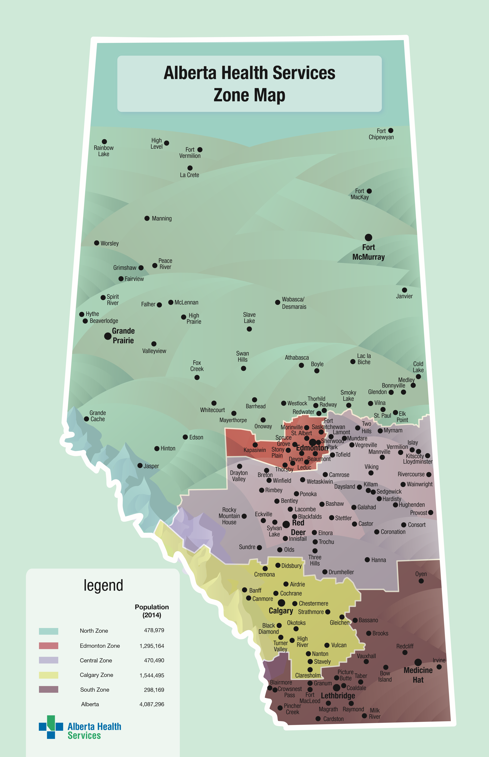
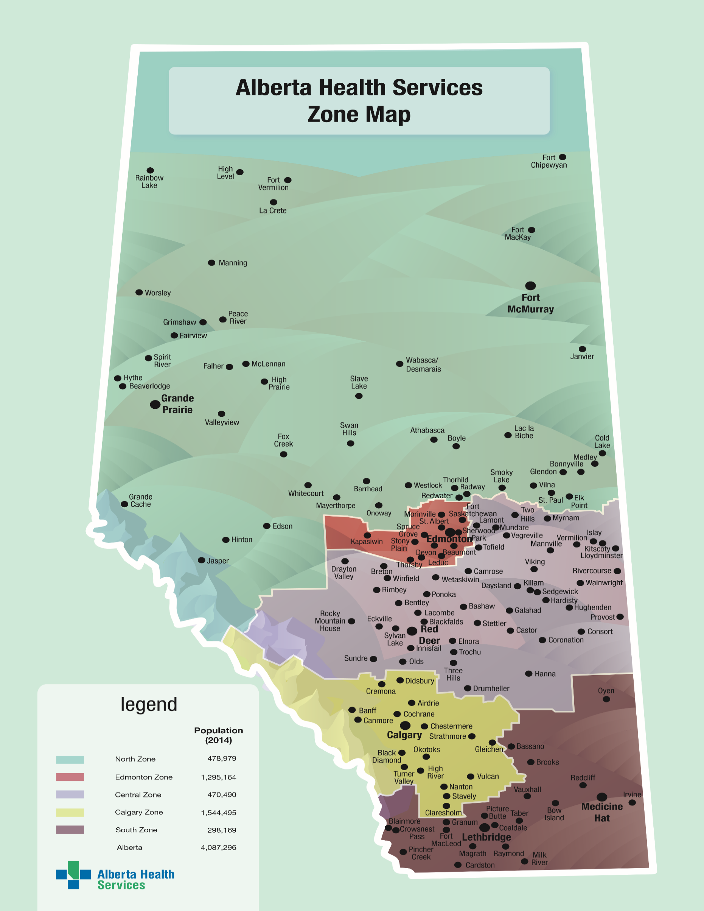
APPENDIX B: ALBERTA HEALTH SERVICES ANIMAL EXPOSURE INVESTIGATION REPORT FORM

APPENDIX C: ALBERTA RABIES POST-EXPOSURE PROPHYLAXIS REPORT

bibliography
- Vora, Neil M., MD, Jessie R. Clippard, MPH, Mary G. Stobierski, DVM, MPH, Kimberly Signs, DVM, and Jesse D. Blanton, MPH. "Animal Bite and Rabies Postexposure Prophylaxis Reporting- United States, 2013." Journal of Public Health Management and Practice 21.3 (2015): 24-27. Web.
- "Rabies." World Health Organization. World Health Organization, 2014. Web. 2 July 2015. <http://www.who.int/mediacentre/factsheets/fs099/en/>.
- Dumas, Florence R., Dieynaba S. N'Diaye, Juliette Paireau, Philippe Gautret, Herve Bourhy, Claude Le Pen, and Yazdan Yazdanpanah. "Cost-Effectiveness of Rabies Post-Exposure Prophylaxis in the Context of Very Low Rabies Risk: A Decision- Tree Model Based on the Experience of France." Vaccine 33.20 (2015): 2367- 378. Elsevier, 20 Mar. 2015. Web. 2 July 2015.
- "Rabies in Canada 2014." Canadian Food Inspection Agency. Government of Canada, 25 Feb. 2015. Web. 2 July 2015.
- "List of Nationally Notifiable Diseases." Public Health Agency of Canada. Public Health Agency of Canada, 31 Mar. 2014. Web. 30 July 2015. <http://dsol-smed.phac- aspc.gc.ca/dsol-smed/ndis/list-eng.php>.
- Canada. Alberta Health Services. Environmental Public Health. Department Standard Operating Procedure. N.p.: Alberta Health Services, 2015. Print.
- Lau, Catherine Y. "Quality Improvement Tools and Processes." Neurosurgery Clinics of North America (2015): 177-87. Print.

